REPORT ON FINANCIAL PERFORMANCE

FOR THE PERIOD 1 JANUARY – 30 SEPTEMBER 2019

Zagreb, November 2019

RESULTS OF THE GROUP

BREAKDOWN OF THE MOST SIGNIFICANT FINANCIAL INFORMATION OF HBOR GROUP
-HRK million-

 | 31 December 2017 | 31 December 2018 | 30 September 2019
Total assets | 28,075.6 | 27,219.0 | 26,612.2
Gross loans | 26,333.0 | 26,243.1 | 26,459.7
Total equity | 10,275.8 | 10,061.1 | 10,247.4
 | 1 January –  30 September 2017 | 1 January –  30 September 2018 | 1 January –  30 September 2019
Total income | 705.6 | 617.4 | 525.2
Total expense | (529.1) | (518.7) | (381.3)
Profit | 176.5 | 98.7 | 143.9
Interest income | 661.2 | 563.1 | 483.3
Interest expense | (301.5) | (255.0) | (236.7)
Net interest income | 359.7 | 308.1 | 246.6

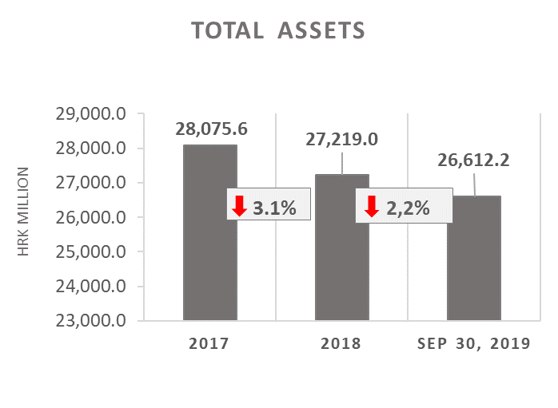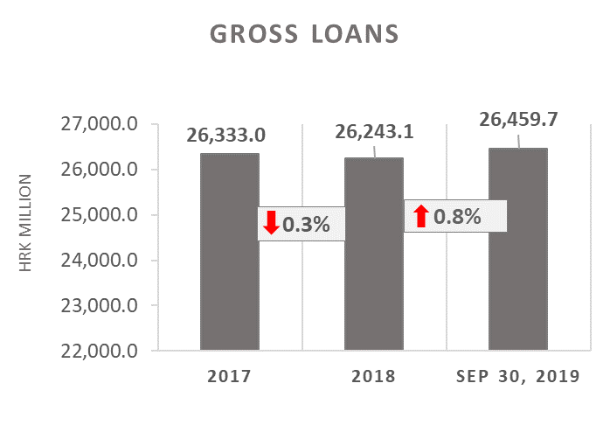

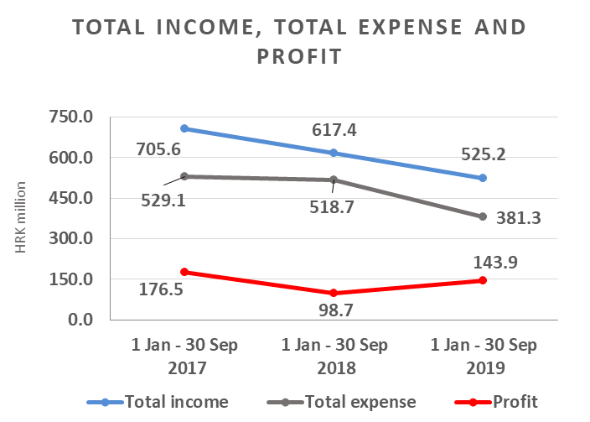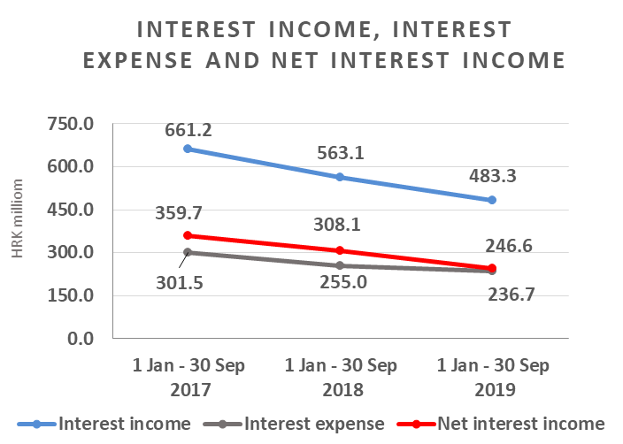

Results of the Group

In the period 1 January – 30 September 2019, the HBOR Group generated profit after tax in the amount of HRK 143.9 million.

Pursuant to the provisions of the Act on HBOR, the parent company is exempt from income tax and income tax liabilities arise exclusively from the activities of the other members of the Group.

In the period 1 January – 30 September 2019, total income on consolidated basis amounted to HRK 525.2 million, whereas total expenses amounted to HRK 381.3 million.

The consolidated total income decreased by 14.9 percent, whereas total expenses decreased by 26.5 percent compared to the same period previous year due to the developments in total income and expenses of the parent company.

In the breakdown of income of the Group, the largest portion, i.e. 92.0 percent, relates to interest income as a result of operations of the parent company.

The major part of total expenses, i.e. 62.1 percent, relates to interest expenses arising from the operations of the parent company.

The consolidated operating expenses in the period 1 January – 30 September 2019 amounted to HRK 124.0 million and consisted of general and administrative expenses and other operating expenses.

On 30 September 2019, the Group had 386 employees (on 30 September 2018: 390 employees).

Assets and liabilities of the Group

Total assets of the Group on consolidated basis amount to HRK 26,612.2 million, a decrease of 2.2 percent compared with the beginning of the year. The reasons for such tendency are stated in the description of HBOR’s financial performance.

In the breakdown of assets, the major portion relates to the lending activities of the parent company, i.e. net loans account for 85.7 percent of total assets.

Total liabilities and total equity as at 30 September 2019 amount to HRK 26,612.2 million, of which amount total liabilities equal HRK 16,364.8 million, i.e. 61.5 percent.

In total liabilities and total equity of the Group, the major portion, i.e. 58.7 percent, consists of borrowings and bonds payable of the parent company.

At the end of the reporting period, total equity on consolidated basis amounted to HRK 10,247.4 million and accounted for 38.5 percent of total liabilities and total equity of the Group.

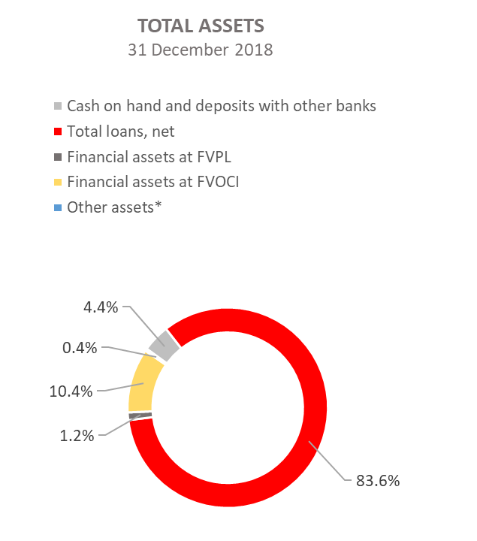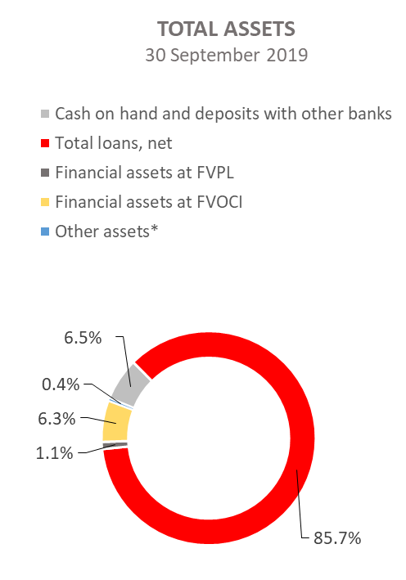

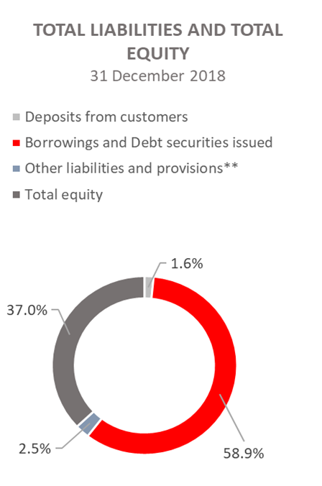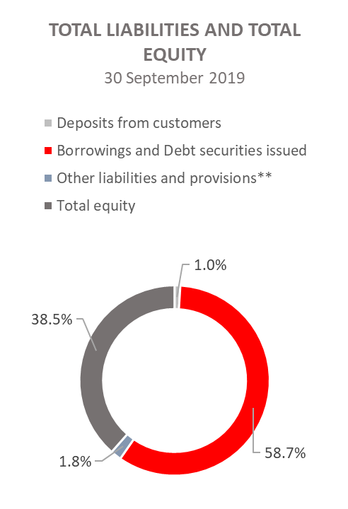
*Property, plant and equipment and intangible assets, Foreclosed assets, Debt securities at AC and Other assets.
**Provisioning includes provisioning for guarantees, commitments and other liabilities.

RESULTS OF HBOR

OVERVIEW OF FINANCIAL PERFORMANCE OF HBOR

The following text gives an overview and explanation of the significant changes in financial position and operating performance in the reporting period.

Financial performance

In the period from 1 January to 30 September 2019, HBOR generated total income of HRK 515.3 million, expenses of HRK 373.6 million and profit in the amount of HRK 141.7 million. HBOR’s profit generated in the reporting period increased by HRK 44.0 million compared with the profit generated in the same period last year, i.e. by 45.0 percent.

Significant increase in profit in the reporting period compared with the same period last year is a result of decrease in total income by HRK 94.6 million and even more significant decrease in total expenses by HRK 138.6 million. The circumstances that affected the financial result achieved in the nine-month reporting period 2019 compared to the results generated in the same period in 2018:
- Decrease in interest income of HRK 79.7 million, i.e. by 14.2 percent,
- Decrease in interest expenses of HRK 18.3 million, i.e. by 7.2 percent,
- Increase in gains from financial activities of HRK 3.1 million, i.e. by 43.1 percent,
- Decrease in losses from impairment and provisions in the amount of HRK 116.3 million,
- Decrease in operating expenses of HRK 3.0 million, i.e. by 2.5 percent,
- Decrease in net fee and commission income of HRK 16.5 million, i.e. by 52.5 percent.

A detailed description of trends is given for each category separately in the following text.

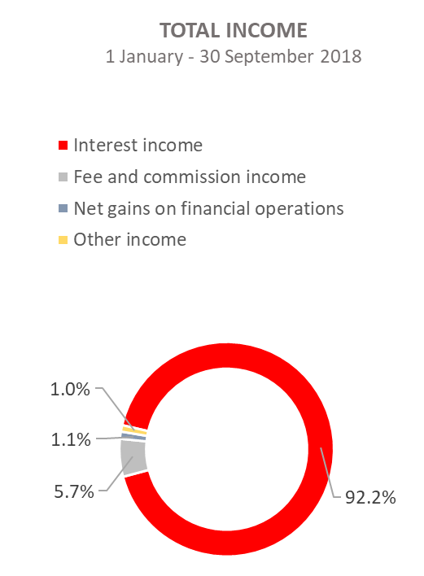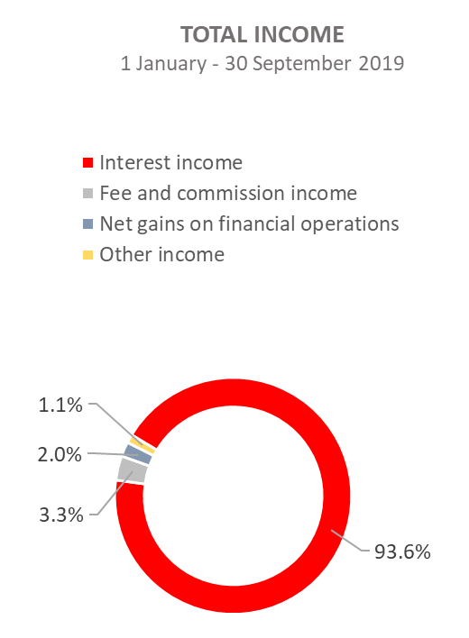

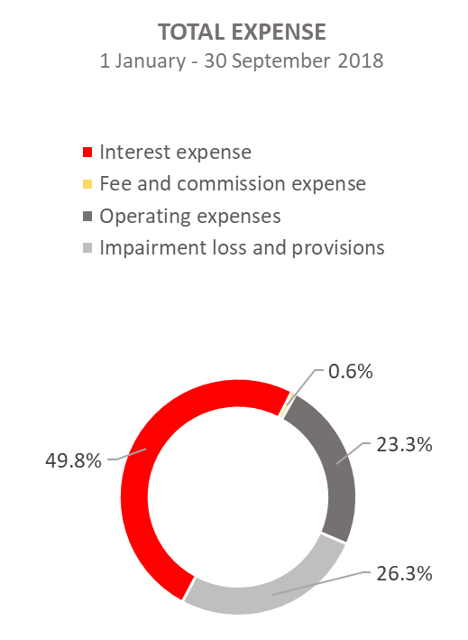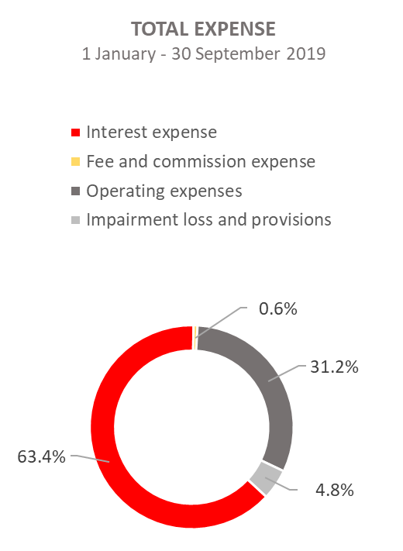

Net interest income

Net interest income amounted to HRK 245.7 million, a decrease of 20.0 percent on the same period of the previous reporting year.

Interest income amounted to HRK 482.4 million, a decrease of 14.2 percent on the same reporting period last year due to decreased interest income from long-term loans as a result of the long-term implementation of measures of interest rate reduction, reduction of interest income from interest rate subsidies, significant amounts of premature loan repayments in 2018 and 2019 and the manner of recording of interest income from exposures classified to stage 3 and POCI assets (unwinding).
On this basis, from 1 January to 30 September 2019, interest income was reduced by HRK 25.5 million.

Interest expenses amounted to HRK 236.7 million, a decrease of 7.2 percent on the same reporting period last year.

Having in mind the described trends in interest income and interest expenses, net interest margin decreased compared with the same reporting period last year and stood at 1.2 percent as against 1.5 percent in the same reporting period last year.

Net fee and commission income

Net fee and commission income amounted to HRK 14.9 million, a decrease of 52.5 percent compared with the same reporting period last year due to calls for payments under guarantees issued, thus decreasing the exposure under guarantees issued.

Net gains/(losses) from financial activities

Net gains/(losses) from financial activities are comprised of net foreign exchange gains/(losses) on the principal amount of receivables and liabilities, net revenues or expenditures arising out of the loan contracts with embedded call option, gains/(losses) arising out of value adjustment of financial assets stated at fair value through profit or loss and realised gains/(losses) arising out of financial assets at fair value through other comprehensive income.

In the reporting period, net gains from financial activities amounted to HRK 10.3 million, whereas net gains stood at HRK 7.2 million in the same period previous year.

A breakdown of changes in the exchange rate of HRK against the EUR and the USD:

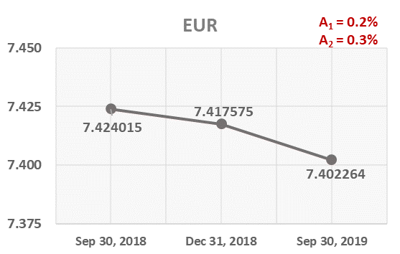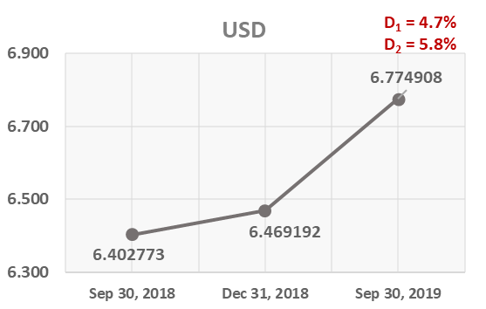

Note:
A₁ = HRK appreciation 30.9.2019/31.12.2018 D₁ = HRK depreciation 30.9.2019/31.12.2018
A₂ = HRK appreciation 30.9.2019/30.9.2018 D₂ = HRK depreciation 30.9.2019/30.9.2018

Foreign currency and foreign currency indexed assets and sources of funds are converted by HBOR into HRK equivalent value by applying the exchange rate of the Croatian National Bank valid at the reporting date.

Foreign currency revenues and expenditures are converted in accordance with the exchange rate at the transaction date. The resulting foreign exchange gains or losses are recorded in the Income Statement in net figures.

Operating expenses

Operating expenses that include general and administrative expenses and other operating expenses stood at HRK 116.5 million, a decrease of 2.5 percent compared with the same reporting period last year. The most significant impact had the item of other expenses that decreased by HRK 6.0 million on the same period previous year. To be precise, in the same period in 2018, financial instruments recalculation expenses rose by 12.0 million on 2019, whereas in 2019 the amount of receivables written off stood at HRK 5.6 million and the amount of HRK 0.4 related to others.

On 30 September 2019, HBOR had 366 employees (on 30 September 2018: 371 employees).

Impairment gain/(loss) and provisions

In the reporting period, placement impairment net losses stood at HRK 18.1 million.

The text to follow contains a breakdown of portfolio quality:

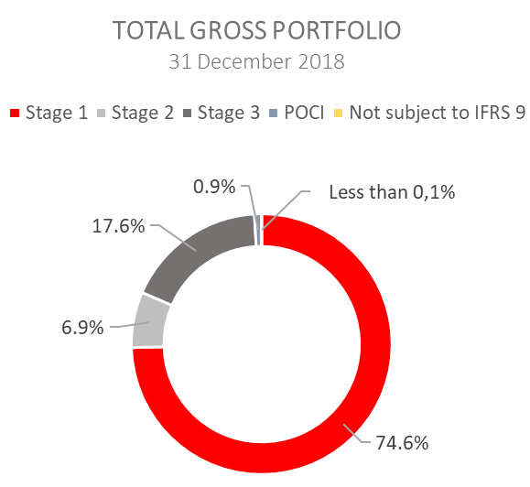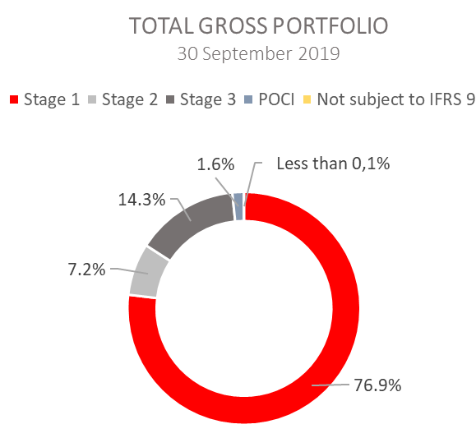

 | 31 December 2018 |  | 30 September 2019
 | In HRK millions | Breakdown  (percent) | In HRK millions | Breakdown (percent)
Total gross portfolio | 35,808.1 | 100.00 | 34,242.4 | 100.00
Of which:
- financial institutions | 13,194.5 | 36.8 | 13,541.1 | 39.5
- direct | 22,613.6 | 63.2 | 20,701.3 | 60.5
Total provisions | 3,795.6 | 100.00 | 3,772.0 | 100.00
Of which:
- financial institutions | 122.6 | 3.2 | 79.9 | 2.1
- direct | 3,673.0 | 96.8 | 3,692.1 | 97.9
Provisions/gross portfolio | 10.6 percent | - | 11.0 percent | -

Significant changes in financial position

Total assets of HBOR as at 30 September 2019 amounted to HRK 26,590.3 million, a decrease of 2.2 percent compared with 31 December 2018, mostly due to repayment of obligations.

Cash on hand and deposits with other banks

As at 30 September 2019, cash on hand and deposits with other banks amounted to HRK 1,740.0 million representing 6.5 percent of total assets, an increase of 44.6 percent compared with 31 December 2018.

Loans to financial institutions and other customers

As at 30 September 2019, total net loans amounted to HRK 22,808.5 million representing 85.8 percent of total assets, an increase 0.3 percent on the beginning of the year.

Total gross loans amounted to HRK 26,459.7 million, an increase of 0.8 percent compared with 31 December 2018. Gross loans to other customers increased by 7.0 percent compared with the end of 2018. Gross loans to financial institutions decreased by 8.7 percent compared with the beginning of the year.

Financial assets at fair value through profit or loss

Loans at fair value (HBOR has determined that mezzanine loans are classified here), investments in investment funds (obligatory pursuant to IFRS) and a part of equity instruments are classified to these assets. As at 30 September 2019, the total amount of these assets equalled HRK 278.6 million representing 1.1 percent of total assets.

Financial assets at fair value through other comprehensive income

a) Debt securities
Bonds of the Republic of Croatia and treasury bills of the Ministry of Finance as part of liquidity reserve as well as bonds of a company are classified to these assets. On the reporting date, they amounted to HRK 1,600.9 million, representing 6.0 percent of total assets, a decrease of 42.1 percent on the beginning of the year. This is a result of a significant outflow of liquidity reserve funds for the purpose of loan disbursements and settling borrowing liabilities.
The impairment of these financial assets is calculated through the application of the model of expected credit losses in the manner that provisions are recognised in the accounts of other comprehensive income, thus not reducing the carrying amount of these financial assets in the statement on financial position. On the reporting date, they amounted to HRK 3.2 million.

b) Equity instruments
Equity instruments (shares of companies) that HBOR does not intend to sell and to which irrevocable option of subsequent measurement of fair value through other comprehensive income without recycling is applied are classified to these assets, i.e. reserves recognised under other comprehensive income will never be transferred to the statement on profit or loss.
On the reporting date, these assets amounted to HRK 26.1 million, representing 0.1 percent of total assets.

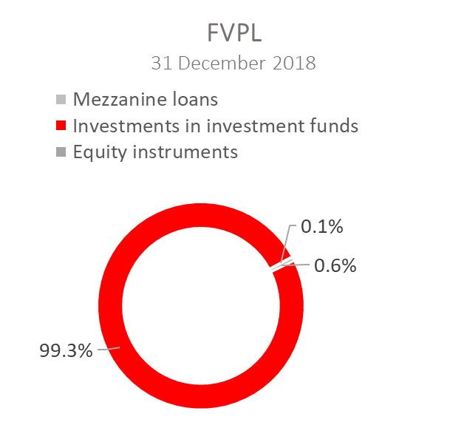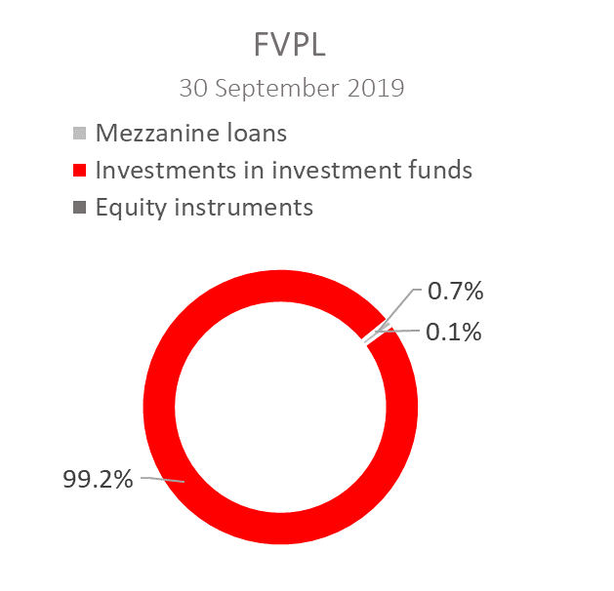
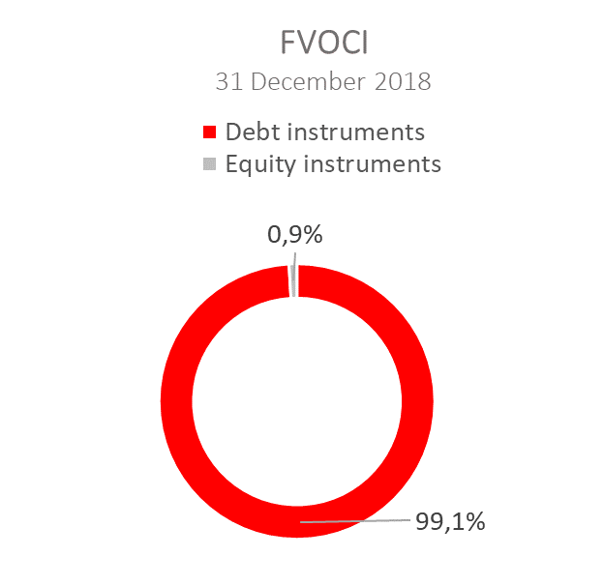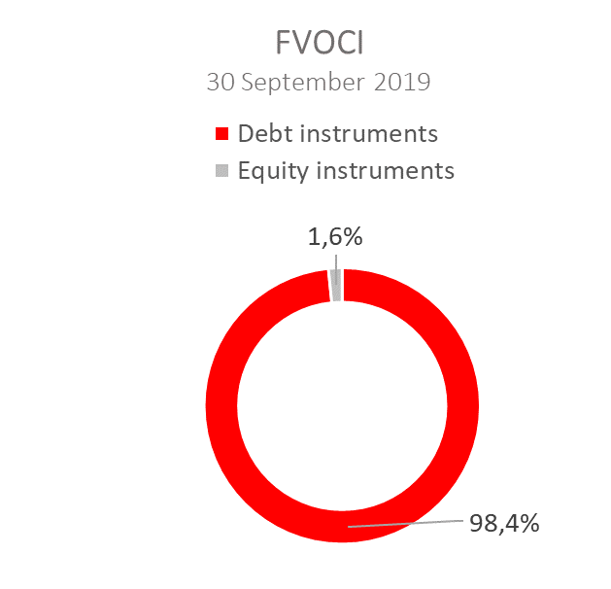

Total liabilities

As at 30 September 2019, total liabilities amounted to HRK 16,352.0 million, which represents 61.5 percent of total liabilities and total equity. The major part of total liabilities consists of HBOR’s foreign borrowings and bond payable in the total amount of HRK 15,618.9 million.

Borrowings and debt securities issued decreased by 2.6 percent compared with the beginning of the year, whereas changes in these liabilities are shown in the following table:

 | (HRK million)
- Draw-down of funds borrowed under previously contracted  funds of special financial institutions | 2,398.2
- Repayments of borrowings | (2,799.2)
- Foreign exchange gains or losses | (1.0)
- Other calculations* | (7.6)
Total changes | (409.6)
*Other calculations relate to the changes in discount, amount of interest not due and deferred fees.

Deposits from customers

Deposits from customers decreased by 39.7 percent on the beginning of the year, and the most significant impact resulted from the return of received short-term deposits and the decrease in transactions performed by HBOR for and on behalf of third parties.

Total equity

Total equity amounted to HRK 10,238.3 million, representing 38.5 percent of total liabilities and total equity.

Total equity of HBOR is comprised of the capital and the guarantee fund. HBOR’s capital is comprised of founder’s capital contributed from the budget of the Republic of Croatia, retained earnings from the profits generated in the previous years, other reserves and profits for the current period.

In the reporting period, the amount of HRK 25.0 million was contributed from the budget of the Republic of Croatia into the founder’s capital. The total amount of capital contributed from the budget of the Republic of Croatia stood at HRK 6,658.0 million, and the remaining amount to be contributed to the founder’s capital up to the total amount of HRK 7,000.0 million set by the HBOR Act is HRK 342.0 million.

After the reporting period, on 22 October 2019, the amount of HRK 25.0 million was contributed into the founder’s capital from the budget of the Republic of Croatia, which means that the planned contribution for 2019 from the budget of the Republic of Croatia in the amount of HRK 50.0 million has been entirely settled.

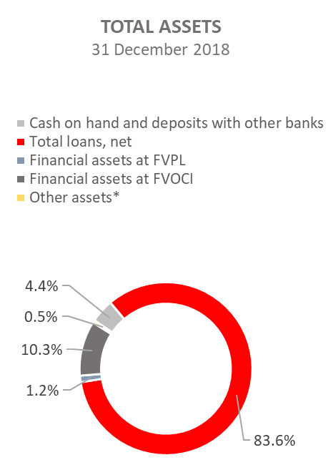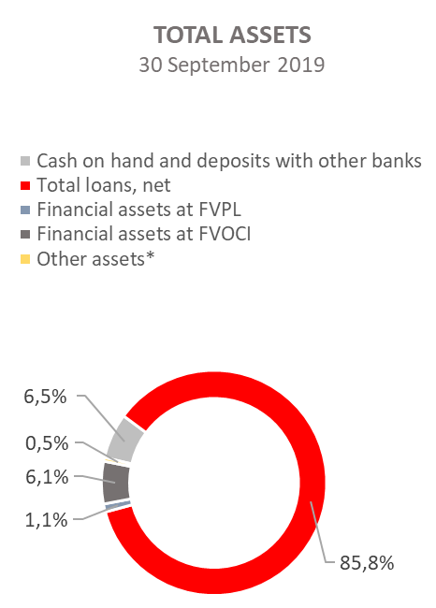

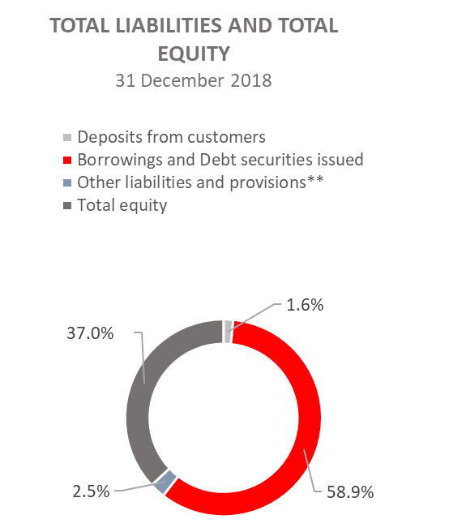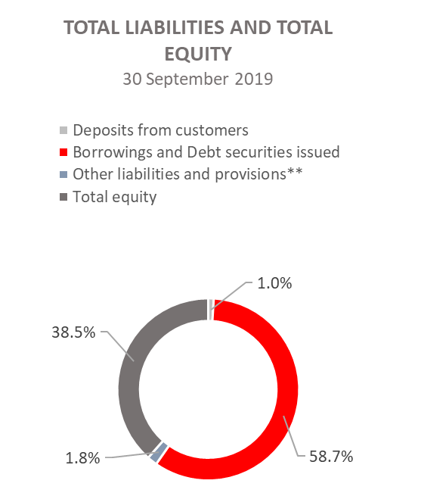

*Investments in subsidiaries, Property, plant and equipment and intangible assets, Foreclosed assets and Other assets.
**Provisioning includes provisioning for guarantees, commitments and other liabilities.

