REPORT ON FINANCIAL PERFORMANCE
FOR THE PERIOD
1 JANUARY – 30 SEPTEMBER 2018

Zagreb, November 2018

RESULTS OF THE GROUP

BREAKDOWN OF THE MOST SIGNIFICANT FINANCIAL INFORMATION OF hbor GROUP
-HRK millions-

 | 2016 | 2017 | 30 September 2018
Total assets | 27,390.82 | 28,075.56 | 27,091.02
Gross loans | 26,343.12 | 26,332.99 | 25,863.02
Total equity | 10,042.70 | 10,275.78 | 9,959.75
 | 30 September 2016 | 30 September 2017 | 30 September 2018
Total income | 677.57 | 705.66 | 617.35
Total expense | (517.79) | (529.12) | (518.67)
Profit | 159.78 | 176.54 | 98.68
Interest income | 644.93 | 661.20 | 563.14
Interest expense | (340.88) | (301.46) | (254.99)
Net interest income | 304.05 | 359.74 | 308.15

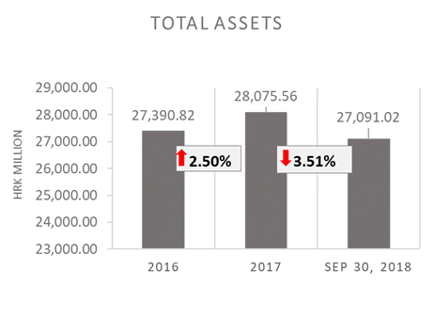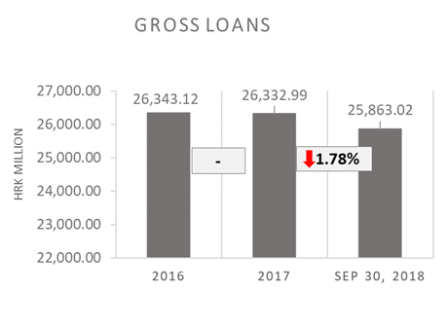

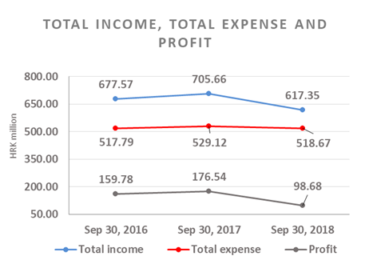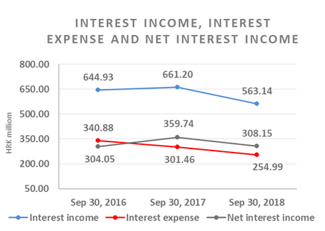

Results of the Group

The effects of application of IFRS 9 were recognised at the expense of retained earnings and reserves as at 1 January 2018 in the amount of HRK 469.97 million.
In the period 1 January – 30 September 2018, the HBOR Group generated profit after tax in the amount of HRK 98.68 million.

Pursuant to the provisions of the Act on HBOR, the parent company is exempt from income tax and income tax liabilities arise exclusively from the activities of the other members of the Group.

In the period 1 January – 30 September 2018, total income on consolidated basis amounted to HRK 617.35 million, whereas total expenses amounted to HRK 518.67 million.

The consolidated total income decreased by 12.51 percent, whereas total expenses decreased by 1.97 percent compared to the same period previous year due to the developments in total income and expenses of the parent company.

In the structure of income of the Group, the largest portion, i.e. 91.22 percent, relates to interest income as a result of operations of the parent company.

The major part of total expenses, i.e. 49.16 percent, relates to interest expenses arising from the operations of the parent company.

The consolidated operating expenses in the period 1 January – 30 September 2018 amounted to HRK 125.88 million and consisted of general and administrative expenses and other operating expenses.

As of 30 September 2018, the Group had 390 employees (as of 30 September 2017: 383 employees), of which 2 are new employees and 5 employees are in substitution for maternity leave, long-term sick leave and return from unpaid leave.

Assets and liabilities of the Group

Total assets of the Group on consolidated basis amount to HRK 27,091.02 million, a decrease of 3.51 percent compared with the beginning of the year. The reasons for such tendency are stated in the description of HBOR’s financial performance.

In the structure of assets, the major portion relates to the lending activities of the parent company, i.e. net loans account for 82.02 percent of total assets.

Total liabilities and total equity as at 30 September 2018 amount to HRK 27,091.02 million, of which total liabilities equal HRK 17,131.27 million, i.e. 63.24 percent.

In total liabilities and total equity of the Group, the major portion, i.e. 59.85 percent, consists of borrowings and bonds payable of the parent company.

At the end of the reporting period, total equity on consolidated basis amounted to HRK 9,959.75 million and accounted for 36.76 percent of total liabilities and total equity of the Group.

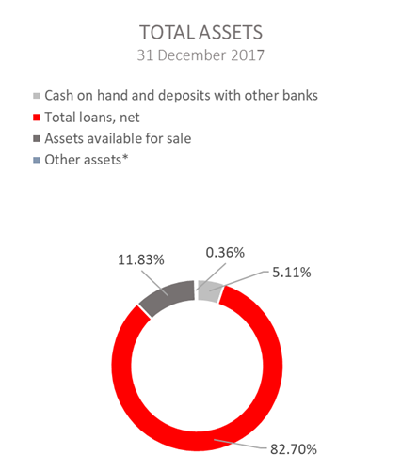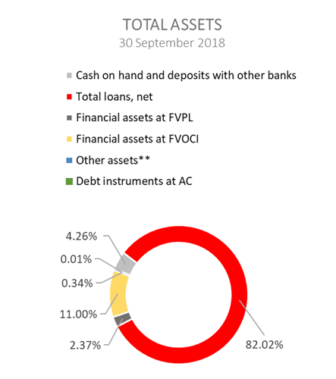

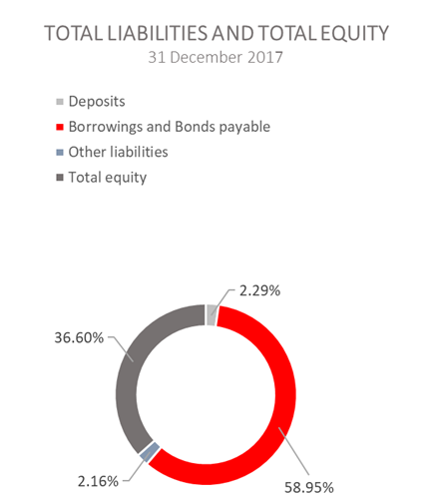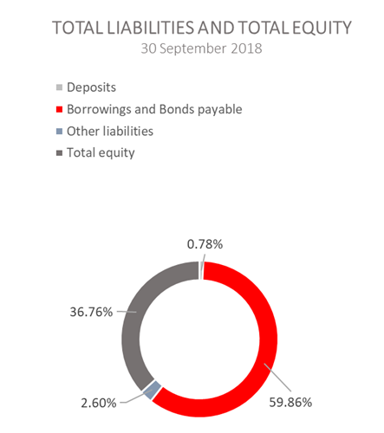

*Financial assets at fair value through profit or loss, Assets held to maturity, Property, plant and equipment and intangible assets, Non-current assets held for sale and Other assets.
**Property, plant and equipment and intangible assets, Non-current assets held for sale and Other assets.

RESULTS OF HBOR

OVERVIEW OF FINANCIAL PERFORMANCE OF HBOR

The following text gives an overview and explanation of the significant changes in financial position and operating performance in the reporting period.

It must be emphasised once again that since 1 January 2018, the Bank has applied the International Financial Reporting Standard (IFRS) 9 Financial Instruments and has not reversed comparative data for 2017, as allowed by the standard. Pursuant to the mentioned, the current period from 1 January to 30 September 2018 is based on IFRS 9, whereas the results for 2017 and for the period from 1 January to 30 September 2017 are based on the International Accounting Standard (IAS) 39, Financial Instruments: Recognition and Measurement, and comparative data for 2017 are not comparable with the information presented in 2018.

Financial performance

The effects of application of IFRS 9 were recognised at the expense of retained earnings and reserves as at 1 January 2018 in the amount of HRK 469.66 million.
In the period from 1 January to 30 September 2018, HBOR generated total income of HRK 609.92 million, expenses of HRK 512.21 million and profit in the amount of HRK 97.71 million. HBOR’s profit generated in the reporting period decreased by HRK 77.80 million compared with the profit generated in the same period last year, i.e. by 44.33 percent.

Significantly lower profit in the reporting period compared with the same period last year is a result of a higher decrease in income, by HRK 87.69 million as against expenses decreasing by HRK 9.89 million. The circumstances that affected the financial result achieved in the nine-month reporting period 2018 compared to the results generated in the same period in 2017 are:
- decrease in interest income of HRK 97.87 million, i.e. by 14.83 percent,
- decrease in interest expenses of HRK 46.47 million, i.e. by 15.41 percent compared with the same period last year,
- gains from financial activities in the amount of HRK 7.20 million, whereas in the same period last year, losses from financial activities in the amount of HRK 18.88 million were recorded,
- increase in losses from impairment and provisions in the amount of HRK 42.56 million, i.e. by 46.33 percent,
- increase in operating expenses of HRK 12.17 million, i.e. by 11.34 percent,
- increase in fee income of HRK 3.30 million, i.e. by 10.52 percent.

A detailed description of trends is given for each category separately in the following text.

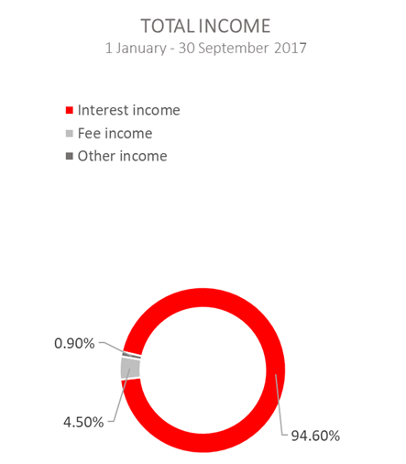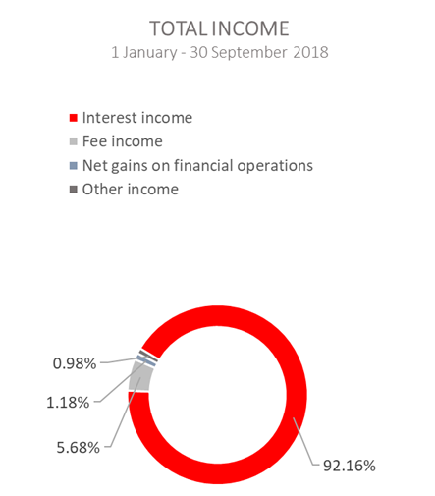

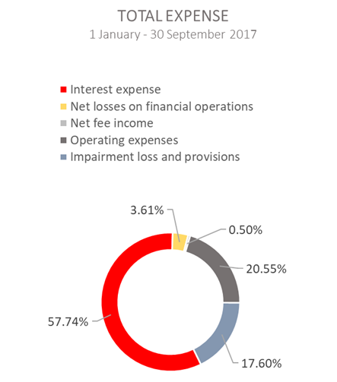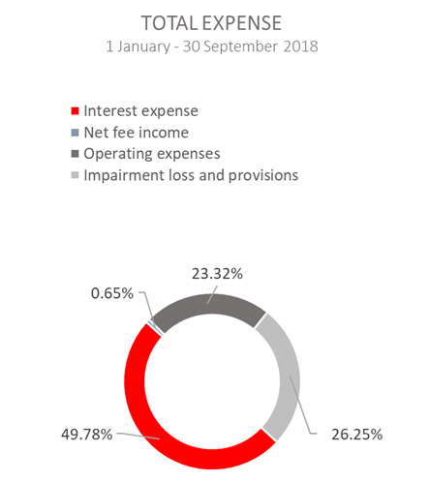

Net interest income

Net interest income amounted to HRK 307.10 million, a decrease of 14.34 percent on the same period of the previous reporting year.

Interest income amounted to HRK 562.09 million, a decrease of 14.83 percent on the same reporting period last year due to decreased interest income from long-term loans due to the long-term implementation of measures of interest rate reduction, reduction of interest income from interest rate subsidies, significant amounts of premature loan repayments in 2017 continued also in 2018, implemented restructurings and the manner of recording of interest income from exposures classified to stage 3 and POCI assets (unwinding).

The application of IFRS 9 affects the comparability of interest income in the current reporting period and in the same period last year, as follows:
- as of 1 January 2018, interest from the previous periods (except for default interest for clients of risk level 3) directly excluded from off-balance sheet records are transferred to the statement on financial position. Due to the mentioned, income from the collection of directly excluded interest income from previous years cannot be compared, because in the current year, no separate records of this income are kept;
- for the purpose of calculation of interest income for exposures allocated to stage 3 or for assets classified as purchased or originated credit-impaired financial assets, the concept of time value of money is used (unwinding). Unwinding, i.e. interest income for the mentioned exposures is calculated after the date of transfer of exposure to stage 3 or after the date of classification of assets as POCI and is recorded as provisions for the financial instrument with simultaneous decrease of interest income. On this basis, from 1 January to 30 September 2018, interest income was reduced by HRK 44.83 million.

Interest expenses amounted to HRK 254.99 million, a decrease of 15.41 percent on the same reporting period last year, which was mostly affected by the repayment of bonds issued that were contracted at high interest rate and the utilisation of credit lines of special financial institutions at favourable interest rates.

Having in mind the described trends in interest income and interest expenses, net interest margin decreased compared with the same reporting period last year and stood at 1.49 percent as against 1.72 percent in the same reporting period last year.
Net fee income

Net fee income amounted to HRK 31.35 million, an increase of 8.93 percent compared with the same reporting period last year due to a higher volume of guarantees issued.

Net gains/(losses) from financial activities

Net gains/(losses) from financial activities are comprised of net foreign exchange gains/(losses) on the principal amount of receivables and liabilities, net revenues or expenditures arising out of the loan contracts with embedded call option, gains/(losses) arising out of value adjustment of assets stated at fair value through profit or loss and realised gains/(losses) arising out of assets at fair value through other comprehensive income.

In the reporting period, net income from financial activities amounted to HRK 7.20 million, whereas, in the same reporting period previous year, net losses amounted to HRK 18.88 million.

A breakdown of changes in the exchange rate of HRK against the EUR and the USD:

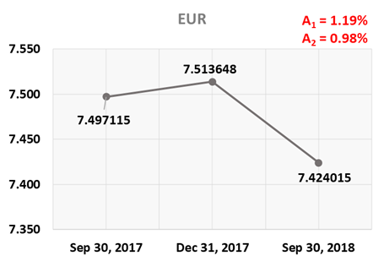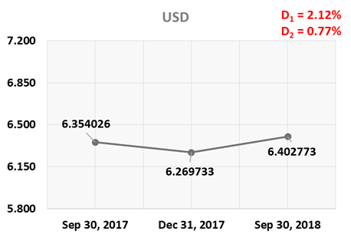

Note:
A₁ = HRK appreciation 30.9.2018/31.12.2017 D₁ = HRK depreciation 30.9.2018/31.12.2017
A₂ = HRK appreciation 30.9.2018/30.9.2017 D₂ = HRK depreciation 30.9.2018/30.9.2017

Foreign currency and foreign currency indexed assets and sources of funds are converted by HBOR into HRK equivalent value by applying the exchange rate of the Croatian National Bank valid at the reporting date.

Foreign currency revenues and expenditures are converted in accordance with the exchange rate at the transaction date. The resulting foreign exchange gains or losses are recorded in the Statement of Profit or Loss and Other Comprehensive Income in net figures.

Operating expenses

Operating expenses that include general and administrative expenses and other operating expenses stood at HRK 119.47 million, an increase of 11.34 percent compared with the same reporting period last year, mostly due to an increase in the other expenses of HRK 8.39 million that relate to recalculations of financial instruments.

As of 30 September 2018, HBOR had 371 employees (as of 30 September 2017: 366 employees), of which 5 employees are in substitution for maternity leave, long-term sick leave and return from unpaid leave.

Impairment gain/(loss) and provisions

As of 1 January 2018, HBOR has applied the International Financial Reporting Standard (IFRS) 9 Financial instruments that introduces significant changes pertaining to the presentation of impairment compared with the previous manner of recognising impairment on the basis of IAS 39.

For the purpose of faster recognition of losses, a model based on the concept of expected losses was introduced pertaining to instruments that are measured at amortised cost and at fair value through other comprehensive income (non-equity instrument) instead of the previous concept of incurred losses pursuant to IAS 39.

Pursuant to the above, as at 1 January 2018, the effects of the application of IFRS 9 were directly recognised in HBOR’s retained earnings and reserves in the amount of HRK 469.66 million.

In the reporting period, net expenses from the impairment of placements stood at HRK 134.43 million.

The text to follow contains a breakdown of portfolio quality:

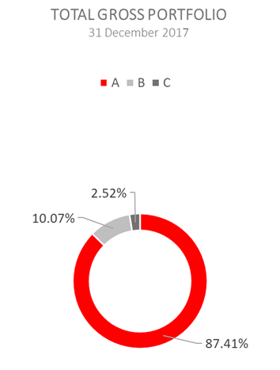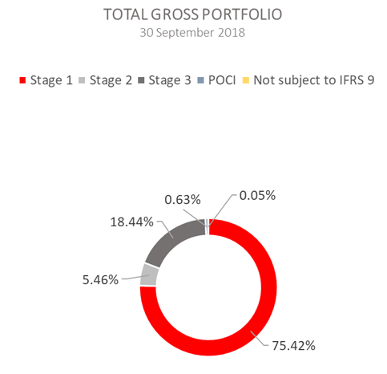
*The disclosed financial statements as at and for the year ended on 31 December 2017 under these positions included also investments in investment funds.

 | 31 December 2017 |  | 30 September 2018
 | In HRK millions | Breakdown (percent) | In HRK millions | Breakdown (percent)
Total gross portfolio | 36,039.89 | 100.00 | 35,181.88 | 100.00
Of which:
- financial institutions | 14,374.59 | 39.89 | 13,255.69 | 37.68
- direct | 21,665.30 | 60.11 | 21,926.19 | 62.32
Total provisions | 3,201.97 | 100.00 | 3,920.15 | 100.00
Of which:
- financial institutions | 259.82 | 8.11 | 120.05 | 3.06
- direct | 2,942.15 | 91.89 | 3,800.10 | 96.94
Provisions/gross portfolio | 8.88 percent | - | 11.14 percent | -

Significant changes in financial position

Total assets of HBOR as at 30 September 2018 amounted to HRK 27,068.86 million, a decrease of 3.52 percent compared with 31 December 2017, mostly due to prepayments of loans, the volume of which for 9 months 2018 amounted to HRK 2,049.98 million. In addition, a significant effect has the application of IFRS 9 from 1 January 2018 due to an increase in the provisions for financial instruments of HRK 469,66 million.

Classification of financial assets

By the application of IFRS 9 since 1 January 2018, all financial assets are classified based on the allocation of financial assets to business models and SPPI test as assets measured subsequently at:

1) amortised cost, if both conditions are fulfilled:

- financial assets are allocated to the business model whose objective is the holding of assets for the purpose of collecting the contracted cash flows, and
- SPPI test generated positive results – for financial assets, cash flows are established that are solely payment of principal and interest on unsettled principal amount.

2) fair value through other comprehensive income, if both conditions are fulfilled:

- financial assets are allocated to the business model whose objective is the collecting of the contracted cash flows and the selling of financial assets, and
- SPPI test generated positive result – for financial assets, cash flows are established that are solely payment of principal and interest on unsettled principal amount.

3) fair value through profit or loss

Financial assets are subsequently measured at fair value through the statement of profit or loss if not subsequently measured at amortised cost or at fair value through other comprehensive income. As an exception, for investments in equity instruments that would otherwise be measured at fair value through profit or loss, at the initial recognition there is a possibility of irrevocable option of stating the changes in fair value through other comprehensive income. In such a case, the reserves recognised under other comprehensive income will never be transferred to the statement of profit or loss, even if a financial instrument is derecognised (financial assets valued at fair value through other comprehensive income without “recycling”). The Bank has used this possibility for a portion of equity instruments.

Cash on hand and deposits with other banks

As at 30 September 2018, cash on hand and deposits with other banks amounted to HRK 1,140.39 million representing 4.21 percent of total assets, a decrease of 20.27 percent compared with 31 December 2017 as a result of reallocation of liquidity reserve funds.
Loans to financial institutions and other customers

As at 30 September 2018, total net loans amounted to HRK 22,221.21 million representing 82.09 percent of total assets, a decrease of 4.30 percent on the beginning of the year.

Total gross loans amounted to HRK 25,863.02 million, a decrease of 1.78 percent compared with 31 December 2107. Gross loans to other customers increased by 2.71 percent compared with the end of 2017. Gross loans to financial institutions decreased by 7.98 percent compared with the end of 2017 as a result of premature repayments of loans.

Financial assets at fair value through profit or loss

Loans at fair value (HBOR has determined that mezzanine loans are classified here), investments in investment funds (obligatory pursuant to IFRS) and a part of equity instruments are classified to these assets. As at 30 September 2018, the total amount of these assets was HRK 636.58 million representing 2.35 percent of total assets.

Financial assets at fair value through other comprehensive income

a) Debt instruments

Bonds of the Republic of Croatia and treasury bills of the Ministry of Finance as part of liquidity reserve as well as bonds of a company are classified to these assets. On the reporting date, they amounted to HRK 2,919.00 million, representing 10.78 percent of total assets. The impairment of these financial assets is calculated through the application of the model of expected credit losses in the manner that provisions are recognised in the accounts of other comprehensive income, thus not reducing the carrying amount of these financial assets in the statement on financial position. On the reporting date, they amounted to HRK 5.44 million in other reserves.

b) Equity instruments

Equity instruments (shares of companies) that HBOR does not intend to sell and to which irrevocable option of subsequent measurement of fair value through other comprehensive income without recycling is applied are classified to these assets, i.e. reserves recognised under other comprehensive income will never be transferred to the statement on profit or loss.
On the reporting date, these assets amounted to HRK 25.73 million, representing 0.10 percent of total assets.

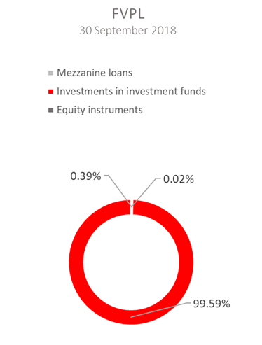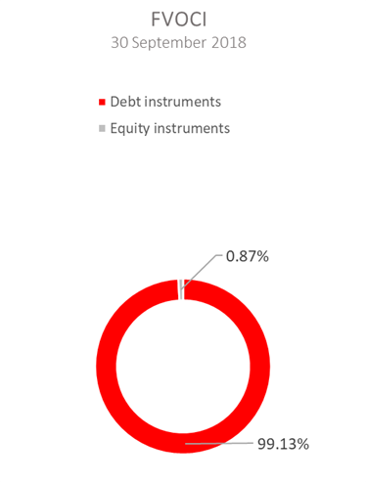

Total liabilities

As at 30 September 2018, total liabilities amounted to HRK 17,116.87 million, which represents 63.23 percent of total liabilities and total equity. The major part of total liabilities consists of HBOR’s foreign borrowings and bonds payable in the total amount of HRK 16,215.33 million.

Borrowings and bonds payable decreased by 2.02 percent compared with the beginning of the year, whereas changes in these liabilities are shown in the following table:

 | (in HRK millions)
- Draw-down of funds borrowed under previously contracted  funds of special financial institutions | 1,726.63
- Repayments of borrowings | (1,890.55)
- Foreign exchange gains or losses | (171.98)
- Other calculations* | 18.93
Total changes | (316.98)
*Other calculations relate to the changes in discount, amount of interest not due and deferred fees.

In 2018, HBOR continued to raise funds for specified purposes from special financial institutions and, on 6 March 2018, entered into a EUR 15.00 million Natural Capital Financing Facility (NCFF) deal with the European Investment Bank. NCFF is the financial instrument that combines the funds of the EIB and the funds of the European Commission under the LIFE Programme (Programme for the Environment and Climate Action) with an objective of providing support to projects expected to have a favourable impact on biodiversity and/or adaptation to climate change.

Furthermore, on 11 September 2018, the second contract was concluded with the European Investment Bank in the amount of EUR 40.00 million for the financing of projects in the tourism industry.

Total equity

Total equity amounted to HRK 9,951.99 million, representing 36.77 percent of total liabilities and total equity reserves.
The decrease of total equity as compared with the end of last year was also affected by the application of IFRS 9 since 1 January 2018 due to recording the effect of IFRS 9 at the expense of the retained earnings.

Total equity reserves of HBOR is comprised of the capital and the guarantee fund. HBOR’s capital is comprised of founder’s capital contributed from the budget of the Republic of Croatia, retained earnings from the profits generated in the previous years, other reserves and profits for the current year.

In the reporting period the amount of HRK 50.00 million was contributed from the budget of the Republic of Croatia into the founder’s capital, as planned in the 2018 budget. The total amount of capital contributed from the budget of the Republic of Croatia amounted to HRK 6,633.00 million, and the remaining amount to be contributed to the founder’s capital up to the total amount of HRK 7,000.00 million set by the HBOR Act is HRK 367.00 million.

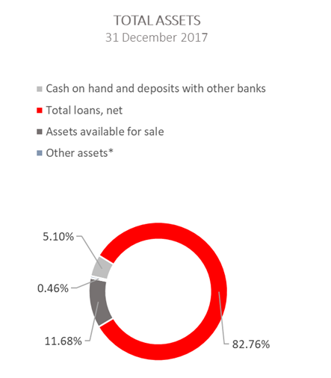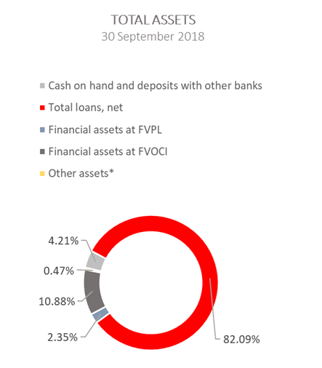

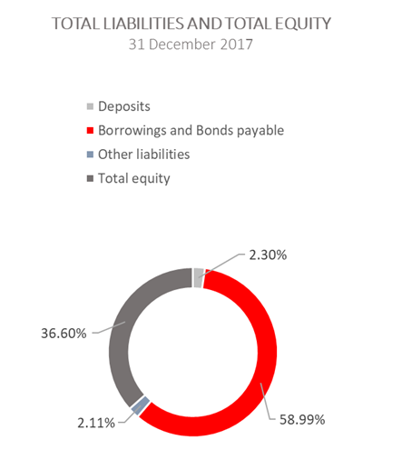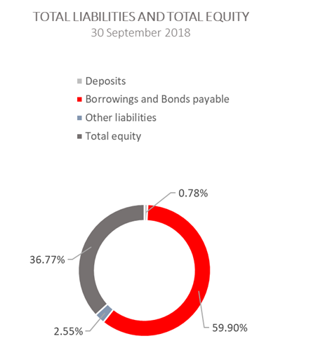

*Investments in subsidiaries, Property, plant and equipment and intangible assets, Non-current assets held for sale and Other assets

