REPORT ON FINANCIAL PERFORMANCE

FOR THE PERIOD 1 JANUARY – 31 MARCH 2019

Zagreb, May 2019

RESULTS OF THE GROUP

BREAKDOWN OF THE MOST SIGNIFICANT FINANCIAL INFORMATION OF hbor GROUP
-HRK million-

 | 31 December 2017 | 31 December 2018 | 31 March 2019
Total assets | 28,075.6 | 27,219.0 | 26,703.9
Gross loans | 26,333.0 | 26,243.1 | 27,122.4
Total equity | 10,275.8 | 10,061.1 | 10,093.6
 | 31 March 2017 | 31 March 2018 | 31 March 2019
Total income | 250.3 | 219.6 | 177.4
Total expense | (208.9) | (144.6) | (155.8)
Profit | 41.4 | 75.0 | 21.6
Interest income | 238.9 | 190.9 | 163.3
Interest expense | (108.1) | (84.5) | (81.8)
Net interest income | 130.8 | 106.4 | 81.5

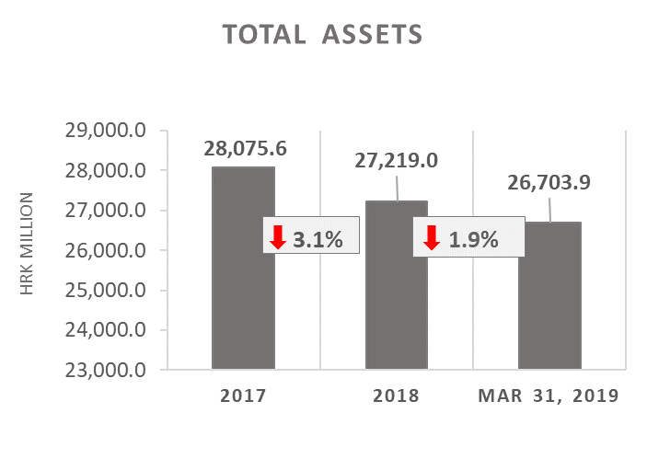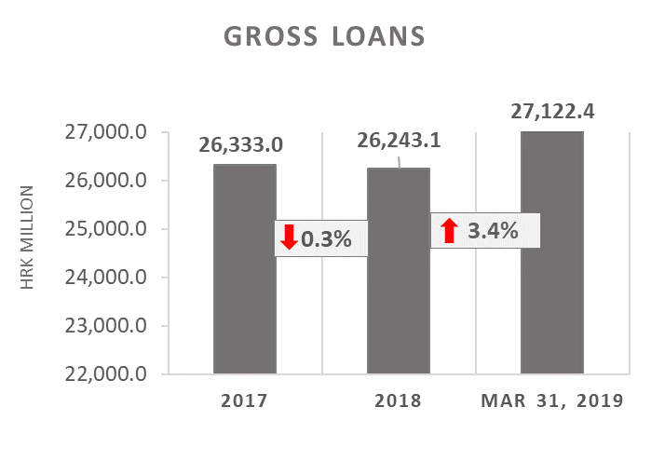

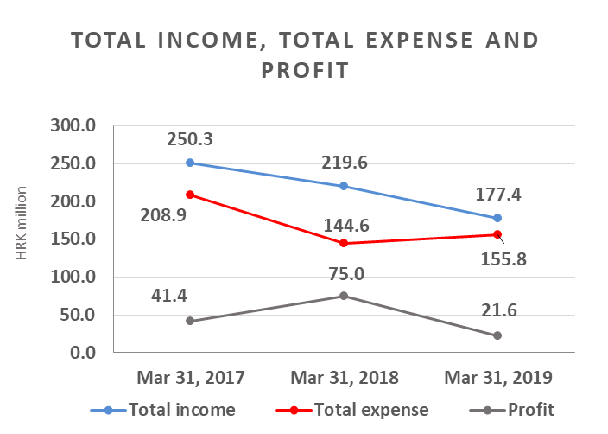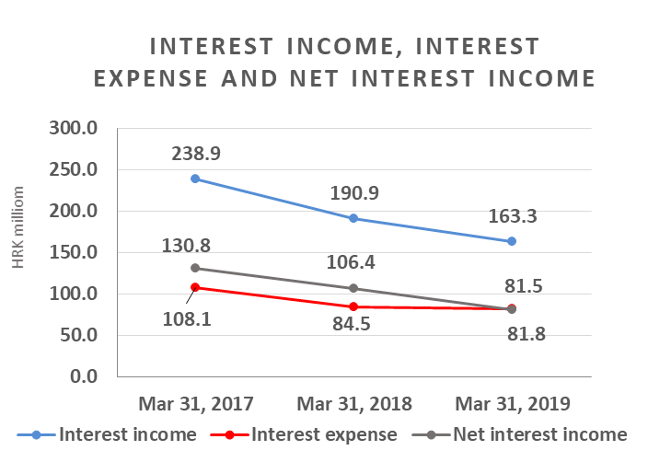

Results of the Group

In the period 1 January – 31 March 2019, the HBOR Group generated profit after tax in the amount of HRK 21.6 million.

Pursuant to the provisions of the Act on HBOR, the parent company is exempt from income tax and income tax liabilities arise exclusively from the activities of the other members of the Group.

In the period 1 January – 31 March 2019, total income on consolidated basis amounted to HRK 177.4 million, whereas total expenses amounted to HRK 155.8 million.

The consolidated total income decreased by 19.2 percent, whereas total expenses rose by 7.7 percent compared to the same period previous year due to the developments in total income and expenses of the parent company.

In the structure of income of the Group, the largest portion, i.e. 92.1 percent, relates to interest income as a result of operations of the parent company.

The major part of total expenses, i.e. 52.5 percent, relates to interest expenses arising from the operations of the parent company.

The consolidated operating expenses in the period 1 January – 31 March 2019 amounted to HRK 37.6 million and consisted of general and administrative expenses and other operating expenses.

On 31 March 2019, the Group had 387 employees (on 31 March 2018: 392 employees).

Assets and liabilities of the Group

Total assets of the Group on consolidated basis amount to HRK 26,703.9 million, a decrease of 1.9 percent compared with the beginning of the year. The reasons for such tendency are stated in the description of HBOR’s financial performance.

In the structure of assets, the major portion relates to the lending activities of the parent company, i.e. net loans account for 88.1 percent of total assets.

Total liabilities and total equity as at 31 March 2019 amount to HRK 26,703.9 million, of which amount total liabilities equal HRK 16,610.3 million, i.e. 62.2 percent.

In total liabilities and total equity of the Group, the major portion, i.e. 58.8 percent, consists of borrowings and bonds payable of the parent company.

At the end of the reporting period, total equity on consolidated basis amounted to HRK 10,093.6 million and accounted for 37.8 percent of total liabilities and total equity of the Group.

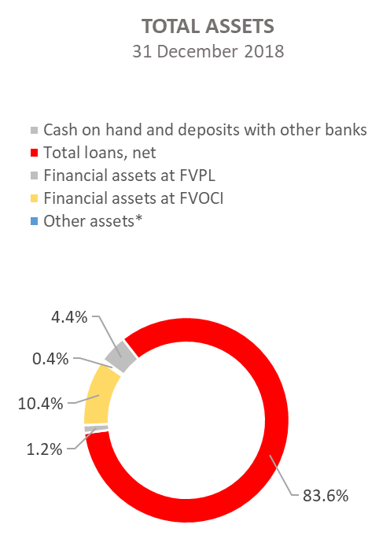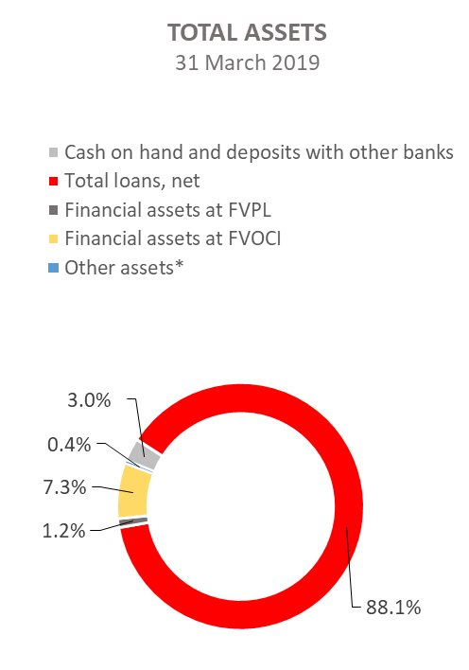

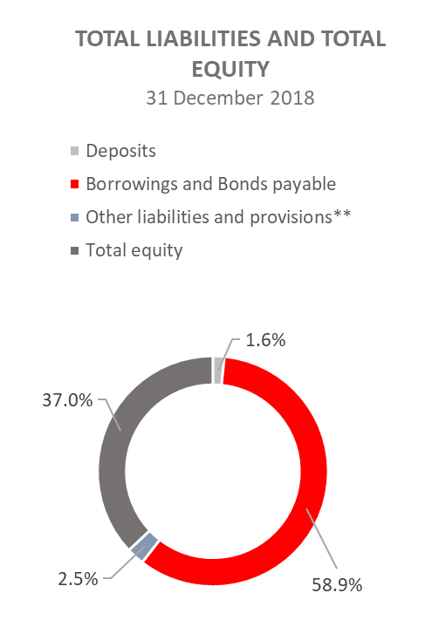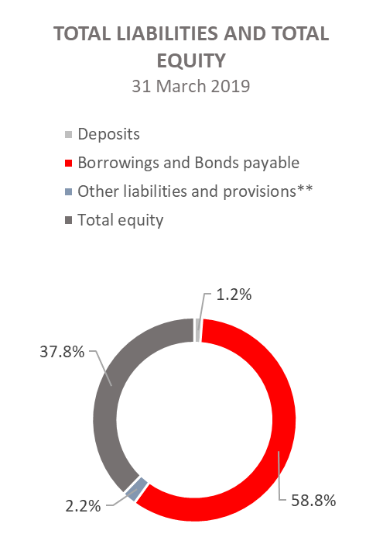
*Property, plant and equipment and intangible assets, Foreclosed assets, Debts securities at AC and Other assets.
**Provisioning includes provisioning for guarantees, commitments and other liabilities.

RESULTS OF HBOR

OVERVIEW OF FINANCIAL PERFORMANCE OF HBOR

The following text gives an overview and explanation of the significant changes in financial position and operating performance in the reporting period.

Financial performance

In the period from 1 January to 31 March 2019, HBOR generated total income of HRK 174.8 million, expenses of HRK 153.5 million and profit in the amount of HRK 21.3 million. HBOR’s profit generated in the reporting period decreased by HRK 53.1 million compared with the profit generated in the same period last year, i.e. by 71.4 percent.

Significantly lower profit in the reporting period compared with the same period last year is a result of decrease in total income by HRK 42.3 million and increase in total expenses by HRK 10.8 million. The circumstances that affected the financial result achieved in the three-month reporting period 2019 compared to the results generated in the same period in 2018 are:
- decrease in interest income of HRK 27.5 million, i.e. by 14.4 percent,
- decrease in interest expenses of HRK 2.6 million, i.e. by 3.1 percent compared with the same period last year,
- decrease in gains from financial activities of HRK 9.8 million, i.e. by 74.2 percent,
- increase in losses from impairment and provisions in the amount of HRK 9.9 million, i.e. by 37.9 percent,
- increase in operating expenses of HRK 3.5 million, i.e. by 11.0 percent,
- decrease in fee income of HRK 5.1 million, i.e. 41.8 percent.

A detailed description of trends is given for each category separately in the following text.

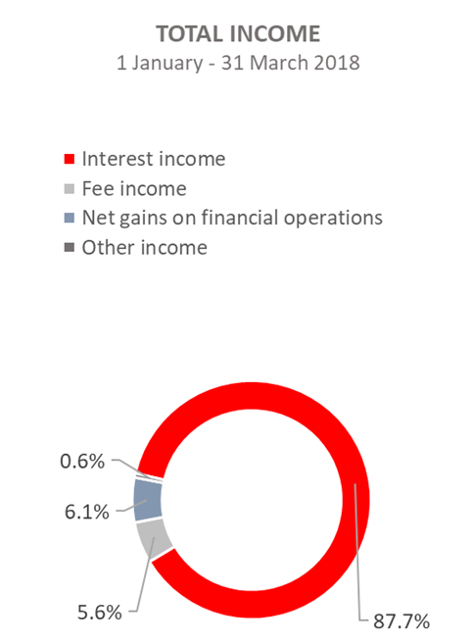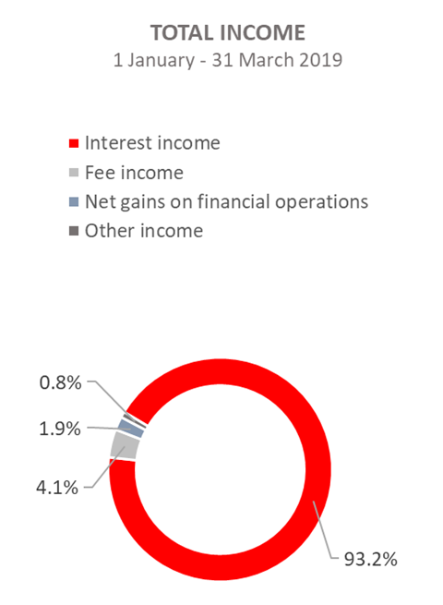

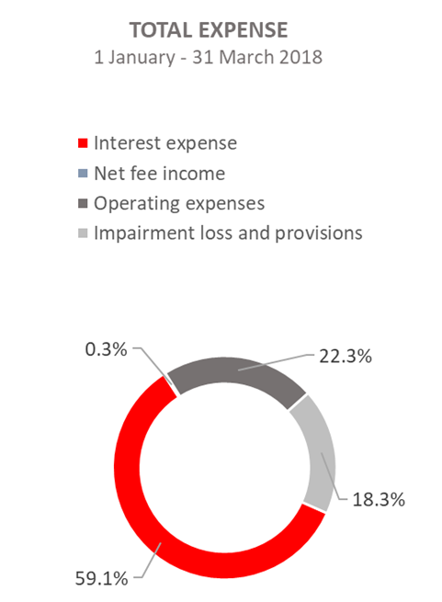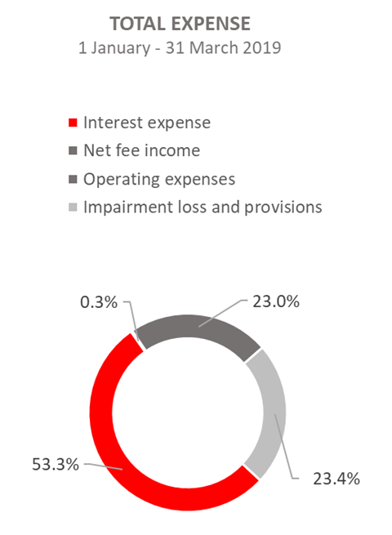

Net interest income

Net interest income amounted to HRK 81.2 million, a decrease of 23.5 percent on the same period of the previous reporting year.

Interest income amounted to HRK 163.0 million, a decrease of 14.4 percent on the same reporting period last year due to decreased interest income from long-term loans due to the long-term implementation of measures of interest rate reduction, reduction of interest income from interest rate subsidies, significant amounts of premature loan repayments in 2018 and the manner of recording of interest income from exposures classified to stage 3 and POCI assets (unwinding).
On this basis, from 1 January to 31 March 2019, interest income was reduced by HRK 8.7 million.

Interest expenses amounted to HRK 81.8 million, a decrease of 3.1 percent on the same reporting period last year.

Having in mind the described trends in interest income and interest expenses, net interest margin decreased compared with the same reporting period last year and stood at 1.2 percent as against 1.5 percent in the same reporting period last year.

Net fee income and commission income

Net fee and commission income amounted to HRK 6.7 million, a decrease of 43.2 percent compared with the same reporting period last year due to payments under the calls for guarantees issued, thus decreasing the exposure under guarantees issued.

Net gains/(losses) on financial operations

Net gains/(losses) on financial operations are comprised of net foreign exchange gains/(losses) on the principal amount of receivables and liabilities, net revenues or expenditures arising out of the loan contracts with embedded call option, gains/(losses) arising out of value adjustment of financial assets stated at fair value through profit or loss and realised gains/(losses) arising out of financial assets at fair value through other comprehensive income.

In the reporting period, net income on financial operations amounted to HRK 3.4 million, which is by 74.2 percent less than the generated net income on financial operations in the same period previous year.

A breakdown of changes in the exchange rate of HRK against the EUR and the USD:

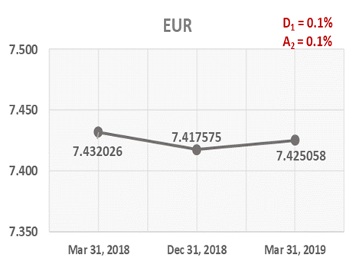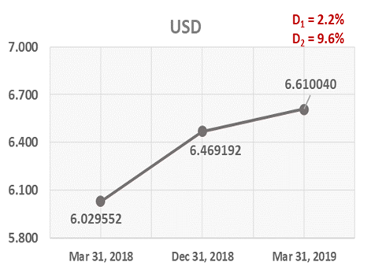

Note:
D₁ = HRK depreciation 31.3.2019/31.12.2018 D₁ = HRK depreciation 31.3.2019/31.12.2018
A₂ = HRK appreciation 31.3.2019/31.3.2018 D₂ = HRK depreciation 31.3.2019/31.3.2018

Foreign currency and foreign currency indexed assets and sources of funds are converted by HBOR into HRK equivalent value by applying the exchange rate of the Croatian National Bank valid at the reporting date.

Foreign currency revenues and expenditures are converted in accordance with the exchange rate at the transaction date. The resulting foreign exchange gains or losses are recorded in the Profit or Loss Account in net figures.

Operating expenses

Operating expenses that include general and administrative expenses and other operating expenses stood at HRK 35.3 million, an increase of 11.0 percent compared with the same reporting period last year, mostly due to an increase in general and administrative expenses of HRK 2.8 million.

On 31 March 2019, HBOR had 367 employees (on 31 March 2018: 374 employees).

Impairment gain/(loss) and provisions

In the reporting period, net expenses from the impairment of placements stood at HRK 36.0 million.

The text to follow contains a breakdown of portfolio quality:

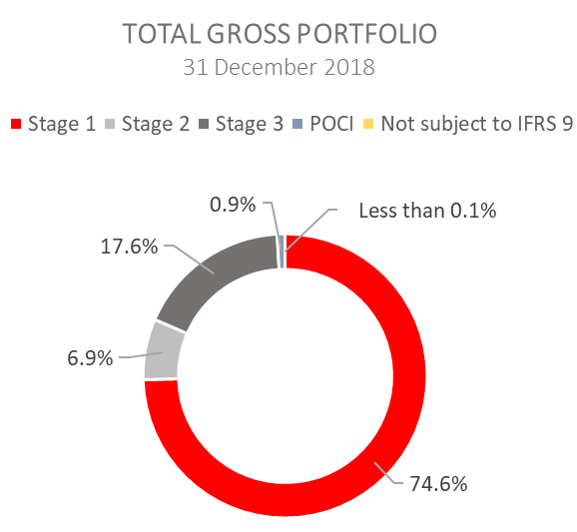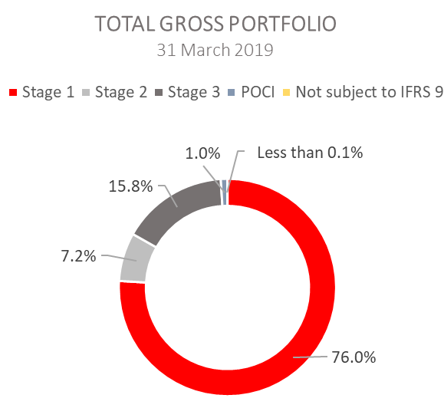

.

 | 31 December 2018 |  | 31 March 2019
 | In HRK millions | Breakdown (percent) | In HRK millions | Breakdown (percent)
Total gross portfolio | 35,808.1 | 100.00 | 35,430.0 | 100.00
Of which:
- financial institutions | 13,194.5 | 36.8 | 13,280.3 | 37.5
- direct | 22,613.6 | 63.2 | 22,149.7 | 62.5
Total provisions | 3,795.6 | 100.00 | 3,814.1 | 100.00
Of which:
- financial institutions | 122.6 | 3.2 | 117.4 | 3.1
- direct | 3,673.0 | 96.8 | 3,696.7 | 96.9
Provisions/gross portfolio | 10.6 percent | - | 10.8 percent | -

Significant changes in financial position

Total assets of HBOR as at 31 March 2019 amounted to HRK 26,682.6 million, a decrease of 1.9 percent compared with 31 December 2018, mostly due to repayment of obligations.

Cash on hand and deposits with other banks

As at 31 March 2019, cash on hand and deposits with other banks amounted to HRK 798.1 million representing 3.0 percent of total assets, a decrease of 33.7 percent compared with 31 December 2018 as a result of reallocation of liquidity reserve funds.

Loans to financial institutions and other customers

As at 31 March 2019, total net loans amounted to HRK 23,513.6 million representing 88.1 percent of total assets, an increase 3.4 percent on the beginning of the year.

Total gross loans amounted to HRK 27,122.4 million, an increase of 3.4 percent compared with 31 December 2018. Gross loans to other customers increased by 5.3 percent compared with the end of 2018. Gross loans to financial institutions were retained at the level generated in 2018.

Financial assets at fair value through profit or loss

Loans at fair value (HBOR has determined that mezzanine loans are classified here), investments in investment funds (obligatory pursuant to IFRS) and a part of equity instruments are classified to these assets. As at 31 March 2019, the total amount of these assets was HRK 332.0 million representing 1.2 percent of total assets.

Financial assets at fair value through other comprehensive income

a) Debt instruments

Bonds of the Republic of Croatia and treasury bills of the Ministry of Finance as part of liquidity reserve as well as bonds of a company are classified to these assets. On the reporting date, they amounted to HRK 1,880.9 million, representing 7.0 percent of total assets. The impairment of these financial assets is calculated through the application of the model of expected credit losses in the manner that provisions are recognised in the accounts of other comprehensive income, thus not reducing the carrying amount of these financial assets in the statement on financial position. On the reporting date, they amounted to HRK 4,9 million in other reserves.

b) Equity instruments

Equity instruments (shares of companies) that HBOR does not intend to sell and to which irrevocable option of subsequent measurement of fair value through other comprehensive income without recycling is applied are classified to these assets, i.e. reserves recognised under other comprehensive income will never be transferred to the statement on profit or loss.
On the reporting date, these assets amounted to HRK 25.7 million, representing 0.1 percent of total assets.

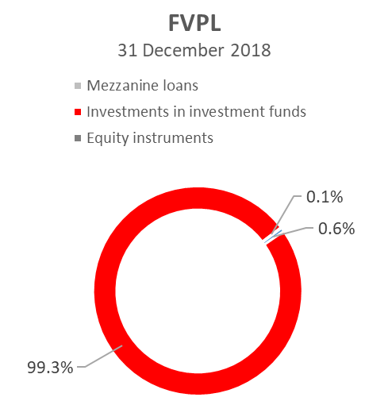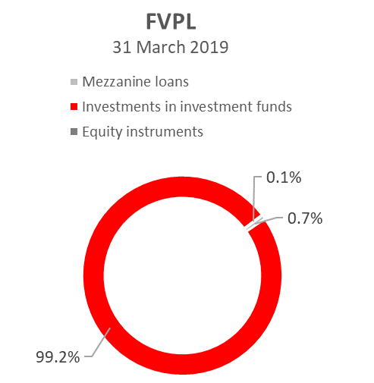
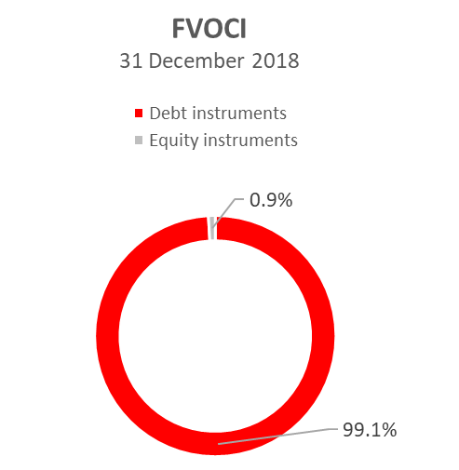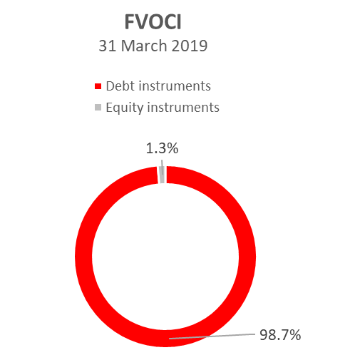

Total liabilities

As at 31 March 2019, total liabilities amounted to HRK 16,597.0 million, which represents 62.2 percent of total liabilities and total equity. The major part of total liabilities consists of HBOR’s foreign borrowings and bonds payable in the total amount of HRK 15,690.4 million.

Borrowings and bonds payable decreased by 2.1 percent compared with the beginning of the year, whereas changes in these liabilities are shown in the following table:

 | (in HRK millions)
- Draw-down of funds borrowed under previously contracted  funds of special financial institutions | 449.1
- Repayments of borrowings | (848.6)
- Foreign exchange gains or losses | 29.3
- Other calculations * | 32.1
Total changes | (338.1)
* Other calculations relate to the changes in discount, amount of interest not due and deferred fees.

Total equity
Total equity amounted to HRK 10,085.6 million, representing 37.8 percent of total liabilities and total equity.

Total equity of HBOR is comprised of the capital and the guarantee fund. HBOR’s capital is comprised of founder’s capital contributed from the budget of the Republic of Croatia, retained earnings from the profits generated in the previous years, other reserves and profits for the current year.

By the end of the reporting period, the total amount of capital contributed from the budget of the Republic of Croatia amounted to HRK 6,633.00 million, and the remaining amount to be contributed to the founder’s capital up to the total amount of HRK 7,000.00 million set by the HBOR Act is HRK 367.00 million. The planned contribution in 2019 is HRK 50.0 million.

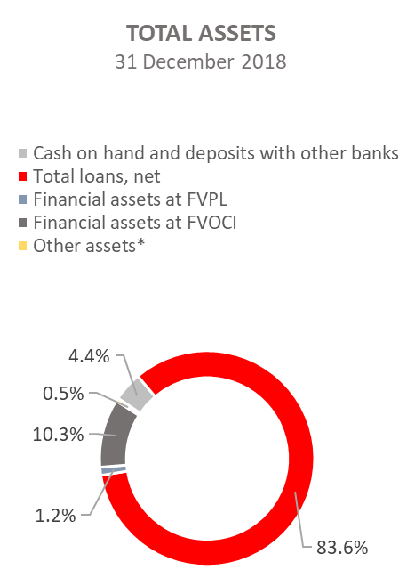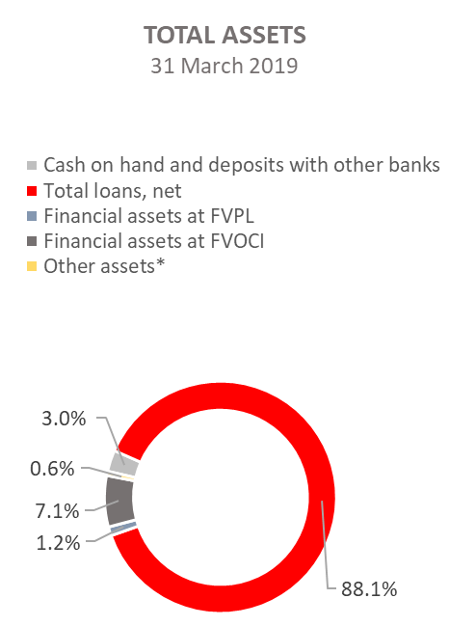

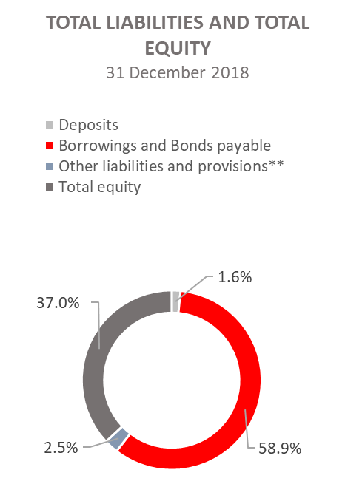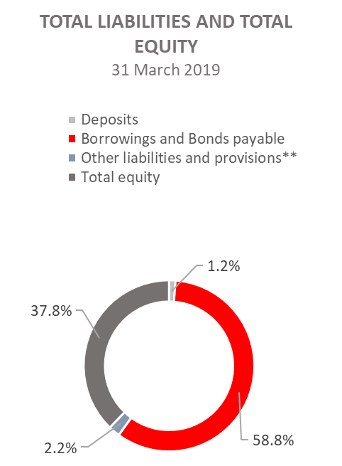

*Investments in subsidiaries, Property, plant and equipment and intangible assets, Foreclosed assets and Other assets.
** Provisioning includes provisioning for guarantees, commitments and other liabilities.

