REPORT ON FINANCIAL PERFORMANCE

FOR THE PERIOD 1 JANUARY – 31 MARCH 2021

Zagreb, May 2021

RESULTS OF THE GROUP

BREAKDOWN OF THE MOST SIGNIFICANT FINANCIAL INFORMATION OF hbor GROUP
-HRK million-

 | 31 December 2019 | 31 December 2020 | 31 March 2021
Total assets | 26,470.6 | 28,706.5 | 29,450.5
Gross loans | 26,571.1 | 27,197.3 | 27,287.1
Total equity | 10,274.6 | 10,363.7 | 10,446.4
 | 1 January –  31 March 2019 | 1 January –  31 March 2020 | 1 January –  31 March 2021
Total income | 177.4 | 170.3 | 193.9
Total expense | (155.8) | (148.1) | (105.3)
Profit | 21.6 | 22.2 | 88.6
Interest income calculated on the basis of effective interest rate method | 163.3 | 160.5 | 170.1
Interest expense | (81.8) | (72.8) | (49.8)
Net interest income | 81.5 | 87.7 | 120.3

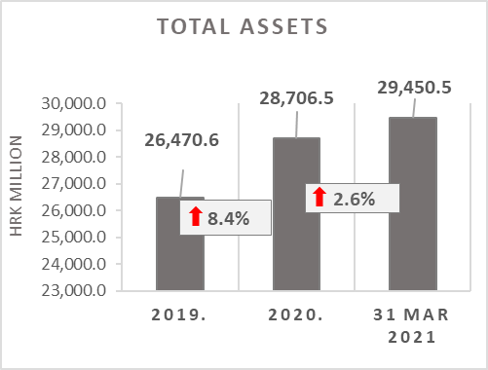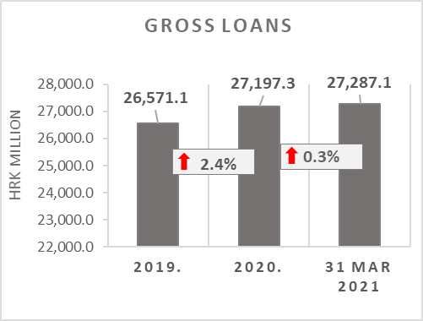

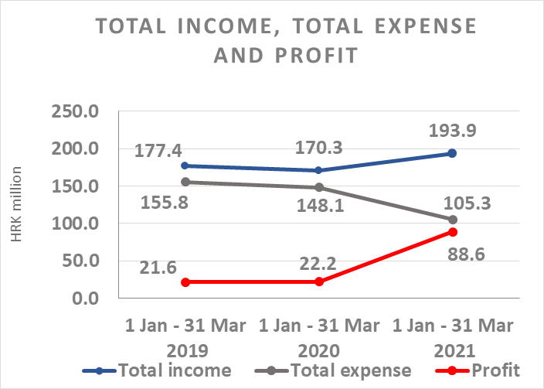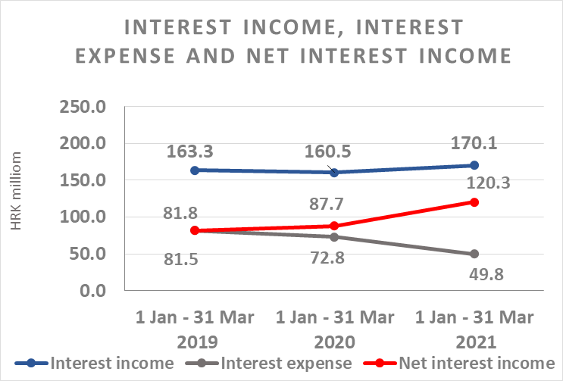

Results of the Group

In the period 1 January – 31 March 2021, the HBOR Group generated profit after tax in the amount of HRK 88.6 million.

Pursuant to the provisions of the Act on HBOR, the parent company is exempt from income tax and income tax liabilities arise exclusively from the activities of the other members of the Group.

In the period 1 January – 31 March 2021, total income on consolidated basis amounted to HRK 193.9 million, whereas total expenses amounted to HRK 105.3 million.

The consolidated total income increased by 13.9 percent, whereas total expenses decreased by 28.9 percent compared to the same period previous year due to the developments in total income and expenses of the parent company.

In the structure of income of the Group, the largest portion, i.e. 87.7 percent, relates to interest income as a result of operations of the parent company.

The major part of total expenses, i.e. 47.3 percent, relates to interest expenses arising from the operations of the parent company.

The consolidated operating expenses in the period 1 January – 31 March 2021 amounted to HRK 47.2 million and consisted of general and administrative expenses and other operating expenses.

On 31 March 2021, the Group had 377 employees (on 31 March 2020: 394 employees).

Assets and liabilities of the Group

Total assets of the Group on consolidated basis amount to HRK 29,450.5 million, an increase of 2.6 percent compared with the beginning of the year. The reasons for such tendency are stated in the description of HBOR’s financial performance.

In the structure of assets, the major portion relates to the lending activities of the parent company, i.e. net loans account for 80.9 percent of total assets.

Total liabilities and total equity as at 31 March 2021 amount to HRK 29,450.5 million, of which amount total liabilities equal HRK 19,004.1 million, i.e. 64.5 percent.

In total liabilities and total equity of the Group, the major portion, i.e. 56.6 percent, consists of borrowings of the parent company.

At the end of the reporting period, total equity on consolidated basis amounted to HRK 10,446.4 million and accounted for 35.5 percent of total liabilities and total equity of the Group.

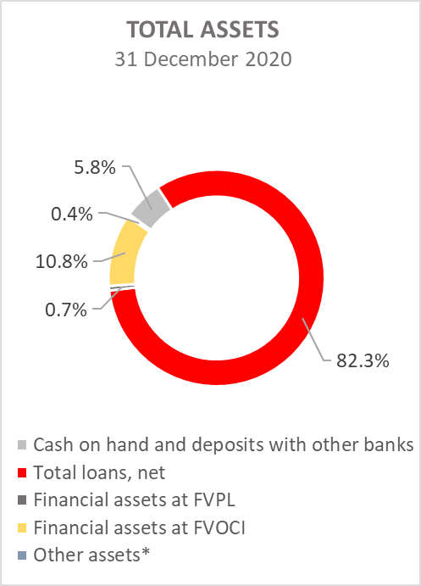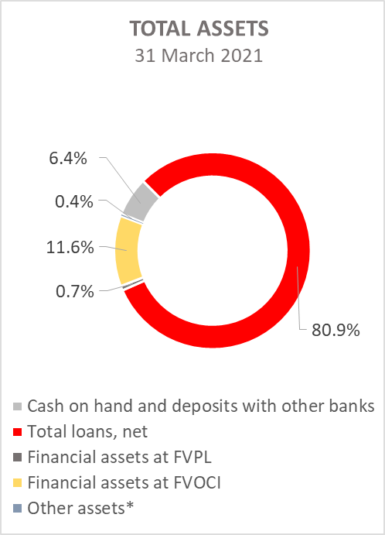

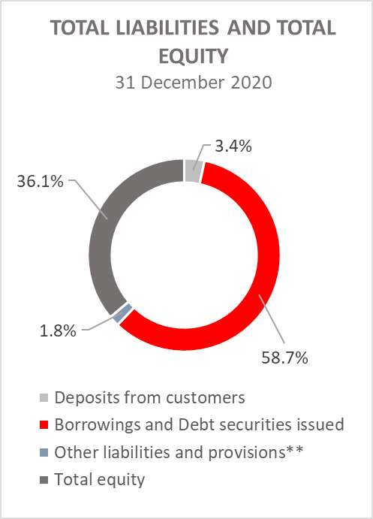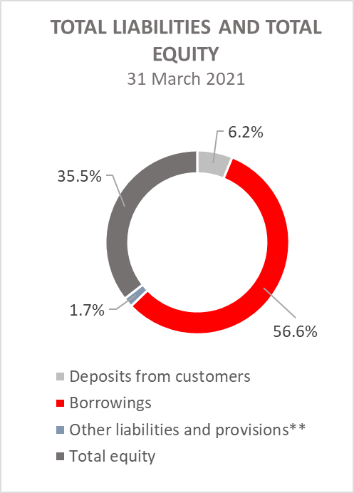
*Property, plant and equipment and intangible assets, Foreclosed assets, Debts securities at AC and Other assets.
**Other liabilities, Provisioning for guarantees, commitments and other liabilities.

RESULTS OF HBOR

OVERVIEW OF FINANCIAL PERFORMANCE OF HBOR

The following text gives an overview and explanation of the significant changes in financial position and operating performance in the reporting period.

Financial performance

In the period from 1 January to 31 March 2021, HBOR generated total income of HRK 191.0 million, expenses of HRK 103.2 million and profit in the amount of HRK 87.8 million. HBOR’s profit generated in the reporting period increased by HRK 66.0 million compared with the profit generated in the same period last year, i.e. by 302.8 percent.

The increase in profit in the period from 1 January to 31 March 2021 compared with the same period last year is a result of a increase in total income by HRK 23.3 million and a decrease in total expenses by HRK 42.7 million.

The circumstances that affected the financial result achieved in the three-month reporting period 2021 compared to the results generated in the same period in 2020 are:

- (+) increase in interest income of HRK 9.6 million, i.e. by 6.0 percent,
- (+) decrease in interest expenses of HRK 22.9 million, i.e. by 31.5 percent,
- (-) decrease in net income from fees and commissions of HRK 0.9 million, i.e. by 18.0 percent,
- (+) reduction of realized net expenses from financial activities by HRK 13.8 million,
- (-) increase in operating expenses of HRK 8.9 million,
- (+) decrease in losses from impairment and provisions in the amount of HRK 27.2 million compared with the same period 2020,
- (+) increase in other income of HRK 2.3 million.

A detailed description of trends is given for each category separately in the following text.

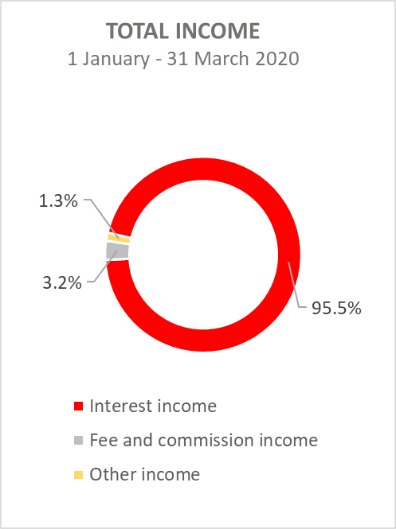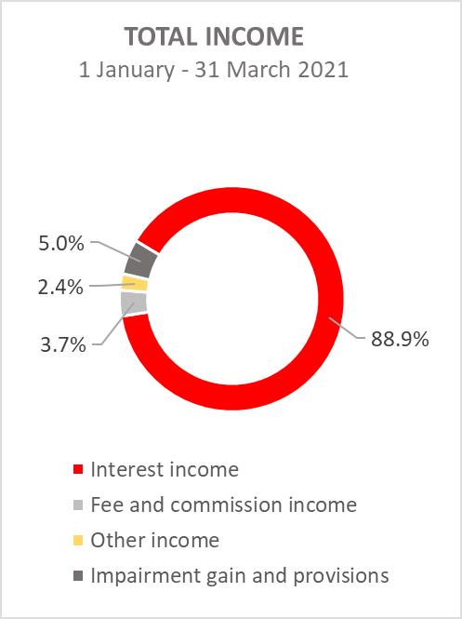

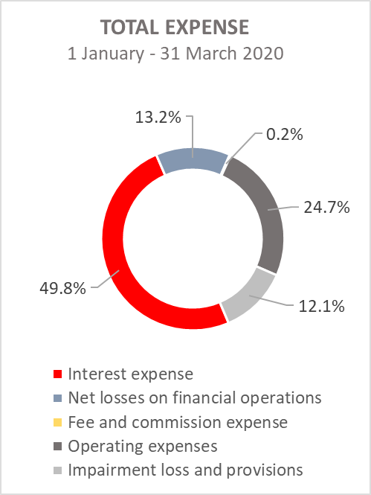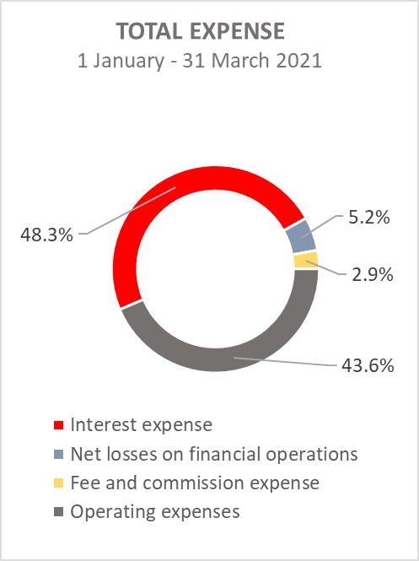

Net interest income

Net interest income amounted to HRK 120.0 million, an increase of 37.1 percent on the same period of the previous reporting year.

Interest income amounted to HRK 169.8 million, an increase of 6.0 percent compared to the same reporting period of the previous year due to the one-time effect of the implementation of the debtor's pre-bankruptcy settlement.

Interest expenses amounted to HRK 49.8 million, a decrease of 31.5 percent on the same reporting period last year, due to the repayment of loans and bonds payable (payment of bonds in May 2020).

Given the described trends, the decrease in interest expenses and the increase in interest income affected the increase in net interest margin compared to the same reporting period of the previous year that amounts to 1.65 percent, while in the same period of the previous year it amounted to 1.32 percent.

Net fee income and commission income

Net fee and commission income amounted to HRK 4.1 million, an decrease of 18.0 percent compared with the same reporting period last year due to a larger increase in fee and commission expenses (by HRK 2.7 million) compared to the increase in fee and commission income (by HRK 1.8 million).

Net gains/(losses) on financial operations

Net gains/(losses) on financial operations are comprised of net foreign exchange gains/(losses) on the principal amount of receivables and liabilities, net revenues or expenditures arising out of the loan contracts with embedded call option, gains/(losses) arising out of value adjustment of financial assets stated at fair value through profit or loss and realised gains/(losses) arising out of financial assets at fair value through other comprehensive income.

In the reporting period, net losses from financial activities amounted to HRK 5.4 million, whereas, in the same reporting period previous year, net losses amounted to HRK 19.2 million.

A breakdown of changes in the exchange rate of HRK against the EUR and the USD:

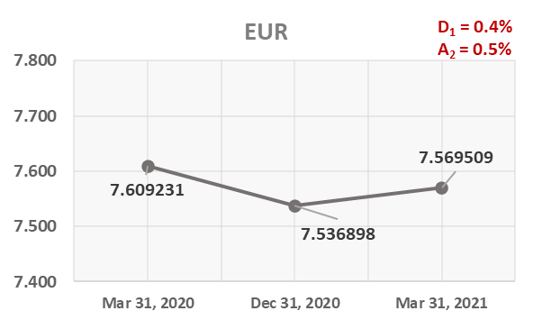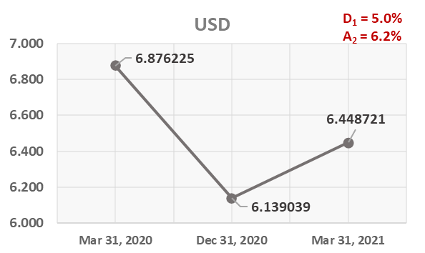

Note:
D₁ = HRK depreciation 31.3.2021/31.12.2020 D₁ = HRK depreciation 31.3.2021/31.12.2020
A₂ = HRK appreciation 31.3.2021/31.3.2020 A₂ = HRK appreciation 31.3.2021/31.3.2020

Foreign currency and foreign currency indexed assets and sources of funds are converted by HBOR into HRK equivalent value by applying the exchange rate of the Croatian National Bank valid at the reporting date.

Foreign currency revenues and expenditures are converted in accordance with the exchange rate at the transaction date. The resulting foreign exchange gains or losses are recorded in the Profit or Loss Account in net figures.

Operating expenses

Operating expenses that include general and administrative expenses and other operating expenses stood at HRK 45.0 million, a increase of 24.7 percent compared with the same reporting period last year, mainly due to a increase in recalculation and write-offs under financial instruments by HRK 8.1 million.

On 31 March 2021, HBOR had 356 employees (on 31 March 2020: 374 employees).

Impairment gain/(loss) and provisions

In the reporting period, a net gain from impairment of placements in the amount of HRK 9.6 million was recorded.

The text to follow contains a breakdown of portfolio quality:

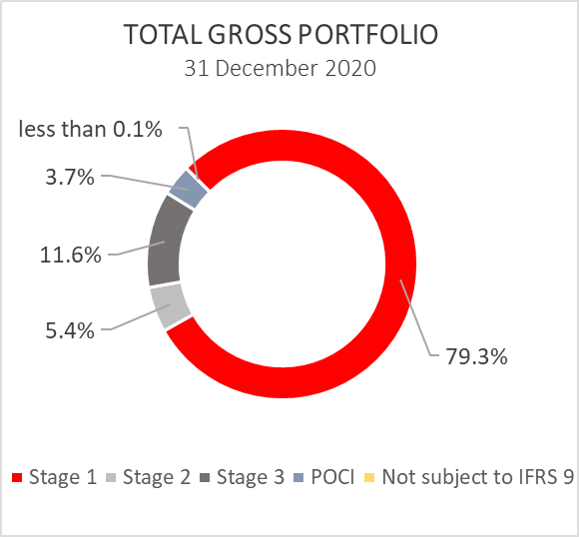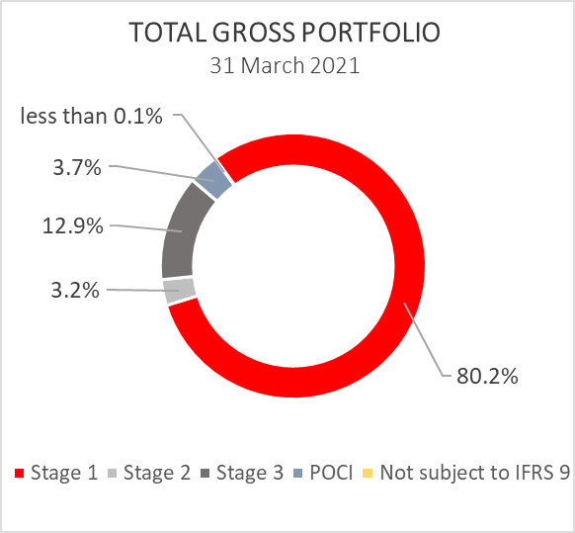

 | 31 December 2020 |  | 31 March 2021
 | In HRK millions | Breakdown  (percent) | In HRK millions | Breakdown  (percent)
Total gross portfolio | 37,401.3 | 100.0 | 38,319.9 | 100.0
Of which:
- financial institutions | 13,728.6 | 36.7 | 13,950.1 | 36.4
- direct | 23,672.7 | 63.3 | 24,369.8 | 63.6
Total provisions | 3,640.1 | 100.0 | 3,561.3 | 100.0
Of which:
- financial institutions | 93.0 | 2.6 | 85.0 | 2.4
- direct | 3,547.2 | 97.4 | 3,476.3 | 97.6
Provisions/gross portfolio | 9.7 percent |  | 9.3 percent

Significant changes in financial position

Total assets of HBOR as at 31 March 2021 amounted to HRK 29,425.5 million, an increase of 2.6 percent compared with 31 December 2020 due to short-term deposits received.

Cash on hand and deposits with other banks

As at 31 March 2021, cash on hand and deposits with other banks amounted to HRK 1,876.8 million representing 6.4 percent of total assets, an increase of 13.0 percent compared with 31 December 2020 as a result of reallocation of liquidity reserve funds.

Loans to financial institutions and other customers

As at 31 March 2021, total net loans amounted to HRK 23,823.4 million representing 81.0 percent of total assets, an increase 0.8 percent on the beginning of the year.

Total gross loans amounted to HRK 27,287.1 million, stood at the same level compared with the end of 2020. Gross loans to other customers increased by 2.4 percent compared with the end of 2020, while gross loans to financial institutions decreased by 3.9 percent compared with the end of 2020.
As at 31 March 2021, the proportion between gross loans on-lent through financial institutions and direct placements stood at 31 percent : 69 percent ( 31 December 2020: 33 percent : 67 percent).

Financial assets at fair value through profit or loss

Loans at fair value (HBOR has determined that mezzanine loans are classified here), investments in investment funds and a part of equity instruments are classified to these assets. As at 31 March 2021, the total amount of these assets was HRK 218.8 million representing 0.7 percent of total assets.

Financial assets at fair value through other comprehensive income

a) Debt instruments

These assets include bonds of the Republic of Croatia and treasury bills of the Ministry of Finance as part of the liquidity reserve, as well as corporate bonds. On the reporting date, they amount to HRK 3,340.9 million and account for 11.4 percent of total assets, an increase of 10.4 percent compared to the beginning of the year as a result of the reallocation of the liquidity reserve.
The impairment of these financial assets is calculated through the application of the model of expected credit losses in the manner that provisions are recognised in the accounts of other comprehensive income, thus not reducing the carrying amount of these financial assets in the statement on financial position. On the reporting date, they amounted to HRK 4.8 million in other reserves.
b) Equity instruments

Equity instruments (shares of companies) that HBOR does not intend to sell and to which irrevocable option of subsequent measurement of fair value through other comprehensive income without recycling is applied are classified to these assets, i.e. reserves recognised under other comprehensive income will never be transferred to the statement on profit or loss.
On the reporting date, these assets amounted to HRK 26.8 million, representing 0.1 percent of total assets.

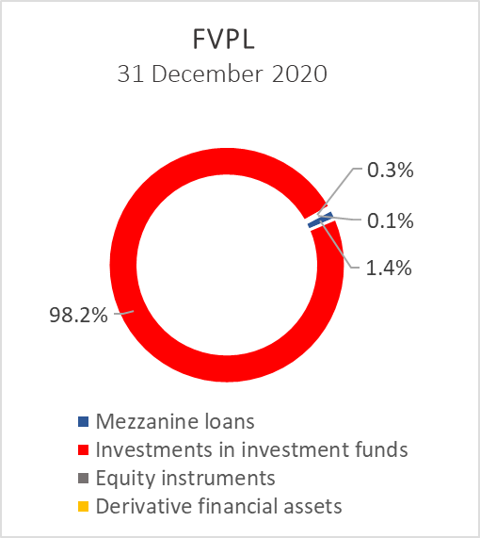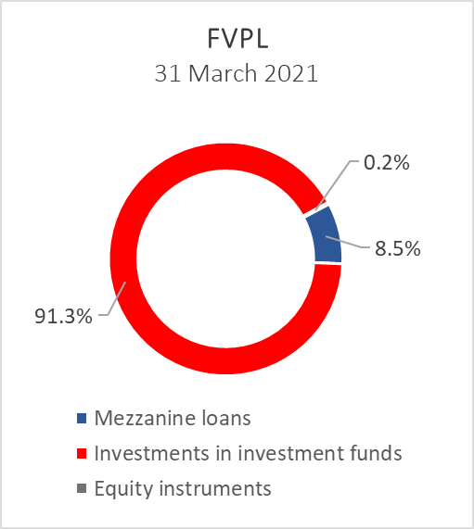

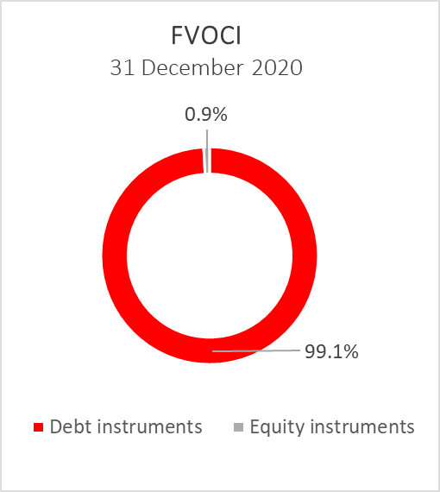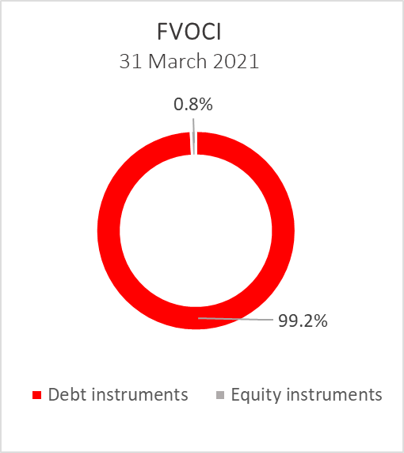

Total liabilities

As at 31 March 2021, total liabilities amounted to HRK 18,988.5 million, which represents 64.5 percent of total liabilities and total equity. The major part of total liabilities consists of HBOR’s borrowings in the total amount of HRK 16,659.9 million.

Borrowings decreased by 1.2 percent compared with the beginning of the year, whereas changes in these liabilities are shown in the following table:

 | (in HRK millions)
- Draw-down of funds borrowed under previously contracted  funds of special financial institutions | 346.4
- Repayments of borrowings | (636.1)
- Foreign exchange gains or losses | 74.6
- Other calculations * | 11.0
Total changes | (204.1)
* Other calculations relate to the changes in discount, amount of interest not due and deferred fees.

Total equity
Total equity amounted to HRK 10,437.0 million, representing 35.5 percent of total liabilities and total equity.

Total equity of HBOR is comprised of the capital and the guarantee fund. HBOR’s capital is comprised of founder’s capital contributed from the budget of the Republic of Croatia, retained earnings from the profits generated in the previous years, other reserves and profits for the current period.

In the period from 1 January to 31 March 2021 there were no payments from the State Budget of the Republic of Croatia to the founder’s capital of HBOR. The planned contribution in 2021 is HRK 50.0 million.

The total amount of capital contributed from the budget of the Republic of Croatia stood at HRK 6,708.0 million, and the remaining amount to be contributed to the founder’s capital up to the total amount of HRK 7,000.0 million set by the HBOR Act is HRK 292.0 million.

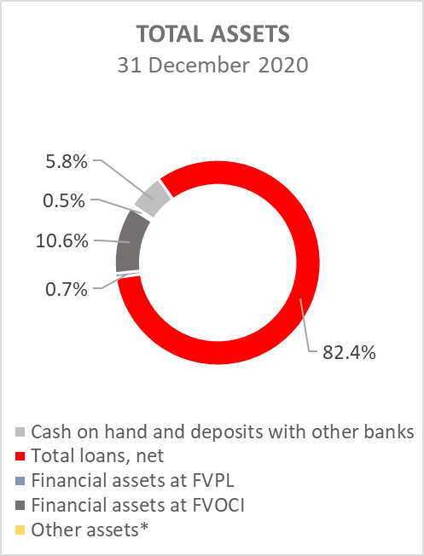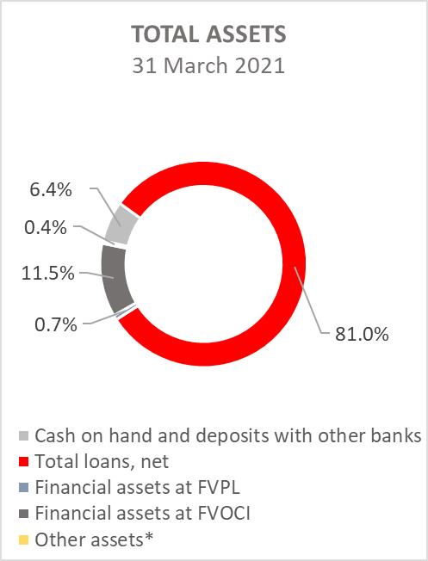

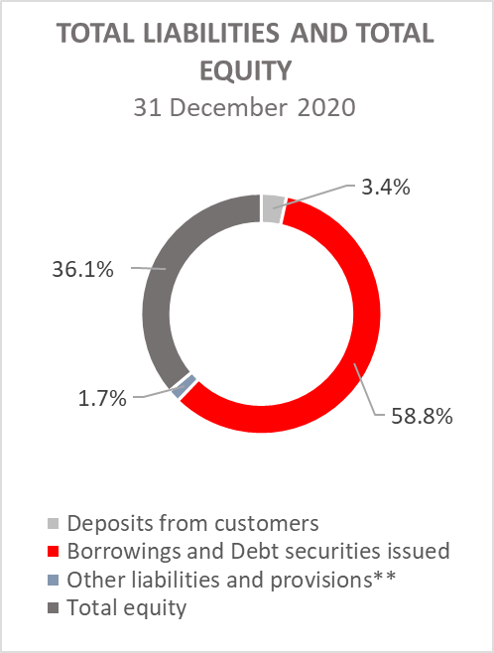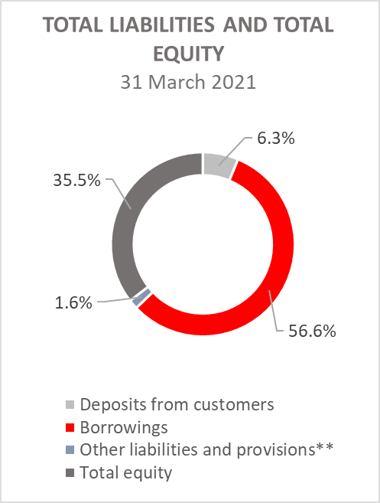

*Investments in subsidiaries, Property, plant and equipment and intangible assets, Foreclosed assets and Other assets.
**Other liabilities, Provisioning for guarantees, commitments and other liabilities.

