

**REPORT ON FINANCIAL PERFORMANCE**

**FOR THE PERIOD 1 JANUARY – 30 SEPTEMBER 2022**

**Zagreb, November 2022**

**RESULTS OF THE GROUP**

**BREAKDOWN OF THE MOST SIGNIFICANT FINANCIAL INFORMATION OF hbor GROUP**

-HRK million-

|  |  |  |  |
| --- | --- | --- | --- |
|  | **2020** | **2021** | **30 September 2022** |
| **Total assets** | 28,706.5 | 28,278.4 | 27,554.9 |
| **Gross loans** | 27,197.3 | 26,329.3 | 26,184.0 |
| **Total equity** | 10,363.8 | 10,576.8 | 10,902.7 |
|  | **1 January – 30 September 2020** | **1 January – 30 September 2021** | **1 January – 30 September 2022** |
| **Total income** | 495.0 | 542.1 | 530.0 |
| **Total expense** | (437.3) | (299.6) | (385.1) |
| **Profit** | 57.7 | 242.5 | 144.9 |
| **Interest income calculated on the basis of effective interest rate method** | 465.3 | 491.7 | 476.1 |
| **Interest expense** | (189.6) | (141.5) | (117.9) |
| **Net interest income** | 275.7 | 350.2 | 358.2 |

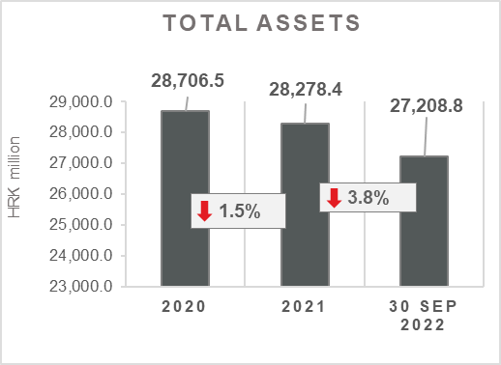 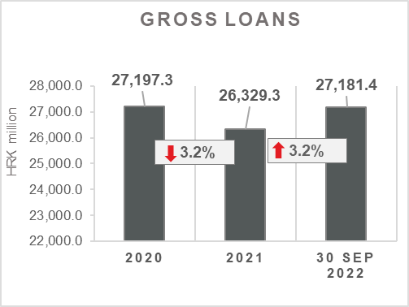

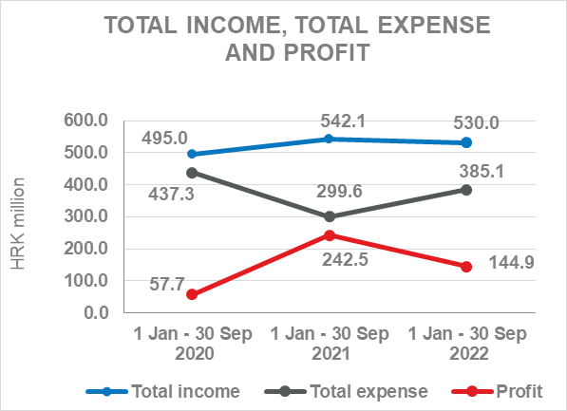 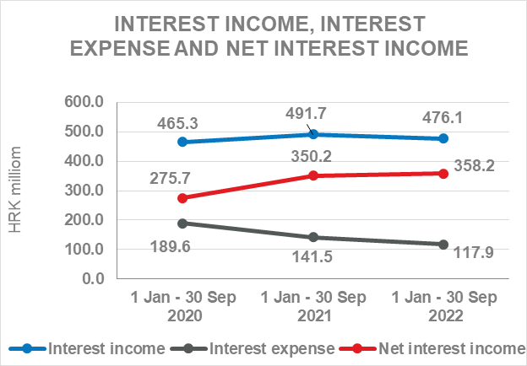

**Results of the Group**

In the period 1 January – 30 September 2022, the HBOR Group generated profit after tax in the amount of HRK 144.9 million.

Pursuant to the provisions of the Act on HBOR, the parent company is exempt from income tax and income tax liabilities arise exclusively from the activities of the other members of the Group.

In the period 1 January – 30 September 2022, total income on consolidated basis amounted to HRK 530.0 million, whereas total expenses amounted to HRK 385.1 million.

The consolidated total income decreased by 2.2 percent, whereas total expenses increased by 28.5 percent compared to the same period previous year due to the developments in total income and expenses of the parent company.

In the structure of income of the Group, the largest portion, i.e. 89.8 percent, relates to interest income as a result of operations of the parent company.

In the part of total expenses, the major part relates to operating expenses (39.9 percent) and interest expenses (30.6 percent) arising from the operations of the parent company.

The consolidated operating expenses in the period 1 January – 30 September 2022 amounted to HRK 153.8 million and consisted of general and administrative expenses and other operating expenses.

On 30 September 2022, the Group had 397 employees (on 30 September 2021: 386 employees).

**Assets and liabilities of the Group**

Total assets of the Group on consolidated basis amount to HRK 27,208.8 million, a decrease of 3.8 percent compared with the beginning of the year. The reasons for such tendency are stated in the description of HBOR’s financial performance.

In the structure of assets, the major portion relates to the lending activities of the parent company, i.e. net loans account for 87.0 percent of total assets.

Total liabilities and total equity as at 30 September 2022 amount to HRK 27,208.8 million, of which amount total liabilities equal HRK 16,560.1 million, i.e. 60.9 percent.

In total liabilities and total equity of the Group, the major portion, i.e. 56.6 percent, consists of borrowings of the parent company.

At the end of the reporting period, total equity on consolidated basis amounted to HRK 10,648.7 million and accounted for 39.1 percent of total liabilities and total equity of the Group.

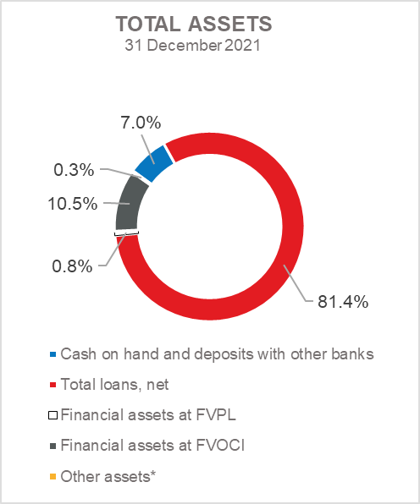 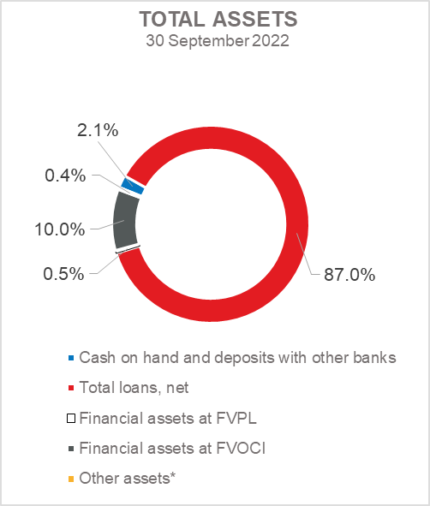

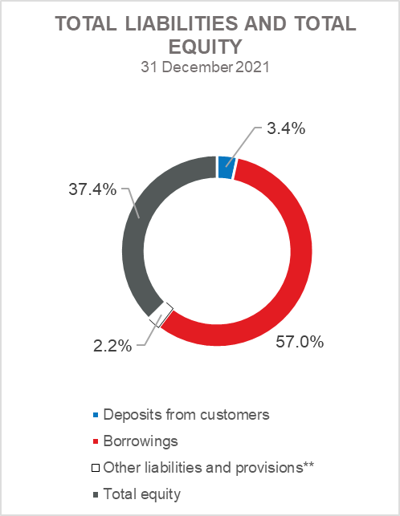 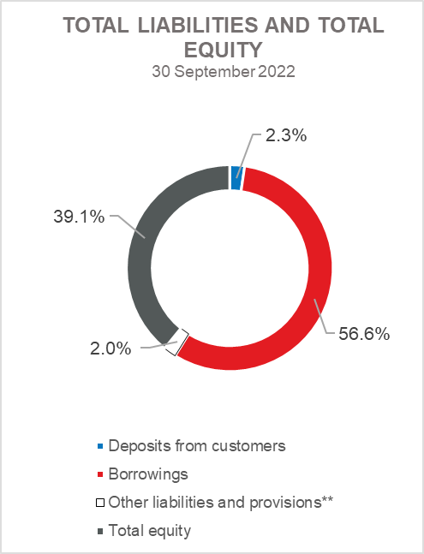

*Property, plant and equipment and intangible assets, Foreclosed assets, Debt securities at AC and Other assets.

**Provisioning includes provisioning for guarantees, commitments and other liabilities.

**RESULTS OF HBOR**

**OVERVIEW OF FINANCIAL PERFORMANCE OF HBOR**

The following text gives an overview and explanation of the significant changes in financial position and operating performance in the reporting period.

**Financial performance**

In the period from 1 January to 30 September 2022, HBOR generated total income of HRK 518.2 million, expenses of HRK 376.6 million and profit in the amount of HRK 141.6 million. HBOR’s profit generated in the reporting period decreased by HRK 99.2 million compared with the profit generated in the same period last year.

The decrease in profit in the period from 1 January to 30 September 2022 compared with the same period last year is a result of a decrease in total income by HRK 14.8 million and an increase in total expenses by HRK 84.4 million.

The circumstances that affected the financial result achieved in the nine-month reporting period 2022 compared to the results generated in the same period in 2021 are:

* (-) decrease in interest income of HRK 15.6,
* (+) decrease in interest expenses of HRK 23.5 million,
* (-) decrease in net income from fees and commissions of HRK 4.0 million,
* (+) increase in net gains from financial activities in the amount of HRK 22.1 million (in the period from 1 January to 30 September 2022 net gains amounted to HRK 14.7 million, whereas in the same period last year, net loss amounted to HRK 7.4 million),
* (-) decrease in other income of HRK 8.5 million,
* (-) increase in impairment loss and provisions by HRK 105.7 million compared to the same period in 2021,
* (-) increase in operating expenses of HRK 11.0 million.

A detailed description of trends is given for each category separately in the following text.

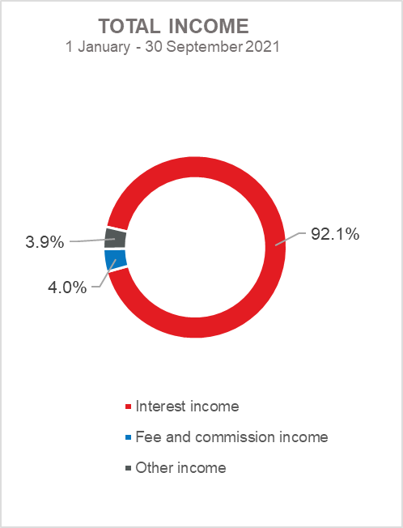 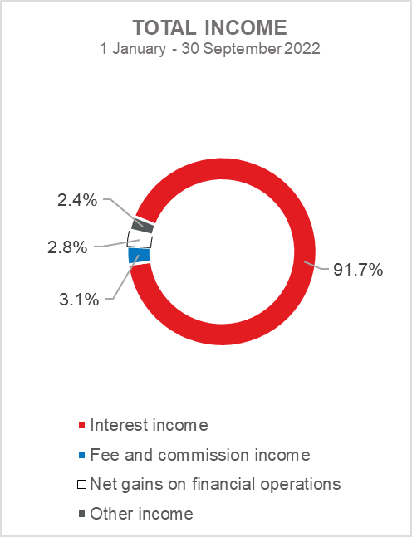

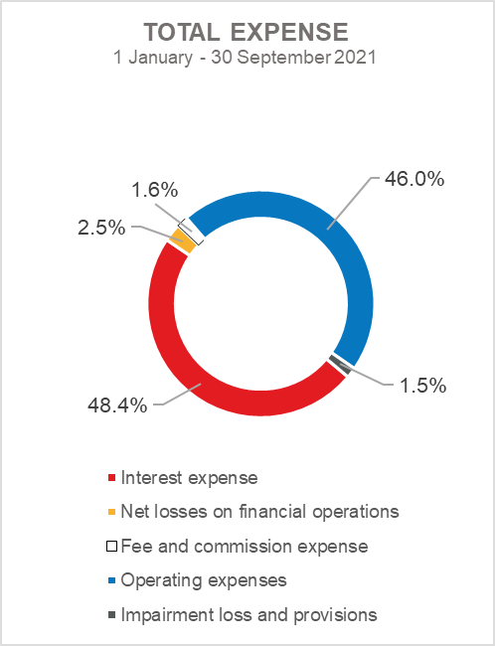 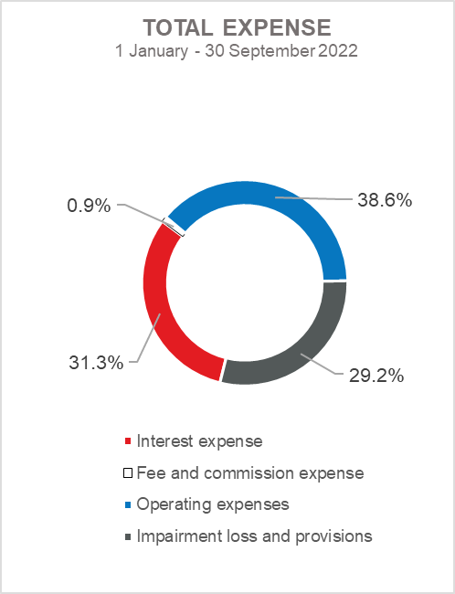

***Net interest income***

Net interest income amounted to HRK 357.2 million, an increase of 2.3 percent on the same period of the previous reporting year.

Interest income amounted to HRK 475.1 million, a decrease of 3.2 percent on the same reporting period last year.

Interest expenses amounted to HRK 117.9 million, a decrease of 16.6 percent on the same reporting period last year.

Given the described trends, a larger decrease in interest expenses than a decrease in interest income affected the increase in net interest margin compared to the same reporting period of the previous year that amounts to 1.7 percent, while in the same period of the previous year it amounted to 1.6 percent.

***Net fee income and commission income***

Net fee and commission income amounted to HRK 12.8 million, a decrease of 23.8 percent compared with the same period last year due to a larger decrease in fee and commission income (by HRK 5.4 million) compared to the decrease in fee and commission expenses (by HRK 1.4 million).

***Net gains/(losses) on financial operations***

Net gains/(losses) on financial operations are comprised of net foreign exchange gains/(losses) on the principal amount of receivables and liabilities, net revenues or expenditures arising out of the loan contracts with embedded call option, gains/(losses) arising out of value adjustment of financial assets stated at fair value through profit or loss and realised gains/(losses) arising out of financial assets at fair value through other comprehensive income.

In the reporting period, net gains from financial activities amounted to HRK 14.7 million, whereas in the same reporting period previous year, net losses amounted to HRK 7.4 million.

A breakdown of changes in the exchange rate of HRK against the EUR and the USD:

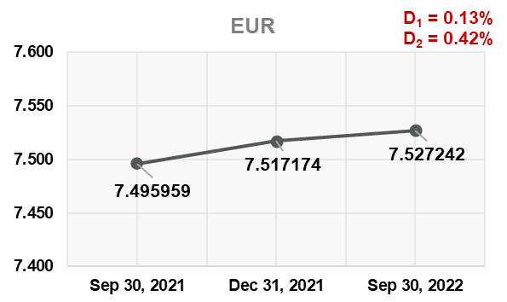 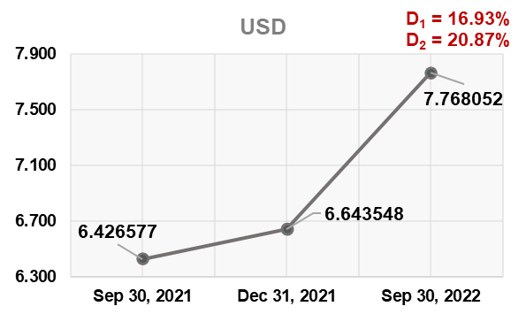

Note:

D1 = HRK depreciation 30.9.2022/31.12.2021 D1 = HRK depreciation 30.9.2022/31.12.2021

D2 = HRK depreciation 30.9.2022/30.9.2021 D2 = HRK depreciation 30.9.2022/30.9.2021

Foreign currency and foreign currency indexed assets and sources of funds are converted by HBOR into HRK equivalent value by applying the exchange rate of the Croatian National Bank valid at the reporting date.

Foreign currency revenues and expenditures are converted in accordance with the exchange rate at the transaction date. The resulting foreign exchange gains or losses are recorded in the Profit or Loss Account in net figures.

***Operating expenses***

Operating expenses that include general and administrative expenses and other operating expenses stood at HRK 145.4 million, an increase of 8.2 percent compared with the same reporting period last year, mainly due to an increase in other expenses in the amount of HRK 9.3 million as a result of recalculation under financial instruments.

On 30 September 2022, HBOR had 378 employees (on 30 September 2021: 366 employees).

***Impairment gain/(loss) and provisions***

In the reporting period, a net loss from impairment of placements in the amount of HRK 110.0 million was recorded (in the period 1 January – 30 September 2021: net loss in the amount of HRK 4.3 million).

The text to follow contains a breakdown of portfolio quality:

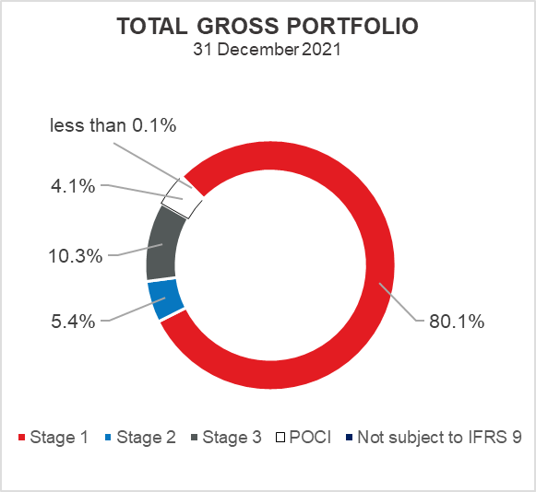 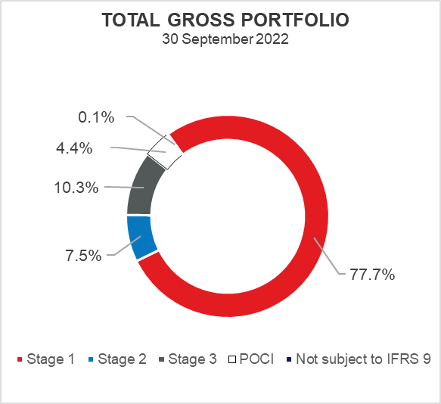

**Overview of total gross portfolio and provisions by structure – financial institutions and direct**

|  |  |  |  |  |
| --- | --- | --- | --- | --- |
|  | **2021** | | **30 September 2022** | |
|  | **In HRK**  **millions** | **Breakdown**  **(percent)** | **In HRK millions** | **Breakdown**  **(percent)** |
| **Total gross portfolio** | **35,412.7** | **100.0** | **34.580,1** | **100,00** |
| **Of which:** |  |  |  |  |
| **- financial institutions** | 10,899.0 | 30.8 | 8.989,1 | 26,0 |
| **- direct** | 24,513.7 | 69.2 | 25.591,0 | 74,0 |
| **Total provisions** | **3,477.9** | **100.0** | **3.635,4** | **100,00** |
| **Of which:** |  |  |  |  |
| **- financial institutions** | 63.4 | 1.8 | 55,2 | 1,5 |
| **- direct** | 3,414.5 | 98.2 | 3.580,2 | 98,5 |
| **Provisions/gross portfolio** | **9.8 percent** | **-** | **10,5 posto** | **-** |

.

**Significant changes in financial position**

Total assets of HBOR as at 30 September 2022 amounted to HRK 27,182.9 million, a decrease of 3.8 percent compared with 31 December 2021 due to the reduction of liabilities on deposits and deleveraging on loan obligations.

***Cash on hand and deposits with other banks***

As at 30 September 2022, cash on hand and deposits with other banks amounted to HRK 554.2 million representing 2.0 percent of total assets, a decrease of 71.8 percent compared with 31 December 2021 as a result of the reduction of liabilities on deposits and debt repayments.

***Loans to financial institutions and other customers***

As at 30 September 2022, total net loans amounted to HRK 23,679.9 million representing 87.1 percent of total assets, an increase2.9 percent on the beginning of the year.

Total gross loans amounted to HRK 27,181.4 million, an increase of 3.2 percent compared with 31 December 2021. Gross loans to other customers increased by 5.8 percent compared with the end of 2021. Gross loans to financial institutions decreased by 3.7 percent compared with the end of 2021.

As at 30 September 2022, the proportion between gross loans on-lent through financial institutions and direct placements stood at 25 percent : 75 percent (31 December 2021: 27 percent : 73 percent).

***Financial assets at fair value through profit or loss***

Loans at fair value (HBOR has determined that mezzanine loans are classified here), investments in investment funds and a part of equity instruments are classified to these assets. As at 30 September 2022, the total amount of these assets was HRK 131.7 million representing 0.5 percent of total assets.

***Financial assets at fair value through other comprehensive income***

***a) Debt instruments***

Bonds of the Republic of Croatia and treasury bills of the Ministry of Finance as part of liquidity reserve as well as bonds of a company are classified to these assets. On the reporting date, they amounted to HRK 2,634.4 million, representing 9.7 percent of total assets and recorded a decrease compared to the beginning of the year by 8.3 percent.

The impairment of these financial assets is calculated through the application of the model of expected credit losses in the manner that provisions are recognised in the accounts of other comprehensive income, thus not reducing the carrying amount of these financial assets in the statement on financial position. On the reporting date, they amounted to HRK 4.6 million in other reserves.

***b) Equity instruments***

Equity instruments (shares of companies) that HBOR does not intend to sell and to which irrevocable option of subsequent measurement of fair value through other comprehensive income without recycling is applied are classified to these assets, i.e. reserves recognised under other comprehensive income will never be transferred to the statement on profit or loss.

On the reporting date, these assets amounted to HRK 53.1 million, representing 0.2 percent of total assets.

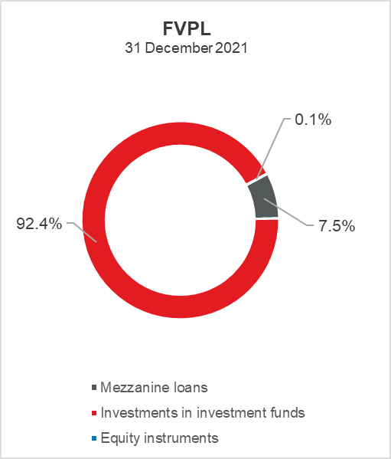 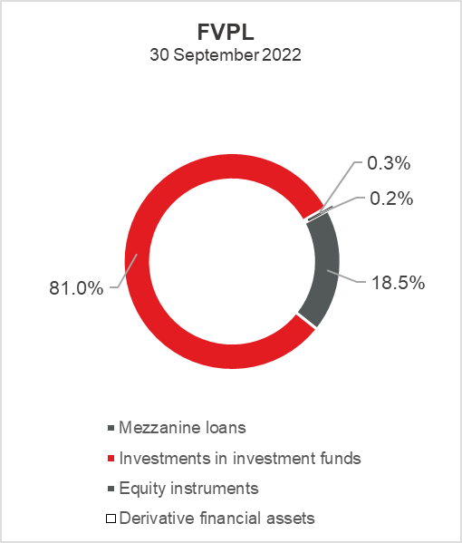

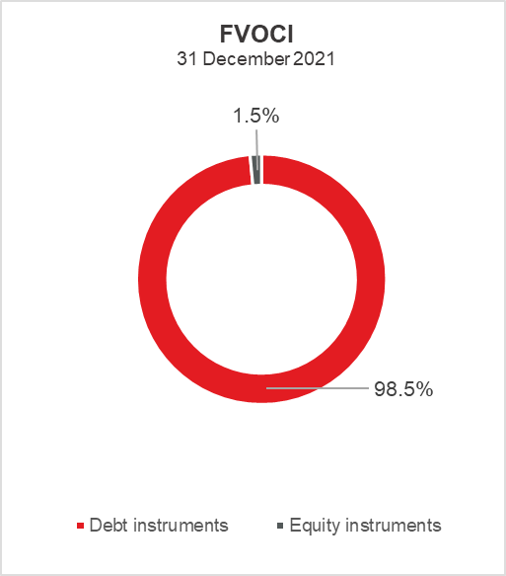 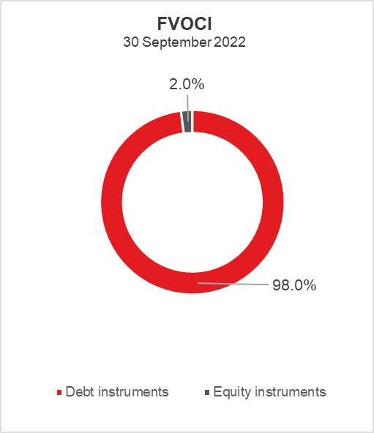

***Total liabilities***

As at 30 September 2022, total liabilities amounted to HRK 16,539.2 million, which represents 60.8 percent of total liabilities and total equity. The major part of total liabilities consists of HBOR’s foreign borrowings in the total amount of HRK 15,386.7 million.

Borrowings decreased by 4.5 percent compared with the beginning of the year, whereas changes in these liabilities are shown in the following table:

|  |  |
| --- | --- |
|  | (in HRK millions) |
| - Draw-down of funds borrowed under previously contracted  funds of special financial institutions | 1,024.2 |
| - Repayments of borrowings | (1,803.1) |
| - Foreign exchange gains or losses | 50.9 |
| - Other calculations * | (0.6) |
| **Total changes** | **(728.6)** |
|  |  |
| *\* Other calculations relate to changes in amount of interest not due and deferred fees.* | |

In 2022, HBOR continued to raise funds, and on 17 May 2022, signed a loan agreement in the amount of EUR 200 million with the Council of Europe Development Bank (CEB) for the promotion of economic growth and assistance for recovery and reconstruction after the earthquakes in Croatia. The proceeds of this loan will be used for financing under existing finance programmes, but also for projects that will be financed within the National Recovery and Resilience Plan (NRRP).

Through HBOR, the CEB loan will be placed directly to the end users for partial financing of the development and upgrading of local and regional infrastructure, such as water supply, sewerage and wastewater treatment networks, local roads, educational, cultural and other communal facilities.

In addition, the loan will enable HBOR to support micro, small and medium-sized enterprises (MSMEs), create new and preserve existing jobs, and finance the reconstruction of and equipment for infrastructure and buildings damaged in the earthquake.

***Total equity***

Total equity amounted to HRK 10,643.7 million, representing 39.2 percent of total liabilities and total equity.

Total equity of HBOR is comprised of the capital and the guarantee fund. HBOR’s capital is comprised of founder’s capital contributed from the budget of the Republic of Croatia, retained earnings from the profits generated in the previous years, other reserves and profits for the current period.

The total amount of capital contributed from the budget of the Republic of Croatia stood at HRK 6,758.0 million, and the remaining amount to be contributed to the founder’s capital up to the total amount of HRK 7,000.0 million set by the HBOR Act is HRK 242.0 million.

After the reporting period, on October 10, 2022, HRK 10 million was contributed from the State Budget out of the planned HRK 20 million.

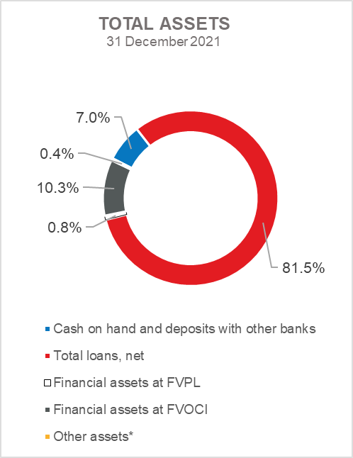 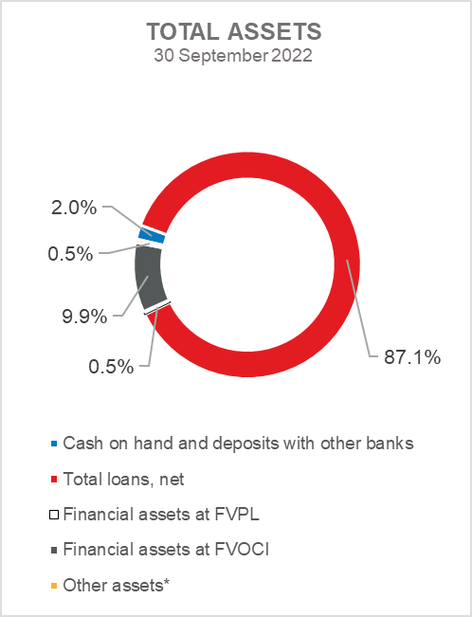

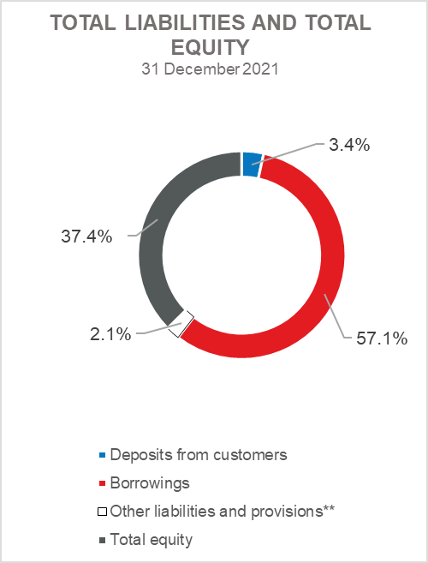 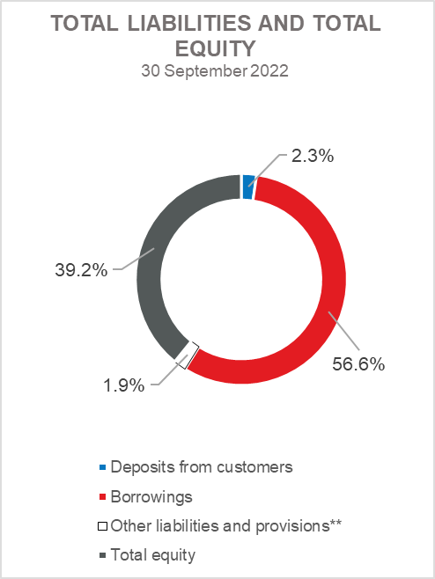

*Investments in subsidiaries, Property, plant and equipment and intangible assets, Foreclosed assets and Other assets.

** Provisioning includes provisioning for guarantees, commitments and other liabilities.