REPORT ON FINANCIAL PERFORMANCE

FOR THE PERIOD 1 JANUARY – 31 MARCH 2023

Zagreb, May 2023

RESULTS OF THE GROUP

Comparative data

The Euro became the functional and presentation currency of HBOR and the HBOR Group on 1 January 2023. In previous years, HBOR’s and the Group's financial statements were presented in Croatian kuna (HRK).
Comparative data for previous years were converted from Croatian kunas to Euros using the official conversion rate, which was set at HRK 7.5345 for EUR 1.

BREAKDOWN OF THE MOST SIGNIFICANT FINANCIAL INFORMATION OF hbor GROUP
-in millions of euros-
 | 2021 | 2023 | 31 March 2023
Total assets | 3,753.2 | 3,857.0 | 3,852.7
Gross loans | 3,494.5 | 3,703.4 | 3,818.9
Total equity | 1,403.8 | 1,422.2 | 1,439.0
 | 1 January – 31 March 2021 | 1 January – 31 March 2022 | 1 January – 31  March 2023
Total income | 25.6 | 44.2 | 31,0
Total expense | (13.9) | (13.7) | (12,3)
Profit | 11.7 | 30.5 | 18,7
Interest income calculated on the basis of effective interest rate method | 22.5 | 24.6 | 21,1
Interest expense | (6.6) | (5.3) | (5,8)
Net interest income | 15.9 | 19.3 | 15,3

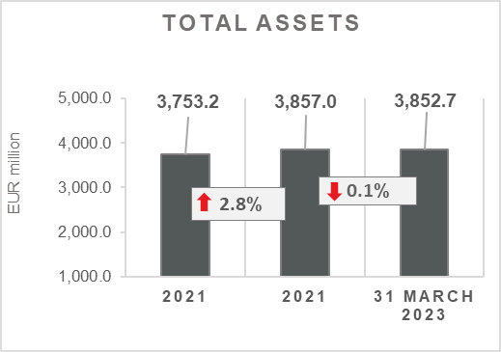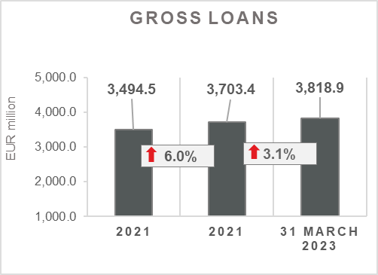

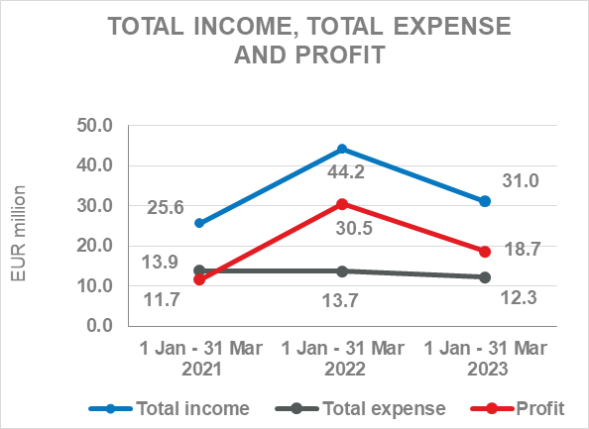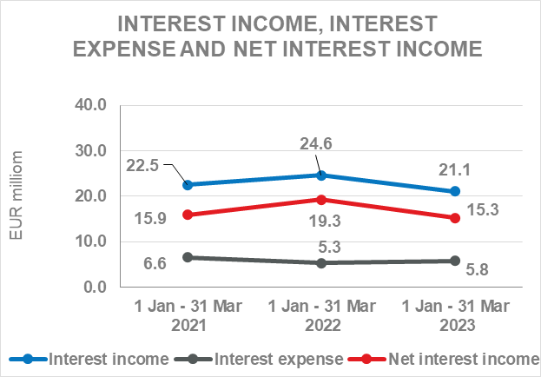

Results of the Group

In the period 1 January – 31 March 2022, the HBOR Group generated profit after tax in the amount of EUR 18.7 million.

Pursuant to the provisions of the Act on HBOR, the parent company is exempt from income tax and income tax liabilities arise exclusively from the activities of the other members of the Group.

In the period 1 January – 31 March 2023, total income on consolidated basis amounted to EUR 31.0 million, whereas total expenses amounted to EUR 12.3 million.

The consolidated total income decreased by 29.8 percent, whereas total expenses decreased by 10.2 percent compared to the same period previous year due to the developments in total income and expenses of the parent company.

In the structure of income of the Group, the largest portion, i.e., 68.1 percent, relates to interest income as a result of operations of the parent company.

The major part of total expenses relates to operating expenses (51.2 percent) and interest expenses (47.2 percent) as a result of operation of the parent company.

The consolidated operating expenses in the period 1 January – 31 March 2023 amounted to EUR 6.3 million and consisted of general and administrative expenses and other operating expenses.

On 31 March 2023, the Group had 408 employees (on 31 March 2022: 395 employees).

Assets and liabilities of the Group

Total assets of the Group on consolidated basis amount to EUR 3,852.7 million and were retained at the level from the beginning of the year. The reasons for such tendency are stated in the description of HBOR’s financial performance.

In the structure of assets, the major portion relates to the lending activities of the parent company, i.e. net loans account for 87.0 percent of total assets.

Total liabilities and total equity as at 31 March 2023 amount to EUR 3,852.7 million, of which amount total liabilities equal EUR 2,413.7 million, i.e., 62.6 percent.

In total liabilities and total equity of the Group, the major portion, i.e., 57.2 percent, consists of borrowings of the parent company.

At the end of the reporting period, total equity on consolidated basis amounted to EUR 1,439.0 million and accounted for 37.4 percent of total liabilities and total equity of the Group.

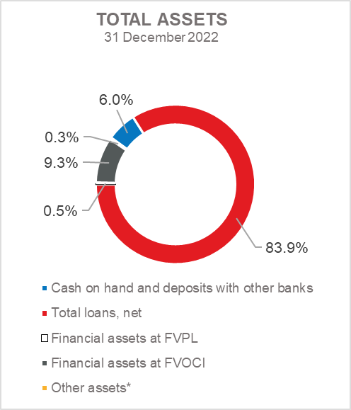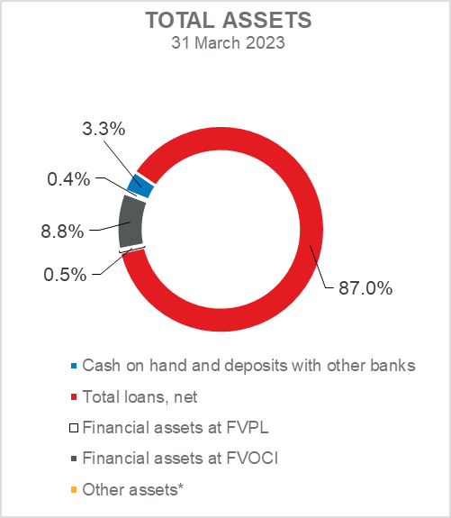

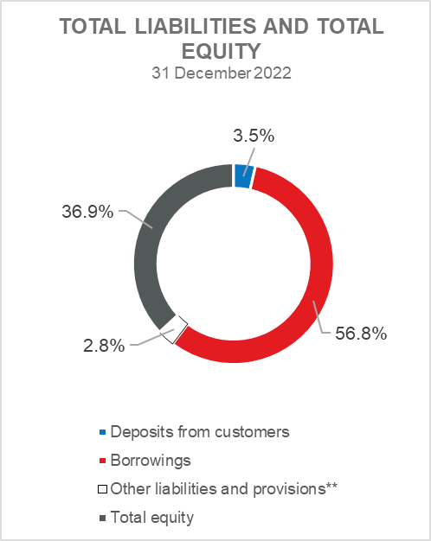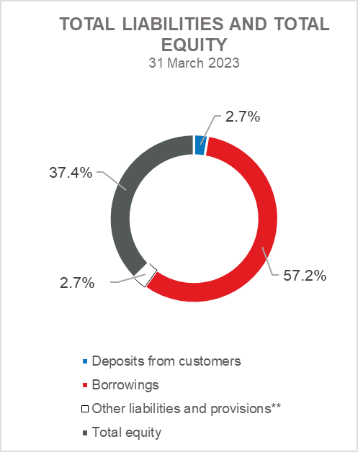

*Property, plant and equipment and intangible assets, Foreclosed assets and Other assets
**Other liabilities and Provisions for guarantees, commitments and other liabilities

RESULTS OF HBOR

OVERVIEW OF FINANCIAL PERFORMANCE OF HBOR

The following text gives an overview and explanation of the significant changes in financial position and operating performance in the reporting period.

Financial performance

In the period from 1 January to 31 March 2023, HBOR generated total income of EUR 30.2 million, expenses of EUR 11.7 million and profit in the amount of EUR 18.5 million. HBOR’s profit generated in the reporting period decreased by EUR 12.1 million compared with the profit generated in the same period last year.

The decrease in profit in the period from 1 January to 31 March 2023 compared with the same period last year is a result of a decrease in total income by EUR 13.5 million and a decrease in total expenses by EUR 1.4 million.

The circumstances that affected the financial result achieved in the three-month reporting period 2023 compared to the results generated in the same period in 2022 are:

- decrease in interest income of EUR 3.5 million,
- increase in interest expenses of EUR 0.5 million,
- increase in net income from fees and commissions of EUR 0.8 million,
- increase in net gains from financial activities in the amount of EUR 2.0 million,
- decrease in other income of EUR 0.2 million,
- decrease in net impairment gains and provisions by EUR 12.6 million,
- decrease in operating expenses of EUR 1.9 million.

A detailed description of trends is given for each category separately in the following text.

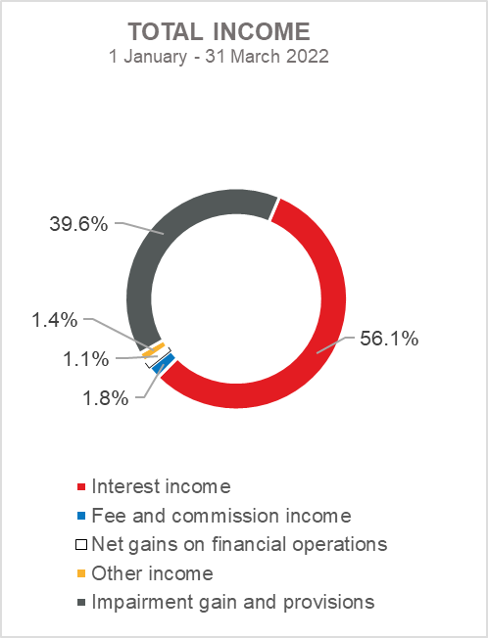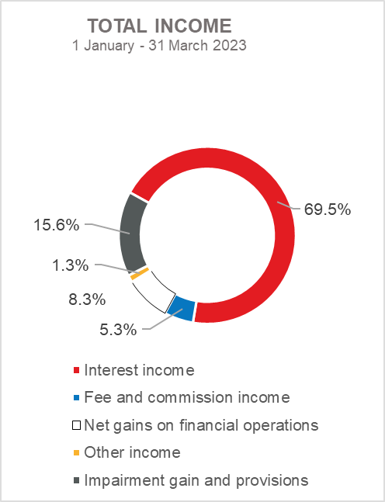

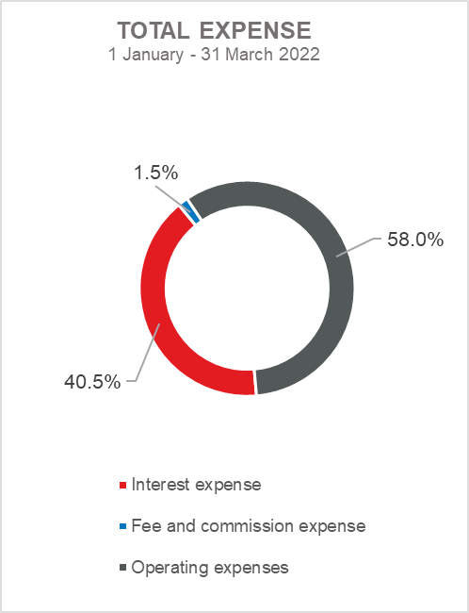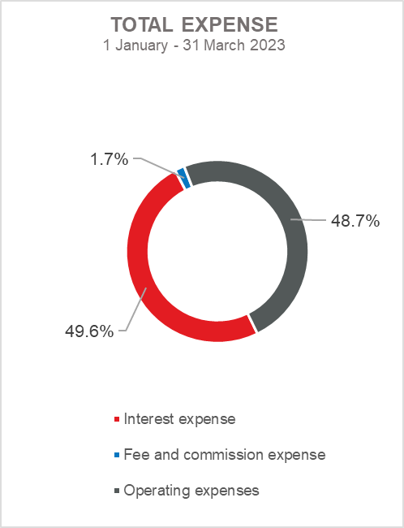

Net interest income

Net interest income amounted to EUR 15.2 million, a decrease of 20.8 percent on the same period of the previous reporting year.

Interest income amounted to EUR 21.0 million, a decrease of 14.3 percent on the same reporting period last year.

Interest expenses amounted to EUR 5.8 million, an increase of 9.4 percent on the same reporting period last year, due to an increase in borrowings.

Given the described trends, the increase in interest expenses and the decrease in interest income affected the decrease in net interest margin compared to the same reporting period of the previous year that amounts to 1.6 percent, while in the same period of the previous year it amounted to 2.1 percent.

Net fee income and commission income

Net fee and commission income amounted to EUR 1.4 million, an increase of 133.3 percent compared with the same reporting period last year due to increase in fee and commission expenses (by EUR 0.8 million) in respect of the fees for issued guarantees and transactions in the name and for the account as well as the retention of fee and commission expenses at the same level as in the same reporting period last year.

Net gains/(losses) on financial operations

Net gains/(losses) on financial operations are comprised of net foreign exchange gains/(losses) on the principal amount of receivables and liabilities, gains/(losses) arising out of value adjustment of financial assets stated at fair value through profit or loss and realised gains/(losses) arising out of financial assets at fair value through other comprehensive income.

In the reporting period, net gains from financial activities amounted to EUR 2.5 million, whereas, in the same reporting period previous year, net gains amounted to EUR 0.5 million.
A breakdown of changes in the exchange rate of the euros against the USD:

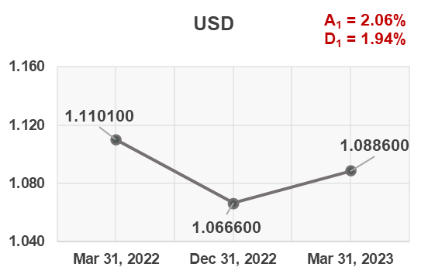

Note:
A₁ = EUR appreciation 31.3.2023/31.12.2022
D₁ = EUR depreciation 31.3.2023/31.3.2022

Funds and sources of funds that are denominated in another currency or are indexed to the currency clause are converted by HBOR into the equivalent value in EUR at the middle exchange rate of HBOR or another agreed exchange rate on the reporting date.

Revenues and expenditures in another currency are converted at the exchange rate on the transaction date. The resulting foreign exchange gains or losses are recorded in the Profit or Loss Account in net figures.

Operating expenses

Operating expenses that include general and administrative expenses and other operating expenses stood at EUR 5.7 million, a decrease of 25.0 percent compared with the same reporting period last year, mainly due to a decrease in other expenses by EUR 2.2 million (recalculation costs).

On 31 March 2023, HBOR had 387 employees (on 31 March 2022: 374 employees).

Impairment gain/(loss) and provisions

In the reporting period, a net gain from impairment of placements in the amount of EUR 4.7 million was recorded (in the period 1 January – 31 March 2022: net gain in the amount of EUR 17.3 million).

The text to follow contains a breakdown of portfolio quality:

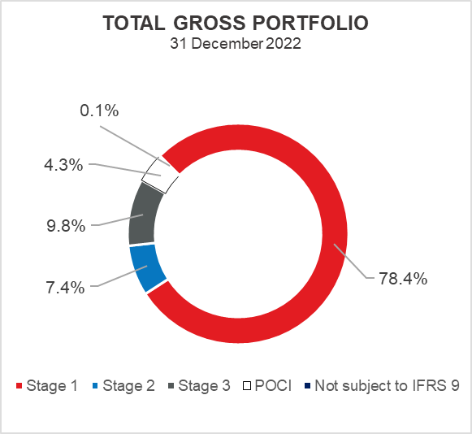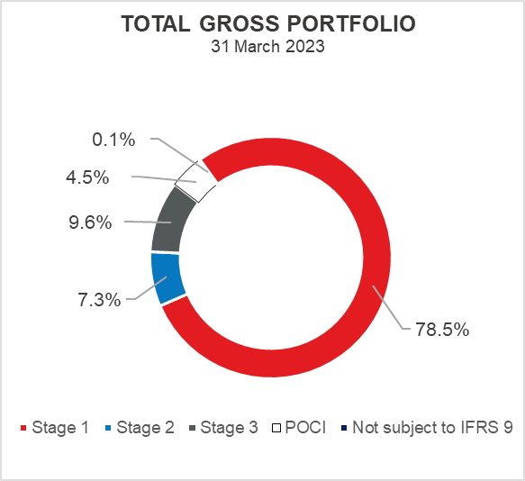

Overview of total gross portfolio and provisions by structure – financial institutions and direct

 | 2022 |  | Mar 31, 2023
 | In millions of euros | Breakdown  (percent) | In millions of euros | Breakdown  (percent)
Total gross portfolio | 4,708.8 | 100.00 | 4,731.9 | 100.00
Of which:
- financial institutions | 1,323.3 | 28.1 | 1,319.0 | 27.9
- direct | 3,385.5 | 71.9 | 3,412.9 | 72.1
Total provisions | 482.8 | 100.00 | 483.1 | 100.00
Of which:
- financial institutions | 9.1 | 1.9 | 8.4 | 1.7
- direct | 473.7 | 98.1 | 474.7 | 98.3
Provisions/gross portfolio | 10.3 percent | - | 10.2 percent | -

Significant changes in financial position

Total assets of HBOR as at 31 March 2023 amounted to EUR 3,849.2 million and were retained at the level from the beginning of the year.

Cash on hand and deposits with other banks

As at 31 March 2023, cash on hand and deposits with other banks amounted to EUR 123.0 million representing 3.2 percent of total assets, a decrease of 46.3 percent compared with 31 December 2022 as a result of reallocation of liquidity reserve funds.

Loans to financial institutions and other customers

As at 31 March 2023, total net loans amounted to EUR 3,350.3 million representing 87.0 percent of total assets, an increase 3.5 percent on the beginning of the year.
Total gross loans amounted to EUR 3,818.9 million, an increase of 3.1 percent compared with 31 December 2022. Gross loans to other customers increased by 2.0 percent compared with the end of 2022. Gross loans to financial institutions increased by 6.5 percent compared with the end of 2022 due to the reallocation of liquidity reserve funds into short-term placements.
As at 31 March 2023, the proportion between gross loans on-lent through financial institutions and direct placements stood at 26 percent: 74 percent (31 December 2022: 25 percent: 75 percent).

Financial assets at fair value through profit or loss

Loans at fair value (HBOR has determined that mezzanine loans are classified here), investments in investment funds and a part of equity instruments are classified to these assets. As at 31 March 2023, the total amount of these assets was EUR 20.8 million representing 0.5 percent of total assets.

Financial assets at fair value through other comprehensive income

a) Debt instruments

Bonds of the Republic of Croatia and treasury bills of the Ministry of Finance as part of liquidity reserve as well as bonds of a company are classified to these assets. On the reporting date, they amounted to EUR 327.4 million, representing 8.5 percent of total assets and recorded a decrease compared to the beginning of the year by 4.6 percent.

The impairment of these financial assets is calculated through the application of the model of expected credit losses in the manner that provisions are recognised in the accounts of other comprehensive income, thus not reducing the carrying amount of these financial assets in the statement on financial position. On the reporting date, they amounted to EUR 0.6 million in other reserves.
b) Equity instruments

Equity instruments (shares of companies) that HBOR does not intend to sell and to which irrevocable option of subsequent measurement of fair value through other comprehensive income without recycling is applied are classified to these assets, i.e. reserves recognised under other comprehensive income will never be transferred to the statement on profit or loss.
On the reporting date, these assets amounted to EUR 7.1 million, representing 0.2 percent of total assets.

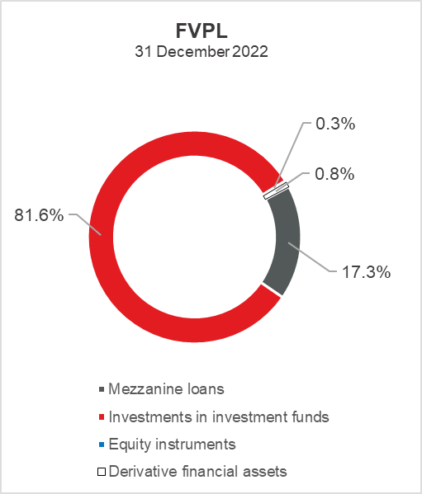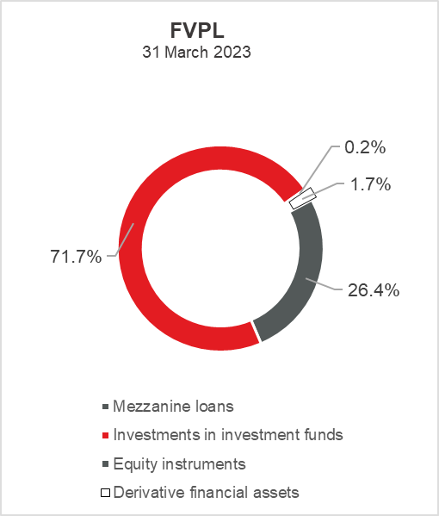

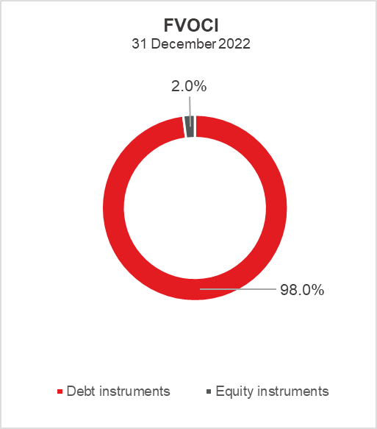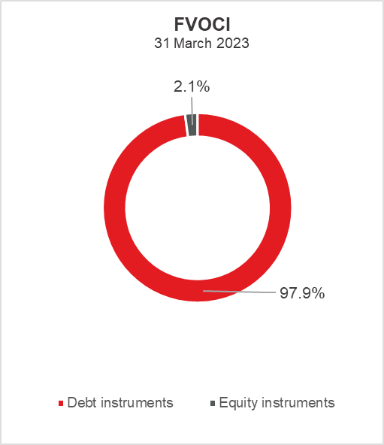

Total liabilities

As at 31 March 2023, total liabilities amounted to EUR 2,410.5 million, which represents 62.6 percent of total liabilities and total equity. The major part of total liabilities consists of HBOR’s foreign borrowings in the total amount of EUR 2,203.9 million.

Borrowings increased by 0.6 percent compared with the beginning of the year, whereas changes in these liabilities are shown in the following table:

 | (in millions of euros)
- Draw-down of funds borrowed under previously contracted  funds of special financial institutions | 125.0
- Repayments of borrowings | (112.1)
- Foreign exchange gains or losses | (0.5)
- Other calculations * | 1.4
Total changes | 13.8
* Other calculations relate to the amount of interest not due and deferred fees.

Total equity

Out of the total amount of total liabilities and total equity, EUR 1,438.7 million or 37.4 percent relate to total equity.

Total equity of HBOR is comprised of the capital and the guarantee fund. HBOR’s capital is comprised of founder’s capital contributed from the budget of the Republic of Croatia, retained earnings from the profits generated in the previous years, other reserves and profits for the current period.

The total amount of capital contributed from the budget of the Republic of Croatia stood at EUR 899.6 million, and the remaining amount to be contributed to the founder’s capital up to the total amount of EUR 929.1 million set by the HBOR Act is EUR 29,5 million.

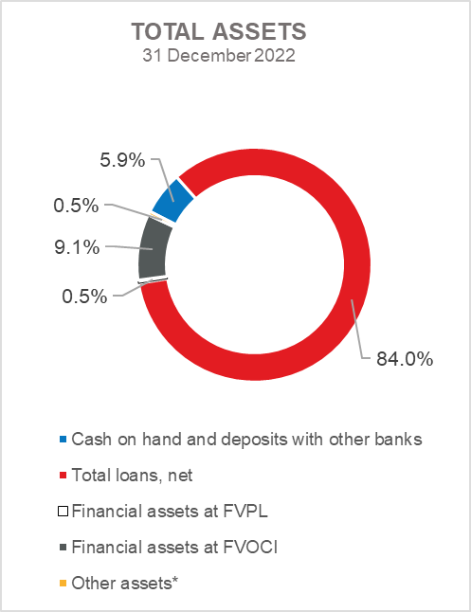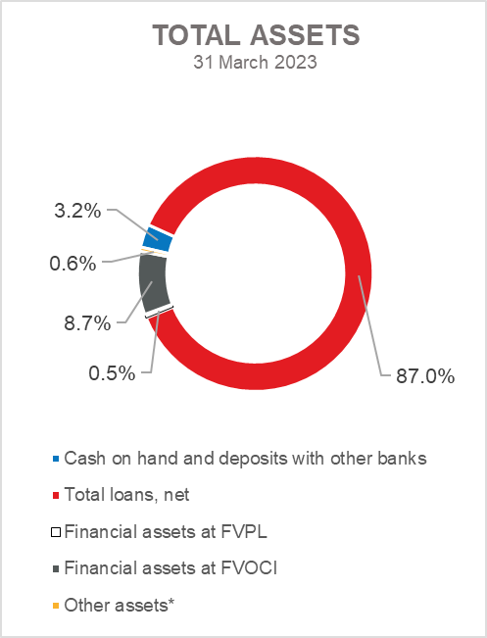

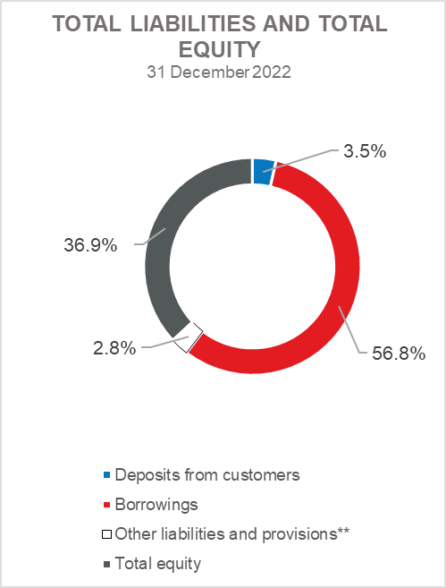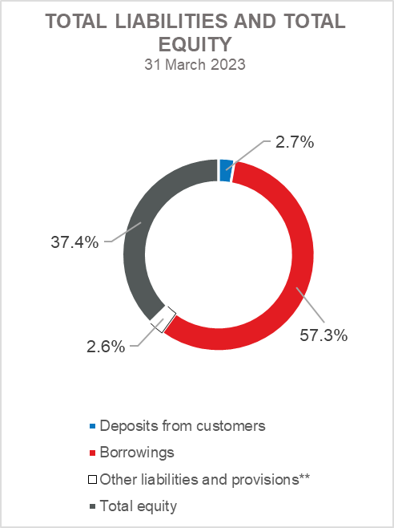

*Investments in subsidiaries, Property, plant and equipment and intangible assets, Foreclosed assets and Other assets

** Other liabilities and Provisions for guarantees, commitments and other liabilities

