SEMI-ANNUAL REPORT

FOR THE PERIOD 1 JANUARY – 30 JUNE 2020

Zagreb, September 2020

STATEMENT OF PERSONS RESPONSIBLE FOR THE PREPARATION OF SEMI-ANNUAL REPORT
To the best of our knowledge the management report for the period 1 January – 30 June 2020 contains a truthful development of events and business results as well as the position of the Croatian Bank for Reconstruction and Development and the Group, and the description of the most significant risks and contingencies the Croatian Bank for Reconstruction and Development and the Group are exposed to.

President of the Management Board Member of the Management Board

Tamara Perko, MSc Hrvoje Čuvalo, MSc

Zagreb, 30 September 2020

MANAGEMENT REPORT FOR THE PERIOD

1 JANUARY – 30 JUNE 2020

RESULTS OF THE GROUP

BREAKDOWN OF THE MOST SIGNIFICANT FINANCIAL INFORMATION OF hbor GROUP
-HRK million-

 | 31 December 2018 | 31 December 2019 | 31 June 2020
Total assets | 27,219.0 | 26,470.6 | 27,323.5
Gross loans | 26,243.1 | 26,571.1 | 25,565.1
Total equity | 10,061.1 | 10,274.6 | 10,296.0
 | 1 January –  30 June 2018 | 1 January –  30 June 2019 | 1 January –  30 June 2020
Total income | 443.0 | 353.5 | 331.5
Total expense | 247.0 | 276.0 | 314.1
Profit | 196.0 | 77.5 | 17.4
Interest income | 381.0 | 322.0 | 312.1
Interest expense | 169.3 | 160.5 | 134.4
Net interest income | 211.7 | 161.5 | 177.7

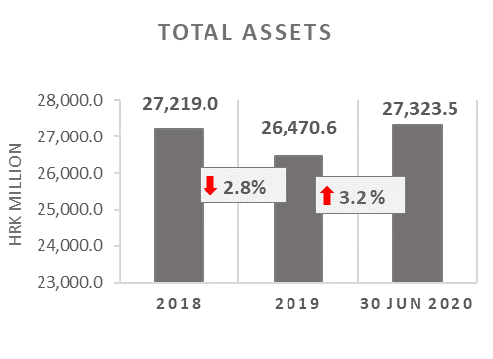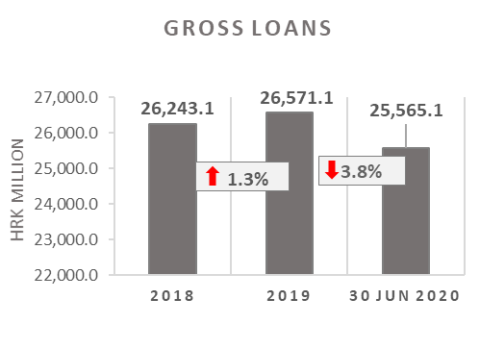

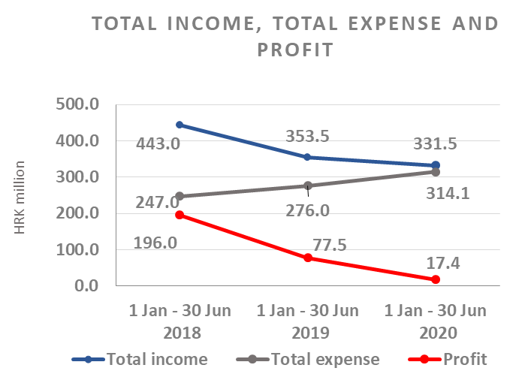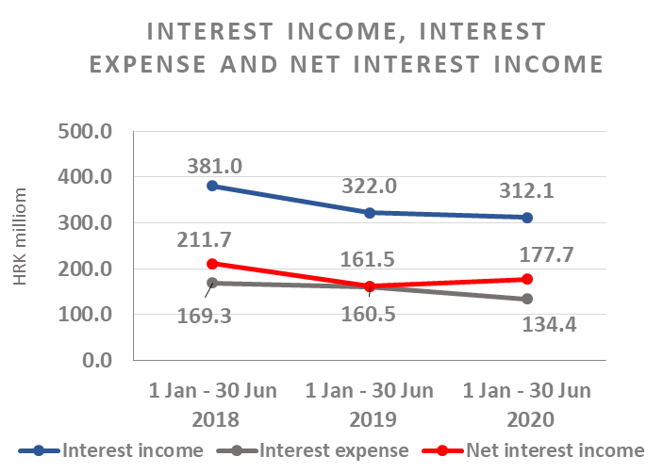

Results of the Group

In the period 1 January – 30 June 2020, the HBOR Group generated profit after tax in the amount of HRK 17.4 million.

Pursuant to the provisions of the Act on HBOR, the parent company is exempt from income tax and income tax liabilities arise exclusively from the activities of the other members of the Group.

In the period 1 January – 30 June 2020, total income on consolidated basis amounted to HRK 331.5 million, whereas total expenses amounted to HRK 314.1 million.

The consolidated total income decreased by 6.2 percent, whereas total expenses rose by 13.8 percent compared to the same period previous year due to the developments in total income and expenses of the parent company.

In the structure of income of the Group, the largest portion, i.e. 94.1 percent, relates to interest income as a result of operations of the parent company.

The major part of total expenses, i.e. 42.8 percent, relates to interest expenses arising from the operations of the parent company.

The consolidated operating expenses in the period 1 January – 30 June 2020 amounted to HRK 74.3 million and consisted of general and administrative expenses and other operating expenses.

On 30 June 2020, the Group had 387 employees (on 30 June 2019: 385 employees).

Assets and liabilities of the Group

Total assets of the Group on consolidated basis amount to HRK 27,323.5 million, an increase of 3.2 percent compared with the beginning of the year. The reasons for such tendency are stated in the description of HBOR’s financial performance.

In the structure of assets, the major portion relates to the lending activities of the parent company, i.e. net loans account for 80.8 percent of total assets.

Total liabilities and total equity as at 30 June 2020 amount to HRK 27,323.5 million, of which amount total liabilities equal HRK 17,027.5 million, i.e. 62.3 percent.

In total liabilities and total equity of the Group, the major portion, i.e. 59.1 percent, consists of borrowings of the parent company.

At the end of the reporting period, total equity on consolidated basis amounted to HRK 10,296.0 million and accounted for 37.7 percent of total liabilities and total equity of the Group.

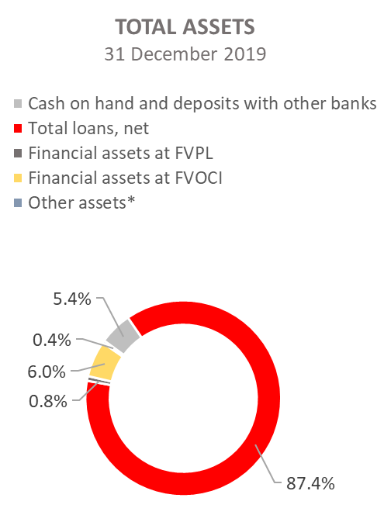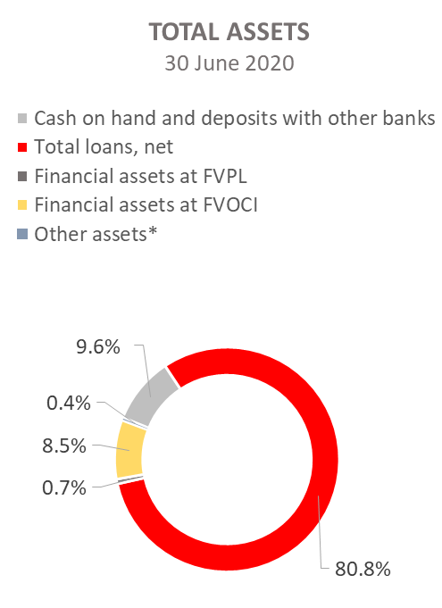

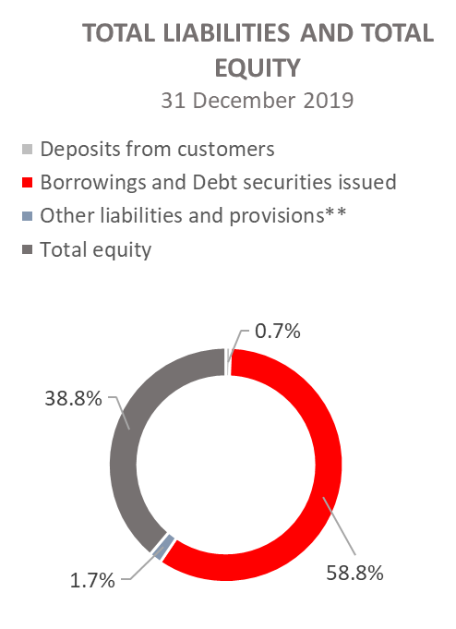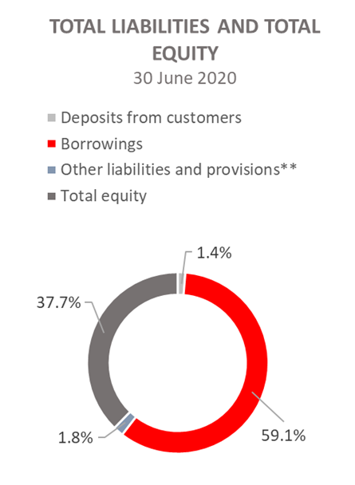

*Property, plant and equipment and intangible assets, Foreclosed assets, Debts securities at AC and Other assets.
**Provisioning includes provisioning for guarantees, commitments and other liabilities.

RESULTS OF HBOR

OVERVIEW OF FINANCIAL PERFORMANCE OF HBOR

The following text gives an overview and explanation of the significant changes in financial position and operating performance in the reporting period.

Financial performance

In the period from 1 January to 30 June 2020, HBOR generated total income of HRK 326.0 million, expenses of HRK 310.0 million and profit in the amount of HRK 16.0 million. HBOR’s profit generated in the reporting period decreased by HRK 61.1 million compared with the profit generated in the same period last year, i.e. by 79.3 percent.

Namely, due to the impact of the COVID - 19 pandemic, HBOR paid special attention to expected credit losses, which resulted in a significant increase in the position of Losses from impairment and provisions, and significantly reduced the profit generated in the first half of 2020 compared to the same period in 2019.

The decrease in profit in the reporting period compared with the same period last year is a result of a decrease in total income by HRK 22.4 million and a decrease in total expenses by HRK 38.7 million. The circumstances that affected the financial result achieved in the six-month reporting period 2020 compared to the results generated in the same period in 2019 are:
- (+) increase in net interest income of HRK 16.4 million, i.e. by 10.2 percent,
- (-) decrease in net income from fees and commissions of HRK 1.1 million, i.e. by 9.7 percent,
- (-) decrease in net gains from financial activities in the amount of HRK 21.0 million and other income in the amount of HRK 0.4 million,
- (+) increase in losses from impairment and provisions in the amount of HRK 62.9 million,
- (+) decrease in operating expenses of HRK 7.9 million, i.e. by 10.1 percent.

A detailed description of trends is given for each category separately in the following text.

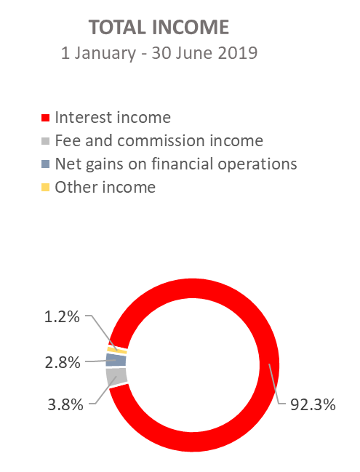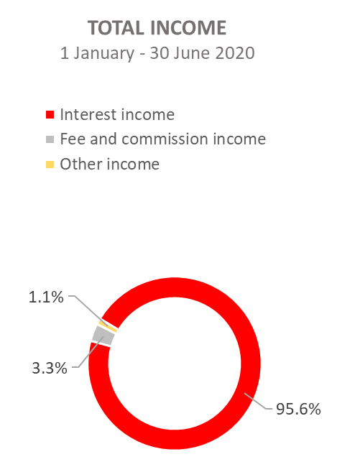

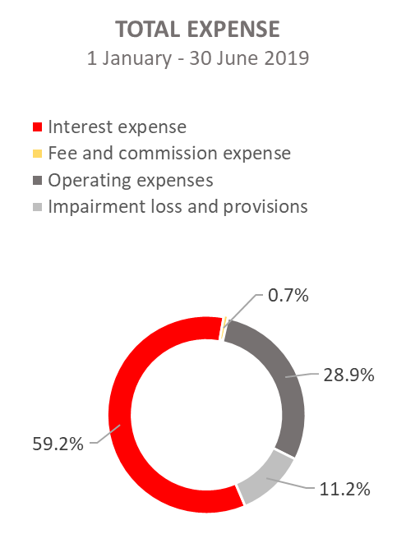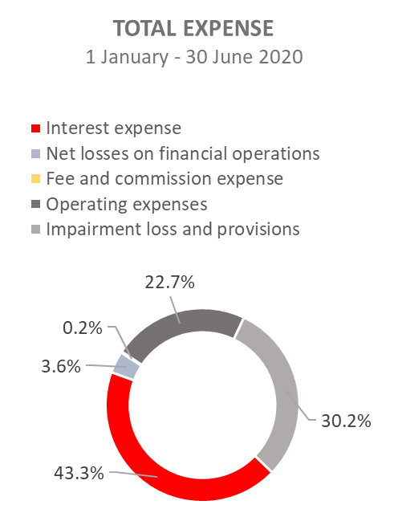

Net interest income

Net interest income amounted to HRK 177.2 million, an increase of 10.2 percent on the same period of the previous reporting year.

Interest income amounted to HRK 311.5 million, a decrease of 3.1 percent on the same reporting period last year due to decreased interest income from long-term loans due to the long-term implementation of measures of interest rate reduction, reduction of interest income from interest rate subsidies, implementation of moratorium and the recalculation of interest due to the implementation of loan restructuring, premature loan repayments in 2019 and the manner of recording of interest income from exposures classified to stage 3 and POCI assets (unwinding).
On this basis, from 1 January to 30 June 2020, interest income was reduced by HRK 21.3 million.

Interest expenses amounted to HRK 134.3 million, a decrease of 16.3 percent on the same reporting period last year, due to the repayment of debt under loan liabilities.

Having in mind the described trends in interest income and interest expenses, a larger decrease in interest expenses than interest income led to an increase in net net interest margin compared with the same reporting period last year and stood at 1.32 percent as against 1.19 percent in the same reporting period last year.

Net fee income and commission income

Net fee and commission income amounted to HRK 10.1 million, a decrease of 9.8 percent compared with the same reporting period last year due to calls for payments under guarantees issued, thus decreasing the exposure under guarantees issued.

Net gains/(losses) on financial operations

Net gains/(losses) on financial operations are comprised of net foreign exchange gains/(losses) on the principal amount of receivables and liabilities, net revenues or expenditures arising out of the loan contracts with embedded call option, gains/(losses) arising out of value adjustment of financial assets stated at fair value through profit or loss and realised gains/(losses) arising out of financial assets at fair value through other comprehensive income.

In the reporting period, net losses from financial activities amounted to HRK 11.2 million, which is HRK 21.0 million less than net gains from financial activities in the same period last year of HRK 9.8 million.

A breakdown of changes in the exchange rate of HRK against the EUR and the USD:

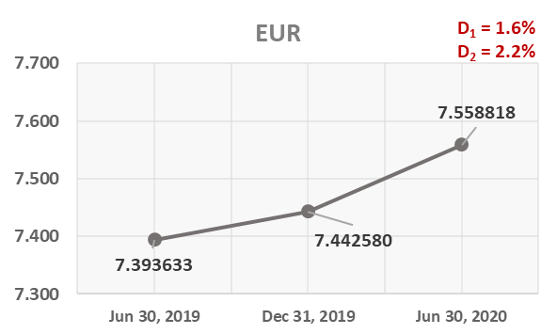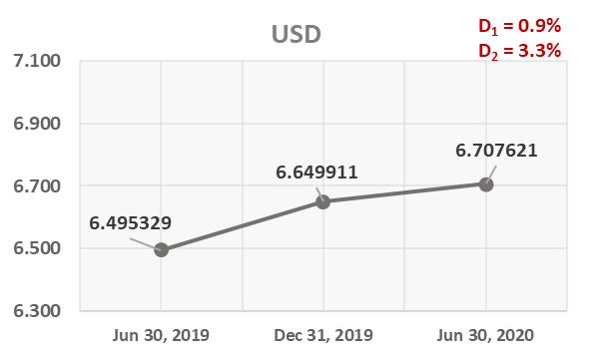

Note:
D₁ = HRK depreciation 30.6.2020/31.12.2019 D₁ = HRK depreciation 30.6.2020/31.12.2019
D₂ = HRK depreciation 30.6.2020/31.3.2019 D₂ = HRK depreciation 30.6.2020/30.6.2019

Foreign currency and foreign currency indexed assets and sources of funds are converted by HBOR into HRK equivalent value by applying the exchange rate of the Croatian National Bank valid at the reporting date.

Foreign currency revenues and expenditures are converted in accordance with the exchange rate at the transaction date. The resulting foreign exchange gains or losses are recorded in the Profit or Loss Account in net figures.

Operating expenses

Operating expenses that include general and administrative expenses and other operating expenses stood at HRK 70.5 million, a decrease of 10.1 percent compared with the same reporting period last year, mainly due to a decrease in administrative expenses by HRK 9.4 million.

On 30 June 2020, HBOR had 366 employees (on 30 June 2019: 365 employees).

Impairment gain/(loss) and provisions

In the reporting period, a net loss from impairment of placements in the amount of HRK 93.4 million was recorded as a result of the impact of the COVID - 19 pandemic on expected credit losses.

The text to follow contains a breakdown of portfolio quality:

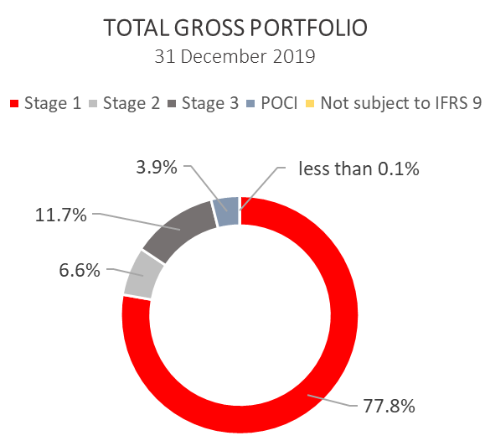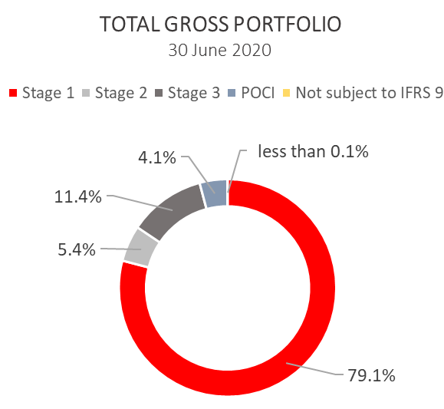
.

 | 31 December 2019 |  | 30 June 2020
 | In HRK millions | Breakdown (percent) | In HRK millions | Breakdown (percent)
Total gross portfolio | 34,024.8 | 100.0 | 36,742.0 | 100.0
Of which:
- financial institutions | 13,186.7 | 38.8 | 15,287.0 | 41.6
- direct | 20,838.1 | 61.2 | 21,455.0 | 58.4
Total provisions | 3,518.7 | 100.0 | 3,614.3 | 100.0
Of which:
- financial institutions | 65.9 | 1.9 | 64.6 | 1.8
- direct | 3,452.8 | 98.1 | 3,549.7 | 98.2
Provisions/gross portfolio | 10.3 percent | - | 9.8 percent | -

Significant changes in financial position

Total assets of HBOR as at 30 June 2020 amounted to HRK 27,299.0 million, an increase of 3.2 percent compared with 31 December 2019 due to significant draw-down of funds under a long-term borrowing from special financial institutions.

Cash on hand and deposits with other banks

As at 30 June 2020, cash on hand and deposits with other banks amounted to HRK 2,607.8 million representing 9.6 percent of total assets, an increase of 81.7 percent compared with 31 December 2019 as a result of reallocation of liquidity reserve funds.

Loans to financial institutions and other customers

As at 30 June 2020, total net loans amounted to HRK 22,081.4 million representing 80.9 percent of total assets, an increase 4.6 percent on the beginning of the year.

Total gross loans amounted to HRK 25,565.1 million, a decrease of 3.8 percent compared with 31 December 2019. Gross loans to other customers decreased by 3.9 percent compared with the end of 2019. Gross loans to financial institutions decreased by 3.6 percent compared with the end of 2019.
As at 30 June 2020, the proportion between gross loans on-lent through financial institutions and direct placements stood at 36 percent : 64 percent same as on 31 December 2019.

Financial assets at fair value through profit or loss

Loans at fair value (HBOR has determined that mezzanine loans are classified here), investments in investment funds and a part of equity instruments are classified to these assets. As at 30 June 2020, the total amount of these assets was HRK 183.1 million representing 0.7 percent of total assets.

Financial assets at fair value through other comprehensive income

a) Debt instruments

Bonds of the Republic of Croatia and treasury bills of the Ministry of Finance as part of liquidity reserve as well as bonds of a company are classified to these assets. On the reporting date, they amounted to HRK 2,261.9 million, representing 8.3 percent of total assets and recorded an increase compared to the beginning of the year by 49.6 percent as a result of reallocation of liquidity reserve funds.
The impairment of these financial assets is calculated through the application of the model of expected credit losses in the manner that provisions are recognised in the accounts of other comprehensive income, thus not reducing the carrying amount of these financial assets in the statement on financial position. On the reporting date, they amounted to HRK 3.7 million in other reserves.
b) Equity instruments

Equity instruments (shares of companies) that HBOR does not intend to sell and to which irrevocable option of subsequent measurement of fair value through other comprehensive income without recycling is applied are classified to these assets, i.e. reserves recognised under other comprehensive income will never be transferred to the statement on profit or loss.
On the reporting date, these assets amounted to HRK 26.8 million, representing 0.1 percent of total assets.

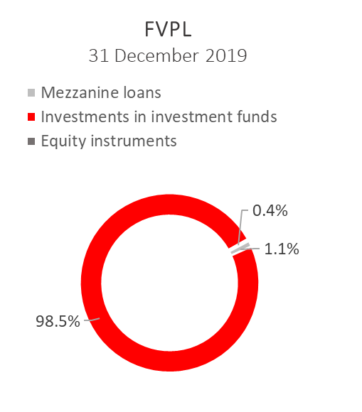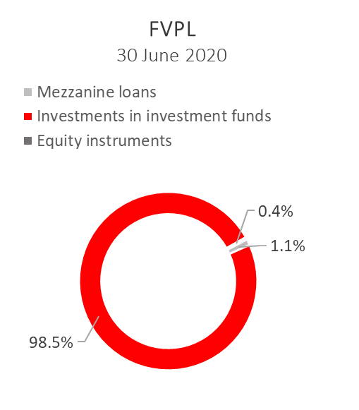
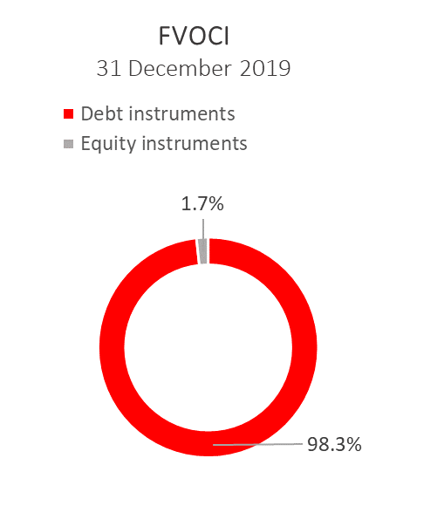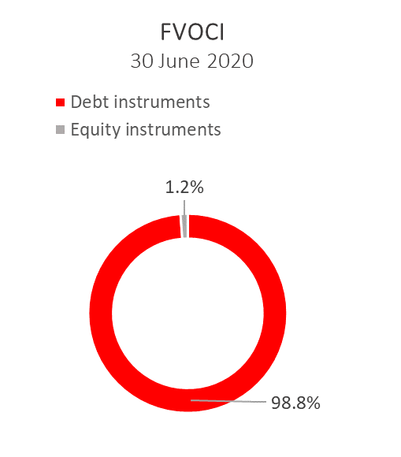

Total liabilities

As at 30 June 2020, total liabilities amounted to HRK 17,011.1 million, which represents 62.3 percent of total liabilities and total equity. The major part of total liabilities consists of HBOR’s foreign borrowings in the total amount of HRK 16,147.6 million.

Borrowings increased by 3.8 percent compared with the beginning of the year, whereas changes in these liabilities are shown in the following table:

 | (in HRK millions)
- Draw-down of funds borrowed under previously contracted  funds of special financial institutions | 3,042.7
- Repayments of borrowings and bonds payable | (2,638.6)
- Foreign exchange gains or losses | 224.5
- Other calculations * | (39.8)
Total changes | 588.8
* Other calculations relate to the changes in discount, amount of interest not due and deferred fees.

During 2020, HBOR continued to raise funds, and on 26 June 2020, a loan agreement was concluded with the Ministry of Finance in the amount of up to HRK 3.0 billion with a fixed interest rate of 0.9% p.a.

On 8 May 2020 HBOR settled the bonds due of HRK 1,203,211 thousand, together with interest (EUR 159,000 thousand, together with interest).

Total equity
Total equity amounted to HRK 10,287.9 million, representing 37.7 percent of total liabilities and total equity.

Total equity of HBOR is comprised of the capital and the guarantee fund. HBOR’s capital is comprised of founder’s capital contributed from the budget of the Republic of Croatia, retained earnings from the profits generated in the previous years, other reserves and profits for the current period.

In the reporting period the amount of HRK 25.0 million was contributed into the founder’s capital from the budget of the Republic of Croatia. The total amount of capital contributed from the budget of the Republic of Croatia stood at HRK 6,708.0 million, and the remaining amount to be contributed to the founder’s capital up to the total amount of HRK 7,000.0 million set by the HBOR Act is HRK 292.0 million.

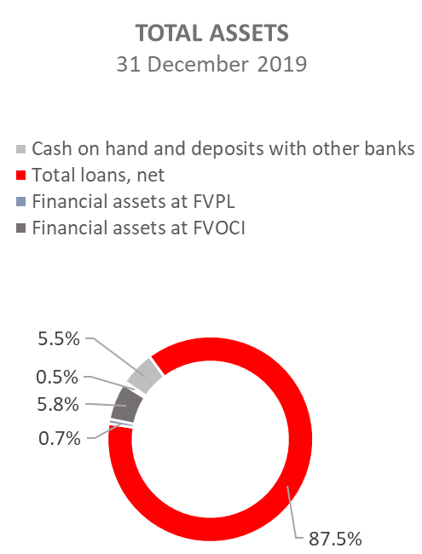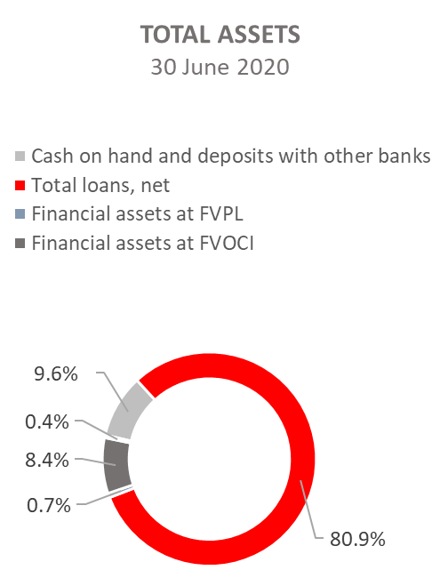

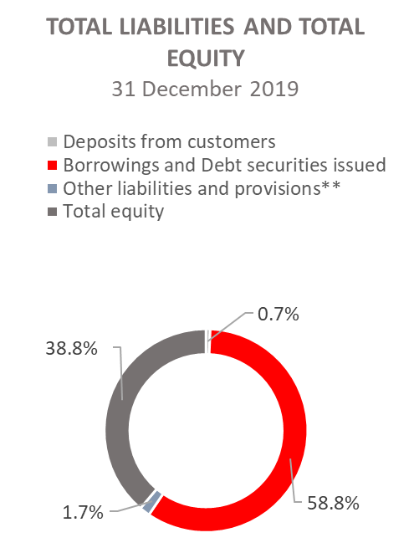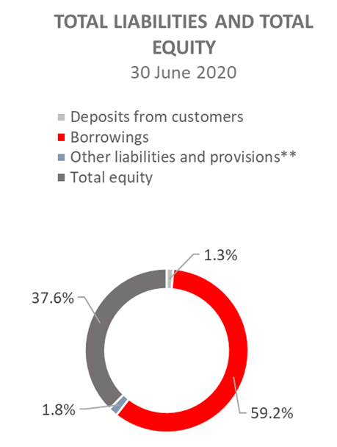

*Investments in subsidiaries, Property, plant and equipment and intangible assets, Foreclosed assets and Other assets.
** Provisioning includes provisioning for guarantees, commitments and other liabilities.

