logo-01a-boja

**REPORT ON FINANCIAL PERFORMANCE**

**FOR THE PERIOD**

**1 JANUARY – 30 SEPTEMBER 2017**

**Zagreb, November 2017**

**RESULTS OF THE GROUP**

**BREAKDOWN OF THE MOST SIGNIFICANT FINANCIAL INFORMATION OF hbor GROUP**

-HRK millions-

|  |  |  |  |
| --- | --- | --- | --- |
|  | **2015** | **2016** | **30 September 2017** |
| Total assets | 25,552.80 | 27,390.82 | 28,300.72 |
| Gross loans | 24,722.82 | 26,343.12 | 27,168.07 |
| Total equity | 9,664.54 | 10,042.70 | 10,260.81 |
|  |  |  |  |
|  | **30 September 2015** | **30 September 2016** | **30 September 2017** |
| Total income | 684.87 | 677.57 | 705.66 |
| Total expense | (575.15) | (517.79) | (529.12) |
| Profit | 109.72 | 159.78 | 176.54 |
|  |  |  |  |
| Interest income | 648.31 | 644.93 | 661.20 |
| Interest expense | (358.09) | (340.88) | (301.46) |
| Net interest income | 290.22 | 304.05 | 359.74 |

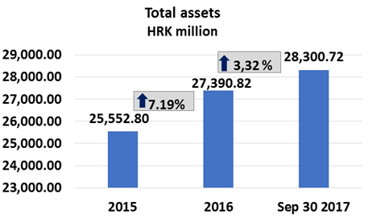 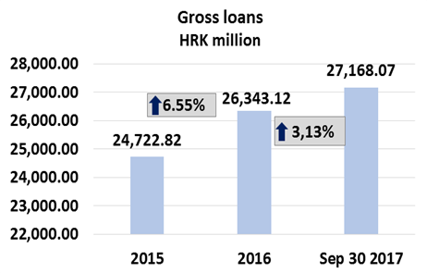

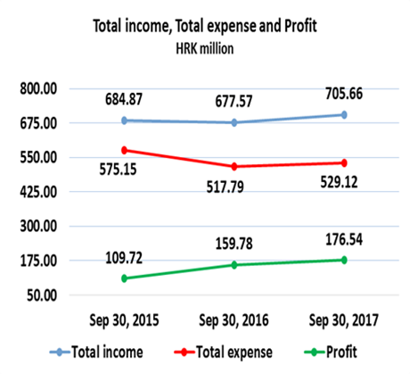 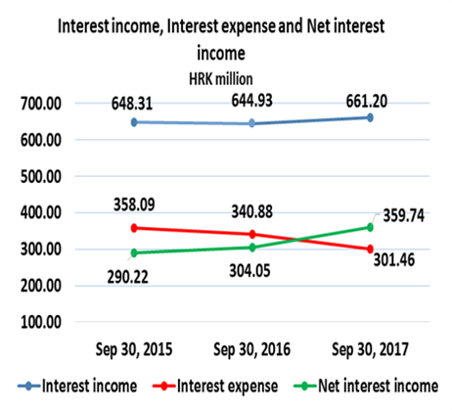

**Results of the Group**

In the period 1 January – 30 September 2017, the HBOR Group generated profit after tax in the amount of HRK 176.54 million.

Pursuant to the provisions of the Act on HBOR, the parent company is exempt from income tax and income tax liabilities arise exclusively from the activities of the other members of the Group.

In the period 1 January – 30 September 2017, total income on consolidated basis amounted to HRK 705.66 million, whereas total expenses amounted to HRK 529.12 million.

The consolidated total income rose by 4.15 percent, whereas total expenses rose by 2.19 percent compared to the same period previous year due to the developments in total income and expenses of the parent company.

In the structure of income of the Group, the largest portion, i.e. 93.70 percent, relates to interest income as a result of operations of the parent company.

The major part of total expenses, i.e. 56.97 percent, relates to interest expenses arising from the operations of the parent company.

The consolidated operating expenses in the period 1 January – 30 September 2017 amounted to HRK 114.18 million and consisted of general and administrative expenses and other operating expenses.

There were 383 employees in the Group on 30 September 2017, whereas there had been 356 employees in the Group on 30 September 2016.

**Assets and liabilities of the Group**

Total assets of the Group on consolidated basis amount to HRK 28,300.72 million, an increase of 3.32 percent compared with the beginning of the year. The reasons for such tendency are stated in the description of HBOR’s financial performance.

In the structure of assets, the major portion relates to the lending activities of the parent company, i.e. net loans account for 85.37 percent of total assets.

Total liabilities and total equity as at 30 September 2017 amount to HRK 28,300.72 million, of which amount total liabilities equal HRK 18,039.91 million, i.e. 63.74 percent.

In total liabilities and total equity of the Group, the major portion, i.e. 58.22 percent, consists of borrowings and bonds payable of the parent company.

At the end of the reporting period, total equity on consolidated basis amounted to HRK 10,260.81 million and accounted for 36,26 percent of total liabilities and total equity of the Group.

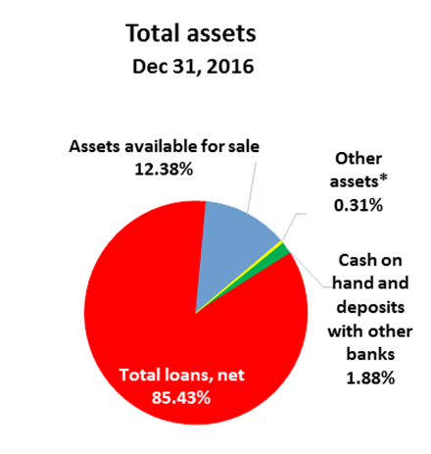 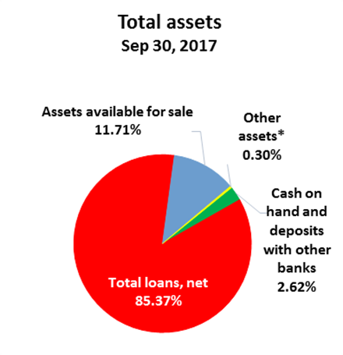

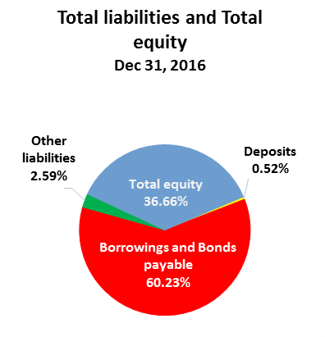 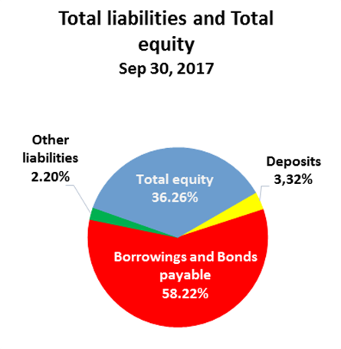

*Financial assets at fair value through profit or loss, Assets held to maturity, Property, plant and equipment and intangible assets, Non-current assets held for sale and Other assets.

**RESULTS OF HBOR**

**OVERVIEW OF FINANCIAL PERFORMANCE OF HBOR**

The following text gives an overview and explanation of the significant changes in financial position and operating performance in the reporting period.

**Financial performance**

In the period from 1 January to 30 September 2017, HBOR generated total income of HRK 697.61 million, expenses of HRK 522.10 million and profit in the amount of HRK 175.51 million. HBOR’s profit generated in the reporting period increased by HRK 16.59 million compared with the profit generated in the same reporting period last year, i.e. by 10.44 percent.

Higher profit in the reporting period compared with the same period last year is a result of a higher increase in income rising by HRK 27.98 million as against expenses rising by HRK 11.39 million. The circumstances that affected the financial result achieved in the nine month reporting period 2017 compared to the results generated in the same period in 2016 are:

* increase in interest income of HRK 16.28 million,
* decrease in interest expenses of HRK 39.41 million,
* increase in net fee income of HRK 9.92 million,
* increase in net losses from financial activities of HRK 7.75 million,
* increase in impairment loss and provisions of HRK 46.99 million,
* decrease in operating expenses of HRK 4.71 million.

A detailed description of trends is given for each category separately in the following text. 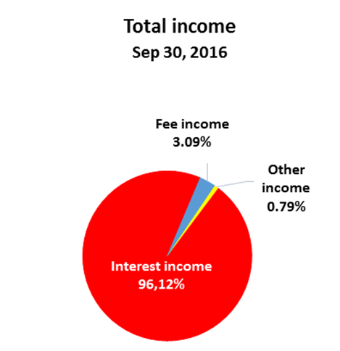 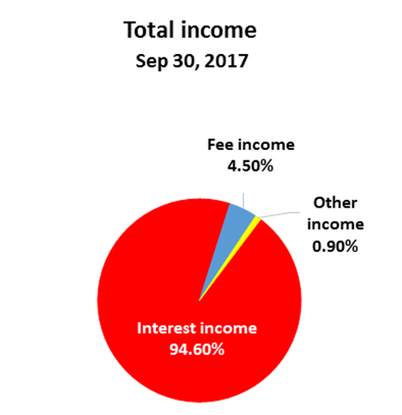

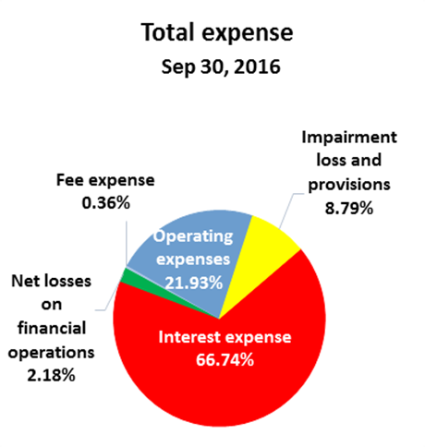 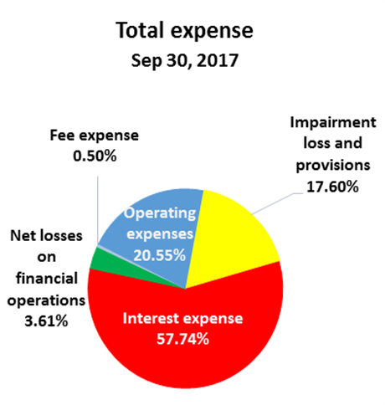

***Net interest income***

Net interest income amounted to HRK 358.50 million, an increase of 18.39 percent on the same reporting period of the previous reporting year.

Interest income amounted to HRK 659.96 million, an increase of 2.53 percent on the same reporting period last year due to increased lending activities and considerable collection of interest income under restructured loans.

Interest expenses amounted to HRK 301.46 million, a decrease of 11.56 percent on the same reporting period last year, which was for the major part affected by the following:

* repayment of borrowings agreed upon at higher interest rate, on maturity,
* utilisation of credit lines of special financial institutions at favourable interest rates.

Having in mind the described trends, net interest margin increased compared with the same reporting period last year and stood at 1.72 percent as against 1.54 percent in the same reporting period last year.

***Net fee income***

Net fee income amounted to HRK 28.78 million, an increase of 52.60 percent compared with the same reporting period last year as a result of increased fee income from guarantee activities caused by a higher volume of guarantees issued and as a result of increased fee income under agent transactions resulting from the performance of new agent transactions.

***Net gains/(losses) from financial activities***

Net gains/(losses) from financial activities are comprised of net foreign exchange gains/(losses) on the principal amount of receivables and liabilities, net revenues or expenditures arising out of the loan contracts with embedded call option, gains/(losses) arising out of value adjustment of assets stated at fair value through profit or loss and realised gains/(losses) arising out of assets available for sale.

In the reporting period, net losses from financial activities amounted to HRK 18.88 million, whereas, in the same reporting period previous year, net losses amounted to HRK 11.13 million,

A breakdown of changes in the exchange rate of HRK against the EUR and the USD:

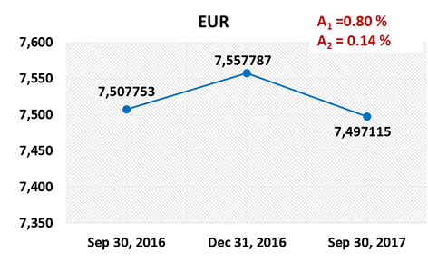 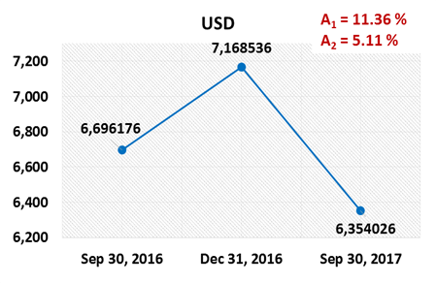

Note:

A1 = HRK appreciation 30.9.2017/31.12.2016 A1 = HRK appreciation 30.9.2017/31.12.2016

A2 = HRK appreciation 30.9.2017/30.9.2016 A2 = HRK appreciation 30.9.2017/30.9.2016

Foreign currency and foreign currency indexed assets and sources of funds are converted by HBOR into HRK equivalent value by applying the exchange rate of the Croatian National Bank valid at the reporting date.

Foreign currency revenues and expenditures are converted in accordance with the exchange rate at the transaction date. The resulting foreign exchange gains or losses are recorded in the Statement of Profit or Loss and Other Comprehensive Income in net figures.

***Operating expenses***

Operating expenses that include general and administrative expenses and other operating expenses stood at HRK 107.30 million, a decrease of 4.21 percent compared with the same period previous year.

This development is mostly affected by other expenses decreasing by HRK 7.74 million compared with the same period previous year.

This decrease is a result of a one-off business event in the same reporting period last year, i.e. a recalculation arising from partial assumption of a placement by another debtor resulting in the expenses of HRK 5.88 million.

Excluding the above mentioned one-off impact reducing the expenses in the reporting period, the operating expenses would increase by 2.90 percent in the reporting period 2017 compared with the same reporting period previous year.

There were 366 employees as at 30 September 2017, whereas there were 342 employees as at 30 September 2016.

***Impairment loss and provisions***

In accordance with the regulations and internal acts, HBOR determines the amount of impairment loss and provisions and maintains it at the level it considers adequate for the coverage of possible future risks.

In the reporting period, net impairment loss stood at HRK 91.87 million.

The following text contains a breakdown of the quality of portfolio:

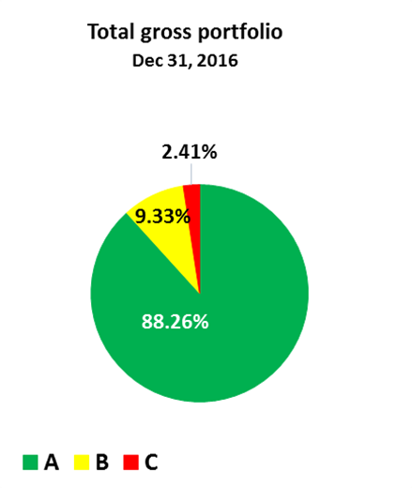 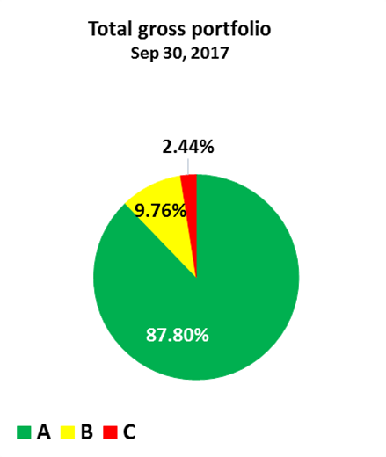

|  |  |  |  |  |
| --- | --- | --- | --- | --- |
|  | **31 December 2016** | | **30 September 2017** | |
|  | **HRK million** | **Structure**  **(%)** | **HRK million** | **Structure**  **(%)** |
| **Total gross portfolio** | **36,481.66** | **100,00** | **37,040.11** | **100.00** |
| Of which: |  |  |  |  |
| - financial institutions | 15,888.50 | 43.55 | 16,150.64 | 43.60 |
| - direct | 20,593.16 | 56.45 | 20,889.47 | 56.40 |
|  |  |  |  |  |
| **Total provisions** | **3,042.51** | **100.00** | **3.100.50** | **100.00** |
| Of which: |  |  |  |  |
| - financial institutions | 395.46 | 13.00 | 290.62 | 9.37 |
| - direct | 2,647.05 | 87.00 | 2,809.88 | 90.63 |
|  |  |  |  |  |
| **Provisions/gross portfolio** | **8.34 percent** | **-** | **8.37 percent** | **-** |

**Significant changes in the financial position**

Total assets of HBOR as at 30 September 2017 amounted to HRK 28,281.60 million, an increase of 3.31 percent, result of increased lending activities.

***Cash on hand and deposits with other banks***

As at 30 September 2017, cash on hand and deposits with other banks amounted to HRK 737.31 million representing 2.61 percent of total assets, an increase of 43.36 percent compared with the beginning of the year as a result of the redistribution of liquidity reserve funds.

***Loans to financial institutions and other customers***

Total net loans as at 30 September 2017 amounted to HRK 24,160.50 million representing 85.43 percent of total assets, an increase of 3.25 percent compared with the beginning of the year.

Total gross loans amounted to HRK 27,168.07 million, an increase of 3.13 percent compared with the beginning of the year. Gross loans to other customers increased by 4.02 percent compared with the beginning of the year, mostly due to the loan Programme for Export Financing, whereas gross loans to financial institutions increased by 2.11 percent.

***Assets available for sale***

Assets available for sale were comprised primarily of liquidity reserve funds, further to which assets available for sale were comprised primarily of debt instruments and, to a minor extent, of investments into investment funds and equity instruments. This item amounted to HRK 3,264.52 million, a decrease of 2.36 percent.

In the reporting period, the total amount of due bonds and treasury bills and sold investments in investment funds stood at HRK 1,316.66 million, whereas the amount of HRK 1,233.05 million was invested in the following instruments of assets available for sale:

|  |  |
| --- | --- |
|  | HRK million |
| Treasury bills of the Ministry of Finance | 1,134.95 |
| Bonds of the Republic of Croatia | 79.67 |
| Investment funds of the Republic of Croatia | 18.43 |
| **Total** | **1,233.05** |

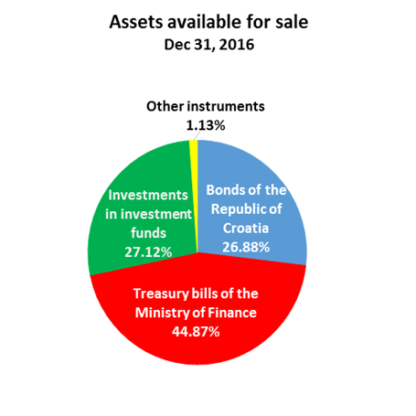 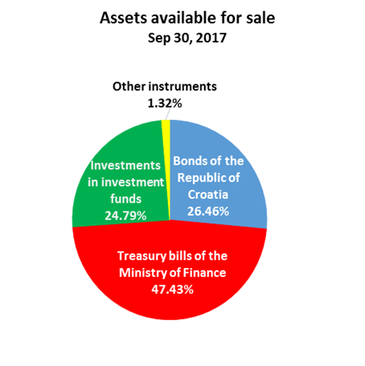

***Total liabilities***

As at 30 September 2017, total liabilities amounted to HRK 18,027.18 million, which represents 63.74 percent of total liabilities and total equity. The major part of total liabilities consists of HBOR’s foreign borrowings and bonds payable in the total amount of HRK 16,477.05 million.

Borrowings and bonds payable decreased compared with the beginning of the year by 0.12 percent, i.e. HRK 20.27 million net, and relate to the following changes:

|  |  |
| --- | --- |
|  | (HRK million) |
| - drawdowns of borrowed funds previously agreed with special financial institutions | 3,255.18 |
| - repayments of borrowings | (3,047.42) |
| - other calculations* | (228.03) |
| **Total changes** | **20.27** |
|  |  |
| *\*Other calculations relate to foreign-exchange gains and losses, changes in discount, changes in the amount of interest not due, and deferred fees,* | |

On 24 March 2017, HBOR entered into a EUR 44.00 million Finance Contract with the European Investment Bank for the financing of a development project in tourism.

In the reporting period, on 29 September 2017, HBOR entered into a EUR 33.30 million Finance Contract with the Bayerische Landesbank for financing renewable energy resource projects.

Of the total amount of repaid borrowings, the most significant amount relates to a one-off payment under the long-term bonds in the amount of HRK 1,852.05 million together with interest of HRK 92.60 million made by HBOR on 13 June 2017. The Bonds had been issued on 14 June 2007 on the basis of the agreement between HBOR and UBS Investment Bank and Deutsche Bank AG London (as joint lead managers) in the amount of EUR 250.00 million with maturity period of 10 years and fixed interest rate of 5.00%.

***Total equity***

Total equity amounted to HRK 10,254.2 million representing 36.26 percent of total liabilities and total equity.

Total equity of HBOR is comprised of the capital and the guarantee fund, HBOR’s capital is comprised of founder’s capital contributed from the budget of the Republic of Croatia, retained earnings from the profits generated in the previous years, other reserves and profits for the current year.

By the end of the reporting period, the total amount of capital contributed from the budget of the Republic of Croatia amounted to HRK 6,558.00 million, and the remaining amount to be contributed to the founder’s capital up to the total amount of HRK 7,000.00 million set by the HBOR Act is HRK 442.00 million.

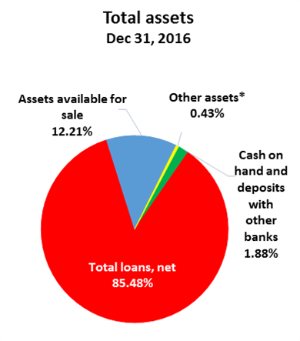 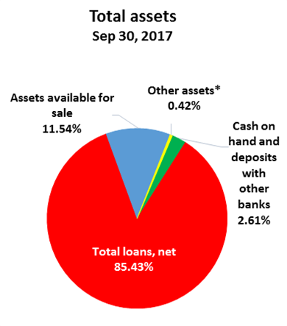

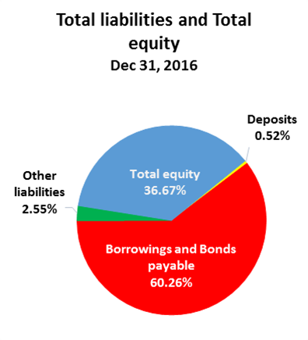 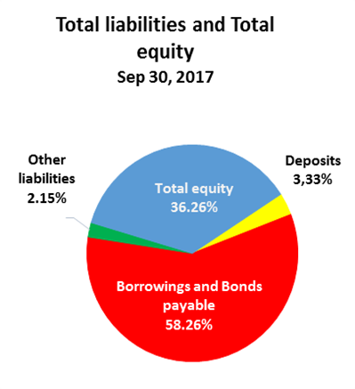

*Investments in subsidiaries, Property, plant and equipment and intangible assets, Non-current assets held for sale and Other assets,