REPORT ON FINANCIAL PERFORMANCE

FOR THE PERIOD 1 JANUARY – 30 SEPTEMBER 2020

Zagreb, November 2020

RESULTS OF THE GROUP

BREAKDOWN OF THE MOST SIGNIFICANT FINANCIAL INFORMATION OF hbor GROUP
-HRK million-

 | 31 December 2018 | 31 December 2019 | 30 September 2020
Total assets | 27,219.0 | 26,470.6 | 28,303.3
Gross loans | 26,243.1 | 26,571.1 | 26,141.9
Total equity | 10,061.1 | 10,274.6 | 10,338.5
 | 1 January –  30 September 2018 | 1 January –  30 September 2019 | 1 January –  30 September 2020
Total income | 617.4 | 525.2 | 495.0
Total expense | (518.7) | (381.3) | (437.3)
Profit | 98.7 | 143.9 | 57.7
Interest income | 563.1 | 483.3 | 465.3
Interest expense | (255.0) | (236.7) | (189.6)
Net interest income | 308.1 | 246.6 | 275.7

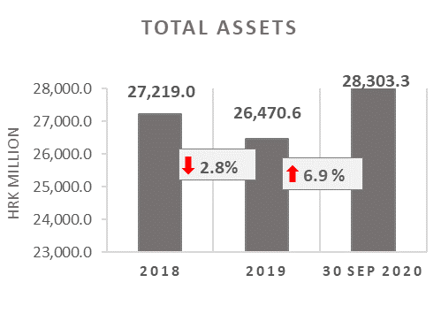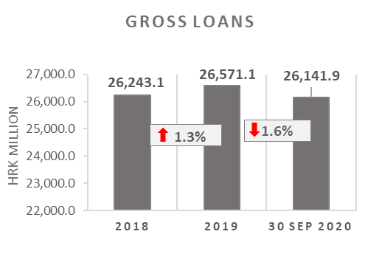

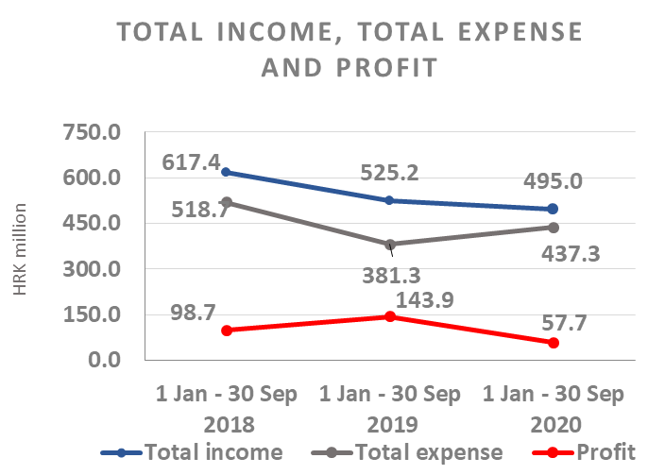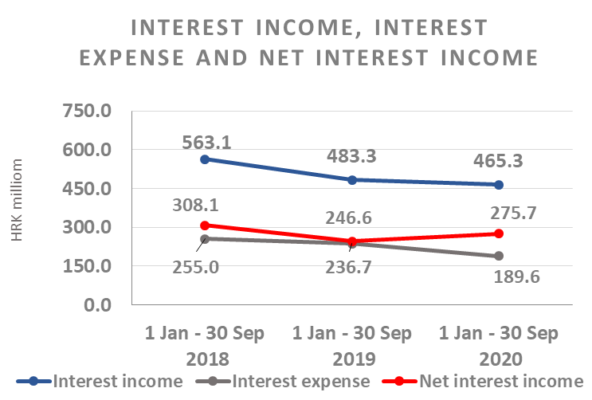

Results of the Group

In the period 1 January – 30 September 2020, the HBOR Group generated profit after tax in the amount of HRK 57.7 million.

Pursuant to the provisions of the Act on HBOR, the parent company is exempt from income tax and income tax liabilities arise exclusively from the activities of the other members of the Group.

In the period 1 January – 30 September 2020, total income on consolidated basis amounted to HRK 495.0 million, whereas total expenses amounted to HRK 437.3 million.

The consolidated total income decreased by 5.8 percent, whereas total expenses rose by 14.7 percent compared to the same period previous year due to the developments in total income and expenses of the parent company.

In the structure of income of the Group, the largest portion, i.e. 94.0 percent, relates to interest income as a result of operations of the parent company.

The major part of total expenses, i.e. 43.4 percent, relates to interest expenses arising from the operations of the parent company.

The consolidated operating expenses in the period 1 January – 30 September 2020 amounted to HRK 111.7 million and consisted of general and administrative expenses and other operating expenses.

On 30 September 2020, the Group had 389 employees (on 30 September 2019: 386 employees).

Assets and liabilities of the Group

Total assets of the Group on consolidated basis amount to HRK 28,303.3 million, an increase of 6.9 percent compared with the beginning of the year. The reasons for such tendency are stated in the description of HBOR’s financial performance.

In the structure of assets, the major portion relates to the lending activities of the parent company, i.e. net loans account for 80.0 percent of total assets.

Total liabilities and total equity as at 30 September 2020 amount to HRK 28,303.3 million, of which amount total liabilities equal HRK 17,964.8 million, i.e. 63.5 percent.

In total liabilities and total equity of the Group, the major portion, i.e. 60.4 percent, consists of borrowings of the parent company.

At the end of the reporting period, total equity on consolidated basis amounted to HRK 10,338.5 million and accounted for 36.5 percent of total liabilities and total equity of the Group.

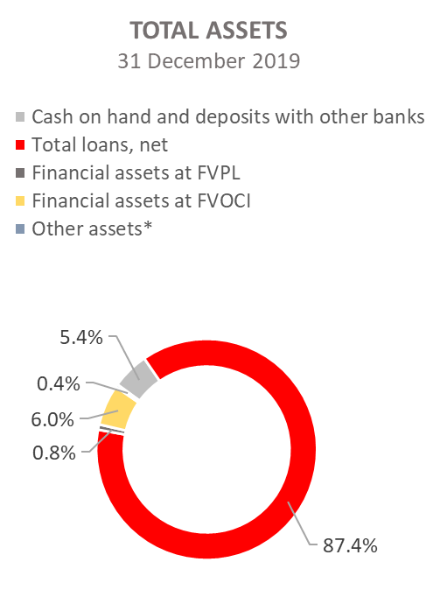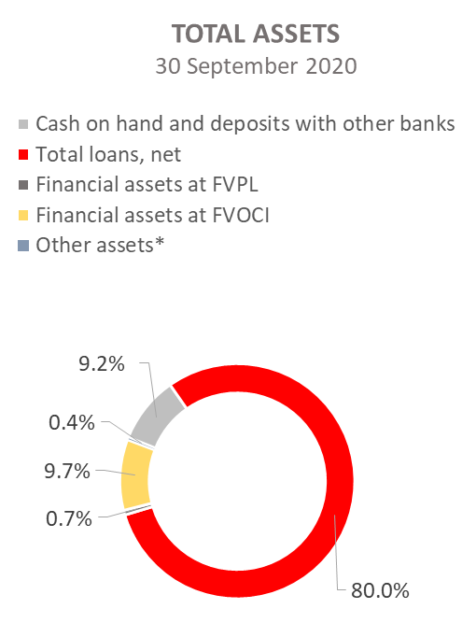

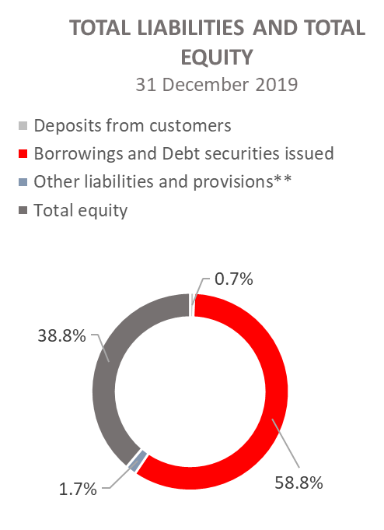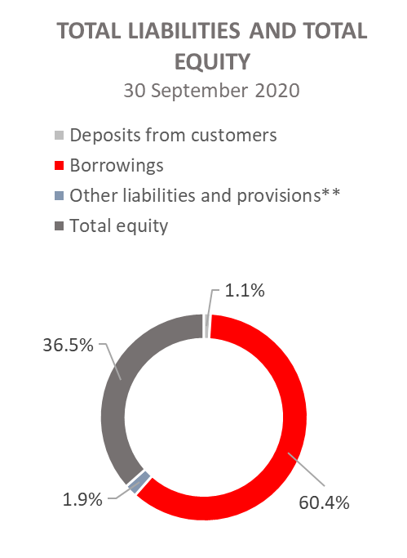

*Property, plant and equipment and intangible assets, Foreclosed assets, Debts securities at AC and Other assets.
**Other liabilities, Provisioning for guarantees, commitments and other liabilities.

RESULTS OF HBOR

OVERVIEW OF FINANCIAL PERFORMANCE OF HBOR

The following text gives an overview and explanation of the significant changes in financial position and operating performance in the reporting period.

Financial performance

In the period from 1 January to 30 September 2020, HBOR generated total income of HRK 486.6 million, expenses of HRK 431.3 million and profit in the amount of HRK 55.3 million. HBOR’s profit generated in the reporting period decreased by HRK 86.4 million compared with the profit generated in the same period last year, i.e. by 61.0 percent.

Namely, due to the impact of the COVID - 19 pandemic, HBOR paid special attention to expected credit losses, which resulted in a significant increase of impairment loss and provisions, and significantly reduced the profit generated in the first half of 2020 compared to the same period in 2019.

The decrease in profit in the reporting period compared with the same period last year is a result of a decrease in total income by HRK 28.7 million and a increase in total expenses by HRK 57.7 million. The circumstances that affected the financial result achieved in the nine-month reporting period 2020 compared to the results generated in the same period in 2019 are:
- (+) increase in net interest income of HRK 29.2 million, i.e. by 11.9 percent,
- (+) increase in net income from fees and commissions of HRK 0.5 million, i.e. by 3.4 percent,
- (-) decrease in net gains from financial activities in the amount of HRK 14.8 million and other income in the amount of HRK 0.1 million,
- (-) increase in losses from impairment and provisions in the amount of HRK 111.8 million,
- (+) decrease in operating expenses of HRK 10.6 million, i.e. by 9.1 percent.

A detailed description of trends is given for each category separately in the following text.

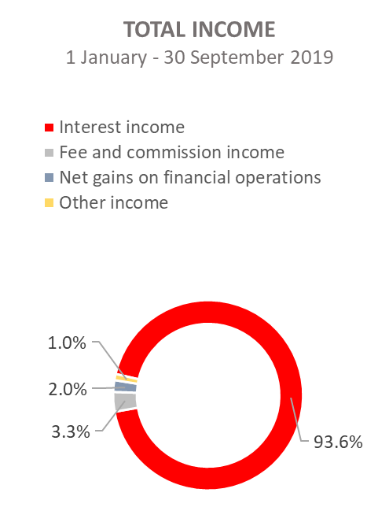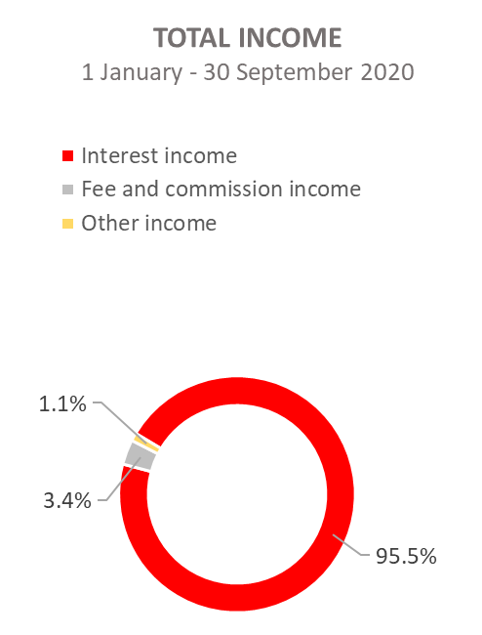

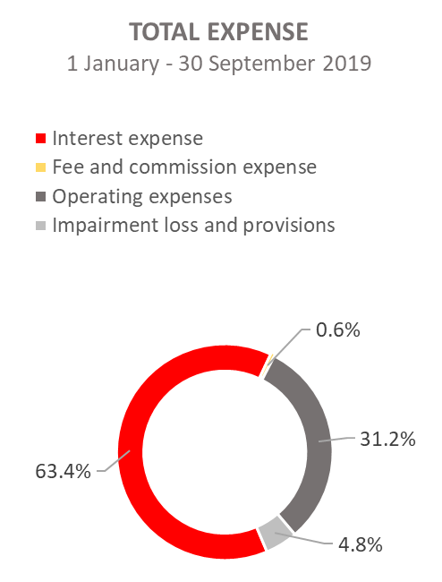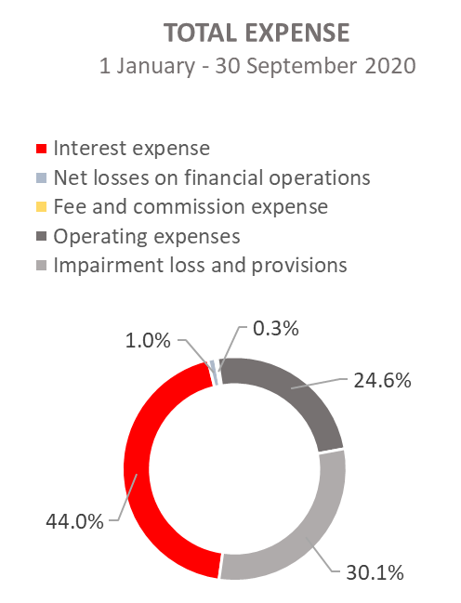

Net interest income

Net interest income amounted to HRK 274.9 million, an increase of 11.9 percent on the same period of the previous reporting year.

Interest income amounted to HRK 464.5 million, a decrease of 3.7 percent on the same reporting period last year due to decreased interest income from long-term loans due to the long-term implementation of measures of interest rate reduction, reduction of interest income from interest rate subsidies, implementation of moratorium and the recalculation of interest due to the implementation of loan restructuring, premature loan repayments in 2019 and 2020 and the manner of recording of interest income from exposures classified to stage 3 and POCI assets (unwinding).
On this basis, from 1 January to 30 September 2020, interest income was reduced by HRK 31.9 million.

Interest expenses amounted to HRK 189.6 million, a decrease of 19.9 percent on the same reporting period last year, due to the repayment of debt under loan liabilities.

Having in mind the described trends in interest income and interest expenses, a larger decrease in interest expenses than interest income led to an increase in net net interest margin compared with the same reporting period last year and stood at 1.34 percent as against 1.22 percent in the same reporting period last year.

Net fee income and commission income

Net fee and commission income amounted to HRK 15.4 million, an increase of 3.4 percent compared with the same reporting period last year due to a larger decrease in fee and commission expenses (by 39.1 percent) compared to the decrease in fee and commission income (by 2.3 percent). Revenues are lower due to lower exposure to issued guarantees compared to the same period last year, and expenditures due to lower foreign banks fees, which represented the end user cost per certain transaction.

Net gains/(losses) on financial operations

Net gains/(losses) on financial operations are comprised of net foreign exchange gains/(losses) on the principal amount of receivables and liabilities, net revenues or expenditures arising out of the loan contracts with embedded call option, gains/(losses) arising out of value adjustment of financial assets stated at fair value through profit or loss and realised gains/(losses) arising out of financial assets at fair value through other comprehensive income.

In the reporting period, net losses from financial activities amounted to HRK 4.5 million, which is HRK 14.8 million less than net gains from financial activities in the same period last year of HRK 10.3 million.

A breakdown of changes in the exchange rate of HRK against the EUR and the USD:

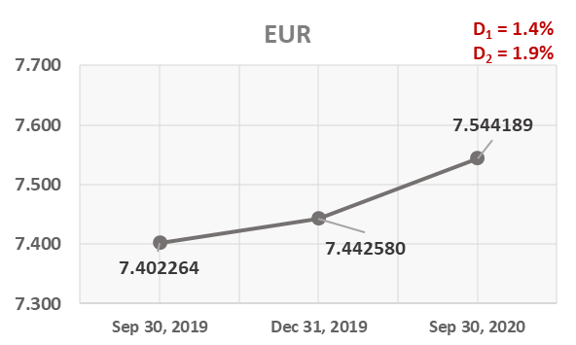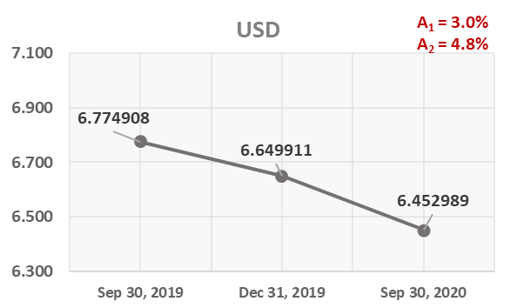

Note:
D₁ = HRK depreciation 30.6.2020/31.12.2019 D₁ = HRK apreciation 30.6.2020/31.12.2019
D₂ = HRK depreciation 30.6.2020/31.3.2019 D₂ = HRK apreciation 30.6.2020/30.6.2019

Foreign currency and foreign currency indexed assets and sources of funds are converted by HBOR into HRK equivalent value by applying the exchange rate of the Croatian National Bank valid at the reporting date.

Foreign currency revenues and expenditures are converted in accordance with the exchange rate at the transaction date. The resulting foreign exchange gains or losses are recorded in the Profit or Loss Account in net figures.

Operating expenses

Operating expenses that include general and administrative expenses and other operating expenses stood at HRK 105.9 million, a decrease of 9.1 percent compared with the same reporting period last year, mainly due to a decrease in administrative expenses by HRK 6.7 million.

On 30 September 2020, HBOR had 368 employees (on 30 September 2019: 366 employees).

Impairment gain/(loss) and provisions

In the reporting period, a net loss from impairment of placements in the amount of HRK 129.9 million was recorded as a result of the impact of the COVID - 19 pandemic on expected credit losses.

The text to follow contains a breakdown of portfolio quality:

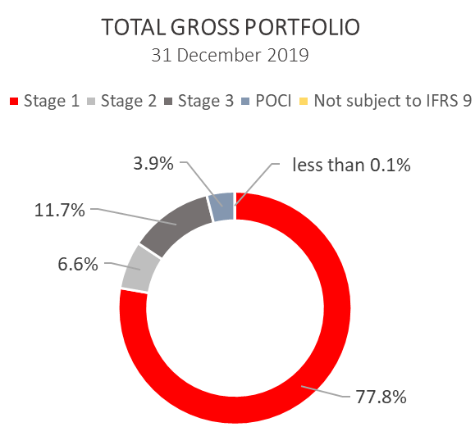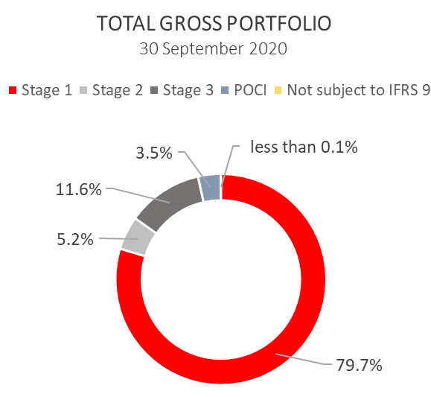
.

 | 31 December 2019 |  | 30 September 2020
 | In HRK millions | Breakdown (percent) | In HRK millions | Breakdown (percent)
Total gross portfolio | 34,024.8 | 100.0 | 37,223.6 | 100.0
Of which:
- financial institutions | 13,186.7 | 38.8 | 15,073.7 | 40.5
- direct | 20,838.1 | 61.2 | 22,149.9 | 59.5
Total provisions | 3,518.7 | 100.0 | 3,613.9 | 100.0
Of which:
- financial institutions | 65.9 | 1.9 | 62.7 | 1.7
- direct | 3,452.8 | 98.1 | 3,551.2 | 98.3
Provisions/gross portfolio | 10.3 percent | - | 9.7 percent | -

Significant changes in financial position

Total assets of HBOR as at 30 September 2020 amounted to HRK 28,279.0 million, an increase of 6.9 percent compared with 31 December 2019 due to significant draw-down of funds under a long-term borrowing from special financial institutions.

Cash on hand and deposits with other banks

As at 30 September 2020, cash on hand and deposits with other banks amounted to HRK 2,586.7 million representing 9.1 percent of total assets, an increase of 80.3 percent compared with 31 December 2019 as a result of reallocation of liquidity reserve funds.

Loans to financial institutions and other customers

As at 30 September 2020, total net loans amounted to HRK 22,655.7 million representing 80.1 percent of total assets, an increase 2.1 percent on the beginning of the year.

Total gross loans amounted to HRK 26,141.9 million, a decrease of 1.6 percent compared with 31 December 2019. Gross loans to other customers stood at the same level compared with the end of 2019. Gross loans to financial institutions decreased by 4.5 percent compared with the end of 2019.
As at 30 September 2020, the proportion between gross loans on-lent through financial institutions and direct placements stood at 35 percent : 65 percent ( 31 December 2019 36 percent : 64 percent).

Financial assets at fair value through profit or loss

Loans at fair value (HBOR has determined that mezzanine loans are classified here), investments in investment funds and a part of equity instruments are classified to these assets. As at 30 September 2020, the total amount of these assets was HRK 184.8 million representing 0.7 percent of total assets.

Financial assets at fair value through other comprehensive income

a) Debt instruments

Bonds of the Republic of Croatia and treasury bills of the Ministry of Finance as part of liquidity reserve as well as bonds of a company are classified to these assets. On the reporting date, they amounted to HRK 2,693.1 million, representing 9.5 percent of total assets and recorded an increase compared to the beginning of the year by 78.1 percent as a result of reallocation of liquidity reserve funds.
The impairment of these financial assets is calculated through the application of the model of expected credit losses in the manner that provisions are recognised in the accounts of other comprehensive income, thus not reducing the carrying amount of these financial assets in the statement on financial position. On the reporting date, they amounted to HRK 4.2 million in other reserves.
b) Equity instruments

Equity instruments (shares of companies) that HBOR does not intend to sell and to which irrevocable option of subsequent measurement of fair value through other comprehensive income without recycling is applied are classified to these assets, i.e. reserves recognised under other comprehensive income will never be transferred to the statement on profit or loss.
On the reporting date, these assets amounted to HRK 26.7 million, representing 0.1 percent of total assets.

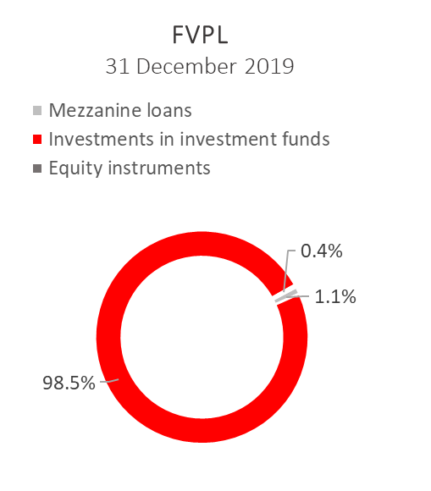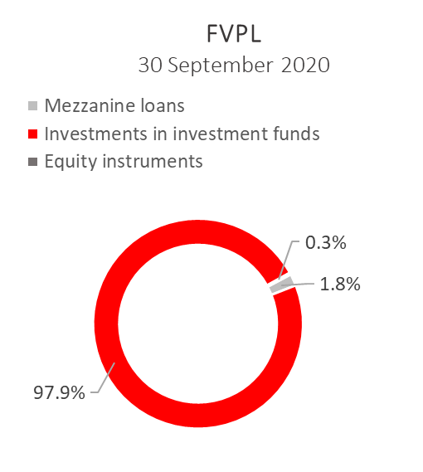
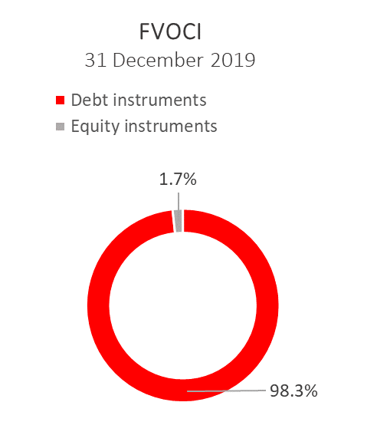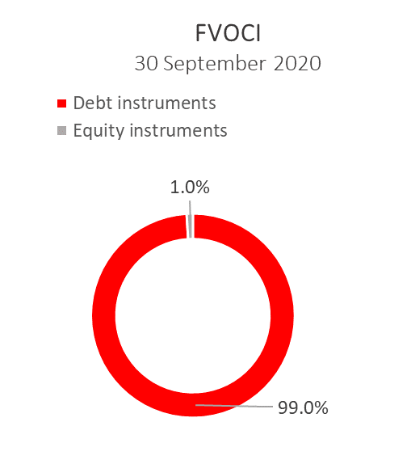

Total liabilities

As at 30 September 2020, total liabilities amounted to HRK 17,949.7 million, which represents 63.5 percent of total liabilities and total equity. The major part of total liabilities consists of HBOR’s foreign borrowings in the total amount of HRK 17,102.4 million.

Borrowings increased by 18.8 percent compared with the beginning of the year, whereas changes in these liabilities are shown in the following table:

 | (in HRK millions)
- Draw-down of funds borrowed under previously contracted  funds of special financial institutions | 4,553.9
- Repayments of borrowings and bonds payable | (3,155.3)
- Foreign exchange gains or losses | 179.5
- Other calculations * | (34.5)
Total changes | 1,543.6
* Other calculations relate to the changes in discount, amount of interest not due and deferred fees.

During 2020, HBOR continued to raise funds, and on 26 June 2020, a loan agreement was concluded with the Ministry of Finance in the amount of up to HRK 3.0 billion with a fixed interest rate of 0.9% p.a.

On 8 May 2020 HBOR settled the bonds due of HRK 1,203,211 thousand, together with interest (EUR 159,000 thousand, together with interest).

Total equity
Total equity amounted to HRK 10,329.3 million, representing 36.5 percent of total liabilities and total equity.

Total equity of HBOR is comprised of the capital and the guarantee fund. HBOR’s capital is comprised of founder’s capital contributed from the budget of the Republic of Croatia, retained earnings from the profits generated in the previous years, other reserves and profits for the current period.

In the reporting period the amount of HRK 25.0 million was contributed into the founder’s capital from the budget of the Republic of Croatia. The total amount of capital contributed from the budget of the Republic of Croatia stood at HRK 6,708.0 million, and the remaining amount to be contributed to the founder’s capital up to the total amount of HRK 7,000.0 million set by the HBOR Act is HRK 292.0 million.

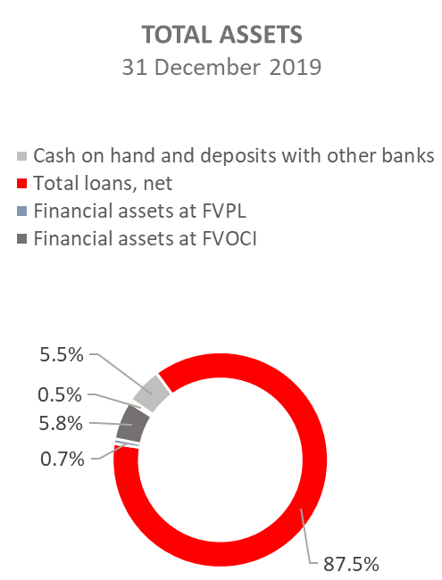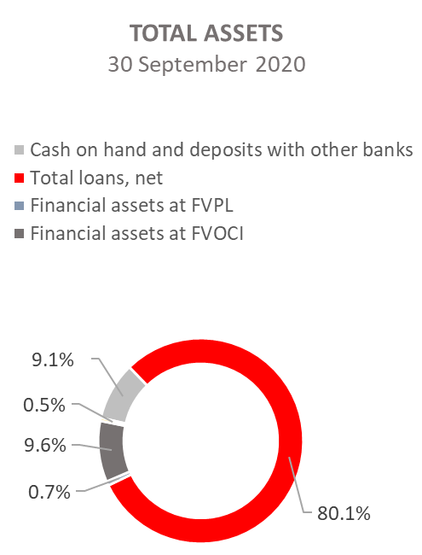

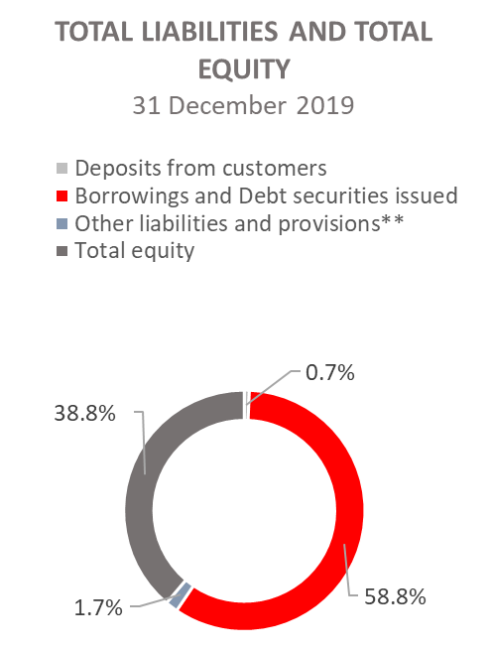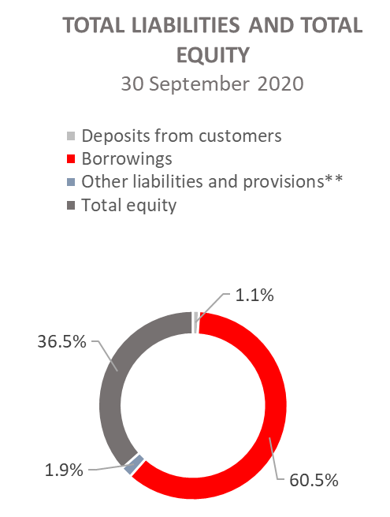

*Investments in subsidiaries, Property, plant and equipment and intangible assets, Foreclosed assets and Other assets.
**Other liabilities, Provisioning for guarantees, commitments and other liabilities.

