logo-01a-boja

**REPORT ON FINANCIAL PERFORMANCE**

**FOR THE PERIOD**

**1 JANUARY – 31 MARCH 2017**

**Zagreb, May 2017**

**RESULTS OF THE GROUP**

**BREAKDOWN OF THE MOST SIGNIFICANT FINANCIAL INFORMATION OF THE GROUP**

-HRK millions-

|  |  |  |  |
| --- | --- | --- | --- |
|  | **2015** | **2016** | **31 March 2017** |
| Total assets | 25,552.80 | 27,390.82 | 28,905.18 |
| Gross loans | 24,722.82 | 26,343.12 | 25,729.69 |
| Total equity | 9,664.54 | 10,042.70 | 10,085.25 |
|  |  |  |  |
|  | **31 March 2015** | **31 March 2016** | **31 March 2017** |
| Total income | 228.06 | 228.81 | 250.36 |
| Total expense | (187.64) | (175.72) | (208.96) |
| Profit | 40.42 | 53.09 | 41.40 |
|  |  |  |  |
| Interest income | 221.00 | 219.04 | 238.91 |
| Interest expense | (120.62) | (114.55) | (108.11) |
| Net interest income | 100.38 | 104.49 | 130.80 |

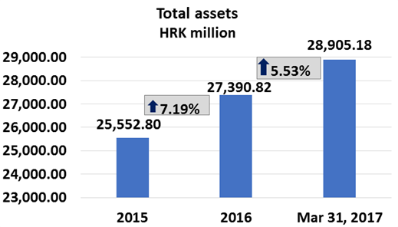 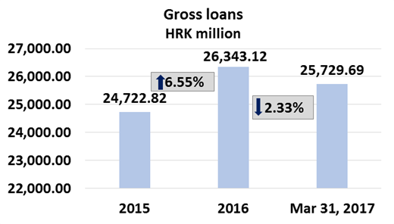

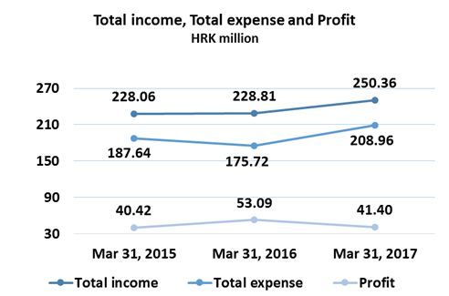 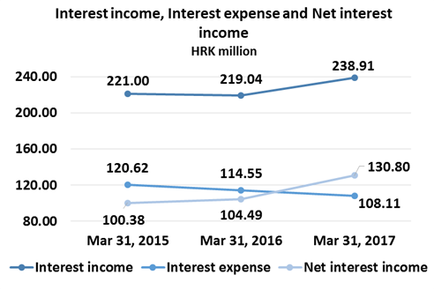

**Results of the Group**

In the period 1 January – 31 March 2017, the HBOR Group generated profit after tax in the amount of HRK 41.40 million.

Pursuant to the provisions of the Act on HBOR, the parent company is exempt from income tax and income tax liabilities arise exclusively from the activities of the other members of the Group.

In the period 1 January – 31 March 2017, total income on consolidated basis amounted to HRK 250.36 million, whereas total expenses amounted to HRK 208.96 million.

The consolidated total income rose by 9.42 percent, whereas total expenses rose by 18.92 percent compared to the same period previous year due to the developments in total income and expenses of the parent company.

In the structure of income of the Group, the largest portion, i.e. 95.43 percent, relates to interest income as a result of operations of the parent company.

The major part of total expenses, i.e. 51.74 percent, relates to interest expenses arising from the operations of the parent company.

The consolidated operating expenses in the period 1 January – 31 March 2017 amounted to HRK 37.15 million and consisted of general and administrative expenses and other operating expenses.

There were 376 employees in the Group on 31 March 2017, whereas there had been 360 employees in the Group on 31 March 2016.

**Assets and liabilities of the Group**

Total assets of the Group on consolidated basis amount to HRK 28,905.18 million, an increase of 5.53 percent compared with the beginning of the year. The reasons for such tendency are stated in the description of HBOR’s financial performance.

In the structure of assets, the major portion relates to the lending activities of the parent company, i.e. net loans account for 78.71 percent of total assets.

Total liabilities and total equity as at 31 March 2017 amount to HRK 28,905.18 million, of which amount total liabilities equal HRK 18,819.92 million, i.e. 65.11 percent.

In total liabilities and total equity of the Group, the major portion, i.e. 61.90 percent, consists of borrowings and bonds payable of the parent company.

At the end of the reporting period, total equity on consolidated basis amounted to HRK 10,085.25 million and accounted for 34.89 percent of total liabilities and total equity of the Group.

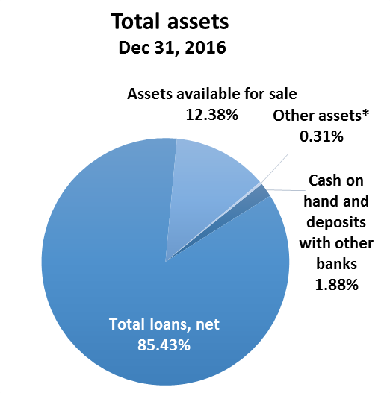

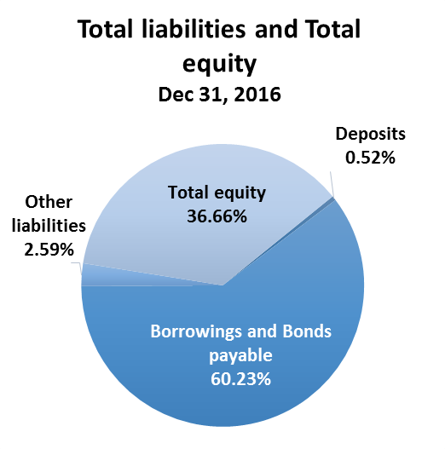 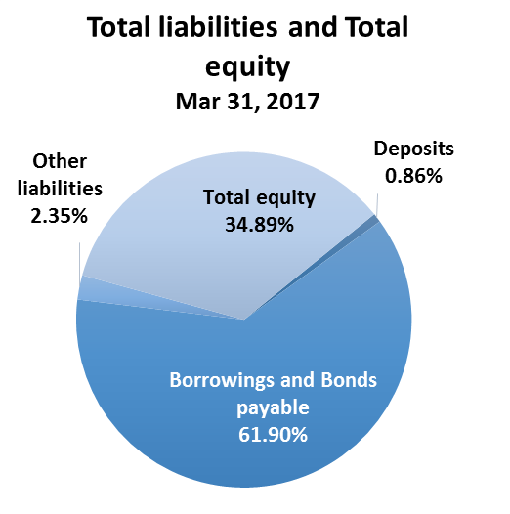

*Financial assets at fair value through profit or loss, Assets held to maturity, Property, plant and equipment and intangible assets, Non-current assets held for sale and Other assets.

**RESULTS OF HBOR**

**OVERVIEW OF FINANCIAL PERFORMANCE OF HBOR**

The following text gives an overview and explanation of the significant changes in financial position and operating performance in the reporting period.

**Financial performance**

In the period from 1 January to 31 March 2017, HBOR generated total income of HRK 247.39 million, expenses of HRK 207.14 million and profit in the amount of HRK 40.25 million. HBOR’s profit generated in the reporting period decreased by HRK 12.66 million compared with the profit generated in the same reporting period last year, i.e. by 23.82 percent.

Lower profit in the reporting period compared with the same period last year is a result of a higher increase in expenses rising by HRK 33.81 million as against income rising by HRK 21.15 million. The circumstances that affected the financial result achieved in Q1 2017 compared to the results generated in Q1 2016 are:

* increase in interest income of HRK 19.87 million,
* decrease in interest expenses of HRK 6.45 million,
* decrease in net losses from financial activities of HRK 10.95 million,
* increase in impairment loss and provisions of HRK 55.12 million,
* decrease in operating expenses of HRK 4.05 million.

A detailed description of trends is given for each category separately in the following text.

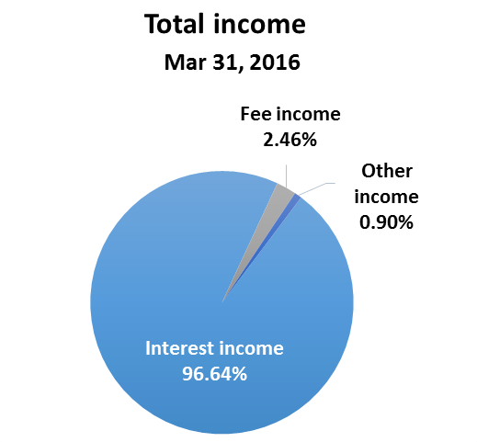 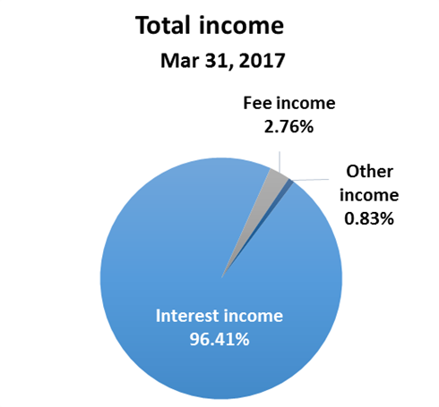

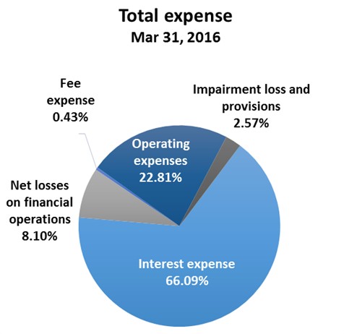 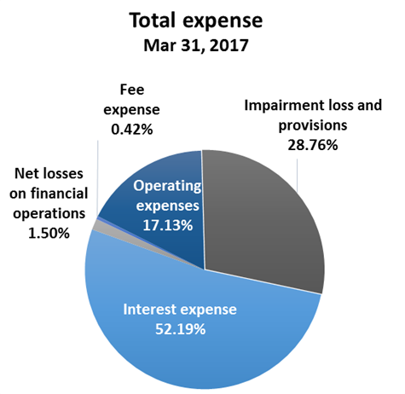

***Net interest income***

Net interest income amounted to HRK 130.39 million, an increase of 25.38 percent on the same reporting period of the previous reporting year.

Interest income amounted to HRK 238.50 million, an increase of 9.10 percent on the same reporting period last year due to increased lending activities and considerable collection of interest income under restructured loans.

Interest expenses amounted to HRK 108.11 million, a decrease of 5.67 percent on the same reporting period last year, which was significantly affected by an appreciation of HRK against EUR in Q1 2017.

Having in mind the described trends, net interest margin increased compared with the same reporting period last year and stood at 1.85 percent as against 1.62 percent in the same reporting period last year.

***Net fee income***

Net fee income amounted to HRK 5.96 million, an increase of 23.21 percent compared with the same reporting period last year as a result of increased fee income from guarantee activities caused by a higher volume of guarantees issued.

***Net gains/(losses) from financial activities***

Net gains/(losses) from financial activities are comprised of net foreign exchange gains/(losses) on the principal amount of receivables and liabilities, net revenues or expenditures arising out of the loan contracts with embedded call option, gains/(losses) arising out of value adjustment of assets stated at fair value through profit or loss and realised gains/(losses) arising out of assets available for sale.

In the reporting period, net losses from financial activities amounted to HRK 3.09 million, whereas, in the same reporting period previous year, net losses amounted to HRK 14.04 million.

A breakdown of changes in the exchange rate of HRK against the EUR and the USD:

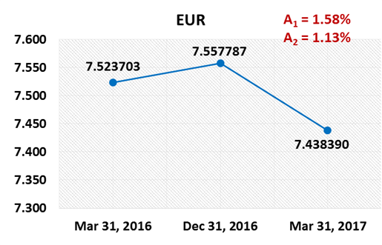 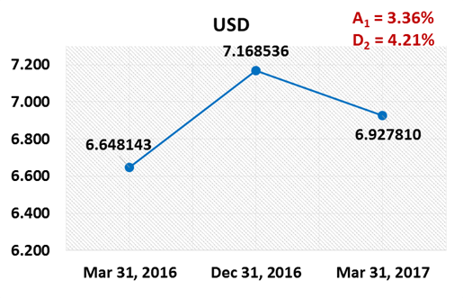

Note:

A1 = HRK appreciation March 31, 2017/Dec 31, 2016 A1 = HRK appreciation March 31, 2017/Dec 31, 2016

A2 = HRK appreciation March 31, 2017/March 31, 2016 D2 = HRK depreciation March 31, 2017/March 31, 2016

Foreign currency and foreign currency indexed assets and sources of funds are converted by HBOR into HRK equivalent value by applying the exchange rate of the Croatian National Bank valid at the reporting date.

Foreign currency revenues and expenditures are converted in accordance with the exchange rate at the transaction date. The resulting foreign exchange gains or losses are recorded in the Statement of Profit or Loss and Other Comprehensive Income in net figures.

***Operating expenses***

Operating expenses that include general and administrative expenses and other operating expenses stood at HRK 35.49 million, a decrease of 10.13 percent compared with the previous year.

This development is mostly affected by other expenses decreasing by HRK 6.60 million compared with the same period previous year.

This decrease is a result of a one-off business event in Q1 2016, i.e. a recalculation arising from partial assumption of a placement by another debtor resulting in the expenses of HRK 5.88 million.

Excluding the above mentioned one-off impact reducing the expenses in the reporting period, the operating expenses would increase by 7.73 percent in Q1 2017 compared with the same reporting period previous year.

There were 360 employees as at 31 March 2017, whereas there were 346 employees as at 31 March 2016.

***Impairment loss and provisions***

In accordance with the regulations and internal acts, HBOR determines the amount of impairment loss and provisions and maintains it at the level it considers adequate for the coverage of possible future risks.

In the reporting period, net impairment loss stood at HRK 59.57 million.

The following text contains a breakdown of the quality of portfolio:

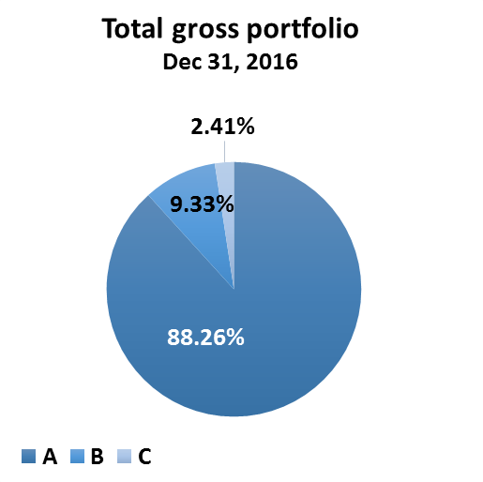 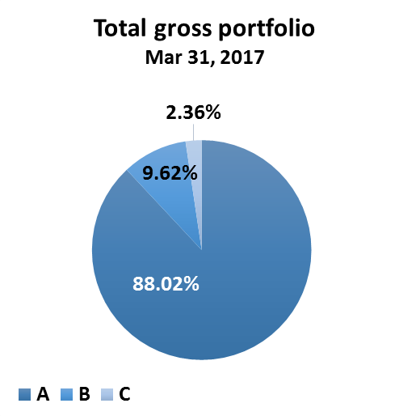

|  |  |  |  |  |
| --- | --- | --- | --- | --- |
|  | **31 December 2016** | | **31 March 2017** | |
|  | **HRK million** | **Structure**  **(%)** | **HRK million** | **Structure**  **(%)** |
| **Total gross portfolio** | **36,481.66** | **100.00** | **38,091.67** | **100** |
| Of which: |  |  |  |  |
| - financial institutions | 15,888.50 | 43.55 | 17,732.00 | 46.55 |
| - direct | 20,593.16 | 56.45 | 20,359.67 | 53.45 |
|  |  |  |  |  |
| **Total provisions** | **3,042.51** | **100.00** | **3,090.79** | **100.00** |
| Of which: |  |  |  |  |
| - financial institutions | 395.46 | 13.00 | 372.06 | 12.04 |
| - direct | 2,647.05 | 87.00 | 2,718.73 | 87.96 |
|  |  |  |  |  |
| **Provisions/gross portfolio** | **8.34 percent** | **-** | **8.11 percent** | **-** |

**Significant changes in the financial position**

Total assets of HBOR as at 31 March 2017 amounted to HRK 28,888.92 million, an increase of 5.53 percent compared with the beginning of the year. The increase in assets is mostly due to the increase in cash on hand.

***Cash on hand and deposits with other banks***

As at 31 March 2017, cash on hand and deposits with other banks amounted to HRK 2,610.27 million representing 9.04 percent of total assets, an increase of 407.28 percent compared with the beginning of the year as a result of the accumulation of funds needed for the repayment of HBOR’s borrowings.

The most significant amount of repayment relates to a one-off repayment of HBOR’s bond issued in the international market in the nominal amount of EUR 250.00 million and the accompanying interest in the amount of EUR 12.50 million maturing on 14 June 2017.

***Loans to financial institutions and other customers***

Total net loans as at 31 March 2017 amounted to HRK 22,750.17 million representing 78.75 percent of total assets, a decrease of 2.78 percent compared with the beginning of the year.

Total gross loans amounted to HRK 25,729.69 million, a decrease of 2.33 percent compared with the beginning of the year. Gross loans to other customers remained at the previous year’s level, whereas gross loans to financial institutions decreased by 4.58 percent.

The remaining of gross loans to other customers at the level from the beginning of the year and the decrease in gross loans to financial institutions are the result of a significant amount of prepayments of loans as well as of a redistribution of liquidity reserve to other financial instruments.

***Assets available for sale***

Assets available for sale were comprised primarily of liquidity reserve funds, further to which assets available for sale were comprised primarily of debt instruments and, to a minor extent, of investments into investment funds and equity instruments.

This item amounted to HRK 3,412.80 million, an increase of 2.07 percent compared with the beginning of the year due to the investments of available funds in treasury bills of the Ministry of Finance and bonds of the Republic of Croatia as liquidity reserve in the reporting period.

In the reporting period, investment in the following instruments of assets available for sale was made:

|  |  |
| --- | --- |
|  | HRK million |
| Treasury bills of the Ministry of Finance | 657.00 |
| Bonds of the Republic of Croatia | 79.67 |
| **Total** | **736.67** |

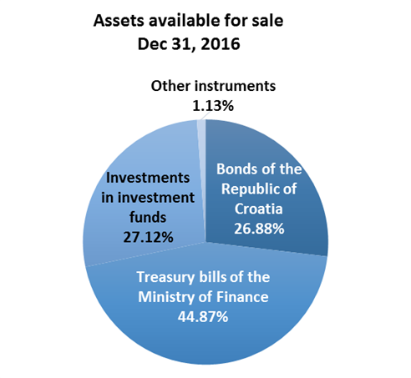 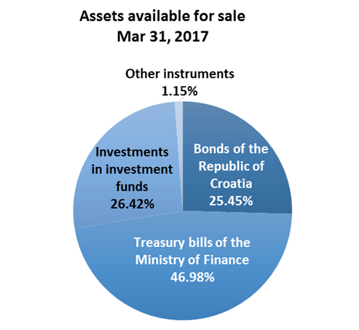

***Total liabilities***

As at 31 March 2017, total liabilities amounted to HRK 18,809.54 million, which represents 65.11 percent of total liabilities and total equity. The major part of total liabilities consists of HBOR’s foreign borrowings and bonds payable in the total amount of HRK 17,891.67 million.

Borrowings and bonds payable increased compared with the beginning of the year by 8.45 percent due to the drawdown of borrowings.

In the reporting period, on 24 March 2017, HBOR concluded a Finance Contract with the European Investment Bank in the amount of EUR 44.00 million for the financing of a development project in tourism.

***Total equity***

Total equity amounted to HRK 10,079.38 million, representing 34.89 percent of total liabilities and total equity.

Total equity of HBOR is comprised of the capital and the guarantee fund. HBOR’s capital is comprised of founder’s capital contributed from the budget of the Republic of Croatia, retained earnings from the profits generated in the previous years, other reserves and profits for the current year.

The total amount of capital contributed from the budget of the Republic of Croatia amounted to HRK 6,533.00 million, and the remaining amount to be contributed to the founder’s capital up to the total amount of HRK 7,000.00 million set by the HBOR Act is HRK 467.00 million.

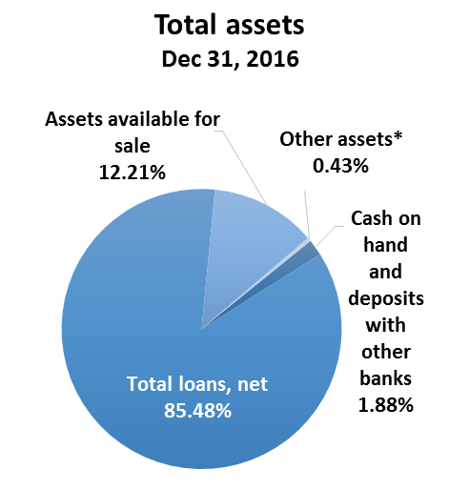

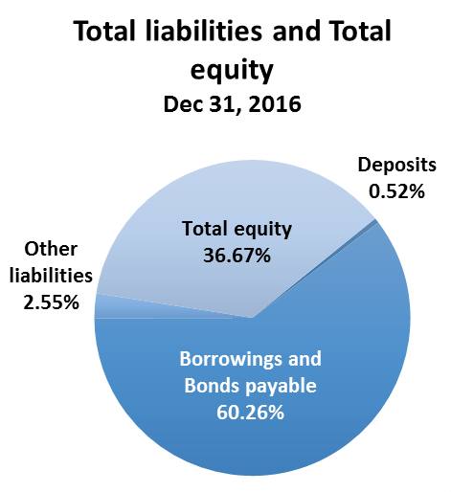 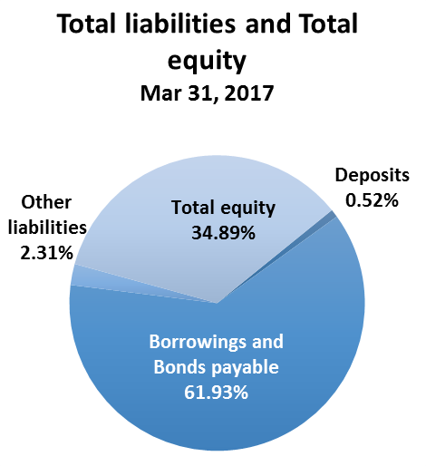

*Investments in subsidiaries, Property, plant and equipment and intangible assets, Non-current assets held for sale and Other assets.